Environmental and Management Influences on Fish and Invertebrate Communities in Agricultural Headwater Systems

by

Jennifer R. Janssen

A thesis submitted

in partial fulfillment of the requirements

for the degree of

Master of Science

(Natural Resources and Environment)

in the University of Michigan

July 2008

Committee:

Professor J. David Allan, Chair
Professor Mike Wiley

Abstract

Agricultural headwaters in the Midwestern United States are extensively modified to transport water from fields drained by subsurface drainage modifications and facilitate rapid conveyance of floodwaters. The resulting channelized streams, county drains, and farm ditches lack structural heterogeneity important to fish and invertebrate communities and contribute to problems downstream of high sediment and nutrient loads. Alternative drain design and maintenance practices have been developed in attempts to improve the sediment and nutrient processing of agricultural, including the two-stage channel design that features a narrow main channel and adjacent bench to act as a narrow floodplain within the drain. Little is known, however, about the significance of in-channel features on drain fish and invertebrate communities.
The goals of this study were to assess what environmental features influence fish and invertebrate communities in agricultural drains; investigate the significance of naturally-formed benches within drain channels; and compare the physical and biotic characteristics of drains with reference streams. Canonical correspondence analysis identified stream size, stream habitat characteristics, and water quality measures as primary environmental characteristics associated with variation among biotic communities. While channel benching was associated with biotic communities, it was not one of the most strongly associated environmental characteristics. Agricultural drains and reference streams were compared using Mann-Whitney U tests, and were found to have few biotic or physical differences. Our findings suggest that alternative channel designs featuring naturally-formed benches within drain channels do little to improve local habitat conditions for invertebrates or improve conditions at a scale relevant to fish.

Acknowledgements
I would like thank my advisor, Dr. David Allan, for giving me the opportunity to work on this project and his support, mentoring, and guidance throughout. My thesis data was successfully collected thanks to Joshua Booker, Michelle Lelli, and Heidi Zigenmeyer who worked with me in the field and lab. Multiple lab mates, including previous River Raisin researchers from the Allan lab shared their time to provide helpful insight throughout my research. Dr. Mike Wiley’s suggestions on statistics, final edits, and how to repair electroshockers are very much appreciated. I would like to thank my partner, Benjamin McBrayer, who is always supportive and even braved the mosquitoes to help out in the field during a heat wave, and my mother, who can always be counted on for a last-minute proofread.
Table of Contents

Abstract ii
Acknowledgements iii
Table of Contents iv
Figure and Table v
Introduction 1
Methods 4
Study Sites 4
Fish Assemblages 5
Macroinvertebrate Assemblages 6
Channel Shape 7
Catchment-Scale Variables 7
Reach-Scale Variables 8
Water Chemistry 8
Data Analysis 9
Results 11
Landscape and Reach Scale Properties 11
Channel Shape 11
Water Chemistry 12
Fish Assemblage 13
Invertebrate Communities 14
Canonical Correspondence Analysis 15
Fish species assemblage 15
Fish community characteristics 18
Invertebrate assemblages 18
Invertebrate community characteristics 19
Maintained drains versus reference streams 21
Discussion 22
Fish species and environmental associations 22
Fish community characteristics and environment associations 25
Invertebrate family and environmental associations 25
Invertebrate community characteristics and environmental associations 26
Bench development in agricultural drains 27
Maintained drains and reference streams 28
Conclusions 31
Figures and Tables 34
References 46

Figures and Tables
Figure 1. Location of study sites 34
Figure 2. Representative cross-section depicting channel morphology measurements 35
Figure 3. Biplot of the first two axes from canonical correspondence analysis (CCA) of fish presence or absence data 36
Figure 4. Biplot of the first two axes from canonical correspondence analysis (CCA) of invertebrate presence or absence data 37
Figure 5. Biplot of the first two axes from canonical correspondence analysis (CCA) of invertebrate community characteristic data 38
Figure 6. Boxplots of comparing physical characteristics of drains and reference sites 39
Table 1. List of fish species (by family), showing the common name, code, and trait classifications 40
Table 2. Tolerance values of invertebrate families collected 42
Table 3. Summary of data from all 33 sites sampled in 2006 or 2007 44
Table 4. Invertebrate abundances 45

Introduction

Headwater streams in agricultural landscapes are highly modified to ensure rapid conveyance of floodwaters and enhance agricultural production on tiled and drained farmland. Agricultural channels are straightened, deepened and widened, and cleaned of wood, resulting in serious loss of instream habitat for fish and invertebrates. Regular drain maintenance activities eliminate naturally formed fluvial features in the channels by removing accumulated sediment and vegetation (Urban 2003, Jayakaran et al. 2005). Often, sediments removed during channel maintenance are placed along banks, forming berms that further limit floodplain connectivity. The resulting channels lack the natural structural heterogeneity and floodplains that are important to fish and invertebrate communities (Frothingham et al. 2002). These channelized streams, county drains and farm ditches are unlikely to maintain the biological communities or ecological functions of healthy headwater streams.
In the highly agricultural Cornbelt and Great Lakes regions of the United States headwaters are extensively modified by subsurface drainage modifications. In these regions, at least 37% of the cropland, or over 200,000 km² of land with slowly draining soils and high water tables, are modified by surface and subsurface drainage to create arable cropland (Fausey et al. 1995). Subsurface drainage consists of perforated pipes (commonly called tile) linked to larger diameter pipes that discharge into surface drainage ditches or channelized streams (Jayakaran et al. 2005). Most naturally occurring streams in these highly agricultural landscapes have been deepened and straightened to meet perceived drainage needs (Rhoads and Herricks 1996).

The design and maintenance of drainage channels is aimed at moving high volumes of water away from cropland during rain events, thereby avoiding a rise in the water table that would interfere with crop growth. Drains and channelized streams are typically built deeper and wider than natural channels with similar flows. The overly wide channel design leads to sedimentation during the frequent low flows and erosion at high flows (Jayakaran et al. 2005). Unlike newly constructed drains, stable natural channels tend to have a smaller main channel sized to carry the effective flow, and a adjacent floodplain (Jayakaran et al. 2005). In some circumstances, the fluvial processes in oversized channelized agricultural headwaters have been observed to create a compound system, with a main channel and benches at the bankfull level (Landwehr and Rhoads 2003). The benches develop naturally through sediment deposition and become increasingly stable with the addition of dense grasses (Jayakaran et al. 2005).
The observed natural bench development in channelized streams suggests the possibility that ecological functioning of agricultural drains may be improved and the export of sediment and nutrients may be reduced through alternative channel design and maintenance. Multiple studies have been completed on the process of bench formation in agricultural drains and the relationship of channel shape to sediment and nutrient transport (Kuhnle et al. 1999, Landwehr and Rhoads 2003, Jayakaran et al. 2005, Powell 2006). However, at this time no studies have determined the ecological implications of alternative channel designs or naturally developed fluvial features in drainage channels. Research is needed on the ecology of headwater drainage channels and potential in-stream conservation practices.
The majority of research aimed at improving the water quality of agricultural

runoff addresses edge-of-field best management practices (BMPs) such as riparian buffer strips, which have been shown to reduce nutrient and sediment loading into streams (Hill 1996, Dosskey 2001, Tomer et al. 2003, Barling and Moore 2006). However, recent studies indicate that bank instability and in-stream processes contribute a significant portion of sediment loads (Trimble and Crosson 2000, Simon et al. 2004). The channel and stream banks are especially important sources of sediment wherever subsurface drainage tiles cause water to be discharged directly into the channel, thus limiting overland flow and the potential for riparian buffers to influence sediment delivery.
The overall goal of this study is to evaluate the ecological functioning of headwater drainage channels in a highly modified agricultural landscape. To do so, three separate objectives are addressed. The first objective is to identify environmental factors influencing fish and invertebrate community assemblage and community characteristics in agricultural drains. The second objective is to evaluate the significance of naturally formed benches in agricultural drains. The final objective is to compare the physical structure and biotic communities of drainage channels to those of reference streams.

Methods

Study Sites
The study area is located in the River Raisin watershed and adjacent tributaries of Lake Erie in southeastern Michigan (Fig. 1). The River Raisin is the most highly agricultural watershed in Michigan with about 63% agricultural land, and drains approximately 2,700 km² into the Western Basin of Lake Erie (Dodge 1998, Cifaldi et al. 2004). Headwater streams in the study are comprised largely of drainage ditches constructed in former wetland, and channelized streams.
The 33 study sites were chosen to include agricultural drains with varying amounts of bench formation and reference streams representing the best available stream conditions (Bailey 2004). Potential study sites were categorized as drains containing in-channel benches (benched sites), drains lacking bench formations (trapezoidal sites), or as reference streams. Drains are regulated under the Michigan Drain Code (1956), and under the legal authority of elected County Drain Commissioners, who maintain a data base of stream segments defined as drains. Reference streams had noticeably more channel bends and wooded riparian, few or no subsurface tile entry points, and less direct proximity to farmland, but cannot be considered unimpacted by human activity. The 21 drains and reference streams sampled in 2006 were selected by visiting a large number of sites and choosing sites representing each category. The local county Drain Commissioners assisted with site selection by recommending locations where they had observed bench formation. The 12 sites sampled in 2007 were selected randomly using ArcGIS to conform to EPA Regional Environmental Monitoring and Assessment

Program requirements.
The majority of drain channels were highly modified and received direct inputs from drainage tiles. Reference sites tended to be located in patches of forest or have wooded riparian and showed no signs of maintenance. The locations of the sites were recorded using handheld Geographic Positioning System (GPS) units, and made into a Geographic Information System (GIS) data layer using ArcGIS 9.3.

Fish Assemblages
Fish were collected by electrofishing during June and July of 2006 and 2007. A Coffelt backpack electroshocking unit was used to sample sites in of 2006. Sampled reaches were at least 150 meters long and blocking seines were placed at the each end of the reach. Fish were captured with dip nets and identified to species in the field. Individuals that could not be identified at the site were preserved and identified in the lab. No fish were collected at three sites where sampling was attempted due to dense algal growth or high water depth. Conditions in summer 2006 were characterized by frequent rain and high flows. In June of 2007, additional sites were sampled using an LR-24 Smith-Root backpack electroshocker. Flow levels were very low and blocking seines deemed unnecessary. Sampling could not be completed at three dry sites where only shallow pools remained.
The biological integrity of the fish assemblages at each site was characterized using the Index of Biotic Integrity (IBI) as modified for Wisconsin (Karr 1981, Lyons 1992). The IBI is comprised of ten metrics of species richness and composition, trophic and reproductive function, and fish abundance and condition. Species richness metrics are standardized by stream size. Trophic and reproductive traits were taken from Lyons, 1992 (Table 1).

Macroinvertebrate Assemblages
Aquatic macroinvertebrates were collected in June and July of both years at a total of 33 sites. Sampling procedures followed the Environmental Protection Agency’s Regional Environmental Monitoring and Assessment Program (REMAP) guidelines (Klemm et al. 1998). Invertebrate samples were collected with a 250 mm D-frame kick-net from ten randomized locations throughout a 100m reach and pooled at each site. Samples were preserved in 70% ethanol, then sorted and identified to family in the laboratory.
The ten metrics included in the Michigan Department of Environmental Quality’s Invertebrate Metric and the overall M-DEQ invertebrate score were calculated for each site (MDEQ 2002). The MI Invertebrate Metric is similar to the Invertebrate Community Index (ICI) developed by the Ohio Environmental Protection Agency (DeShon 1995). The metrics include six positive and three negative indicators: total number of taxa, number of Ephemeroptera taxa, number of Trichoptera taxa, number of Plecoptera taxa, percent Ephemeroptera taxa, percent Trichoptera taxa, percent Plecoptera taxa, percent of sample comprised of the dominant taxa, percent Isopoda, Mollusca and Hirudinea, and percent surface dependent. Scoring is standardized by stream size and is ecoregion-specific. The proportion Ephemeroptera, Plecoptera, and Trichoptera (EPT) was also calculated.
The Hilsenhoff Biotic Index (HBI) at the family level was calculated for each site. The HBI is a metric that reflects water quality and organic pollution from very poor to excellent, based on the average tolerance level of the invertebrates collected. Tolerance-level classifications used in this analysis were based on Hilsenhoff (1988) (Table 2).

Channel Shape
Cross-sectional surveys were conducted at each site. Channel morphology was surveyed at two to three randomly chosen transects approximately 50 m apart within the study reach. Measurements followed Ward and Trimble (2004) and were conducted with a laser level, telescoping rod with a laser receiver, and measuring tapes. Channel features measured included the edge of bank, edge of mud bars or benches, bankfull features, edge of the surrounding agricultural field or wood, and grade-breaks. Data were entered into the Reference Reach Spreadsheet, which calculated cross-sectional area, entrenchment ratio, and the flood plain area width at twice the bankfull depth (Mecklenburg 2004). Bankfull depths were determined by indicators in the field and gradient changes or benching apparent in the cross-sections, in accordance with best professional judgment (Ward 2007). Bench widths were measured from graphs produced from cross-sectional transects (Fig. 2). The ratio of benched width to channel width in each cross-section was calculated by dividing the width of the benches by the width of the channel at a depth twice that of the bankfull depth. The average benching ratio for the cross-sections at each site was used in analysis.

Catchment-Scale Variables
The drainage area (km²) of each site was calculated with ArcGIS 9.3 using data layers obtained from three sources. County hydrography layers and digital elevation models were obtained from the online Michigan Center for Geographic Information (MCGI). Drain watershed boundary data layers were provided by the Lenawee County Drain Commission, or were digitized from the Monroe County Drain Commission’s drain watershed boundary maps. The proportion of agricultural land in each site’s basin was calculated using MCGI county-wide land cover data. Stream order and distance downstream to a stream of higher order (km) were determined using MCGI hydrography layers and stream layers showing additional drains created by the Lenawee County Drain Commission.

Reach -Scale Variables
The Michigan Department of Environmental Quality’s qualitative habitat index was used to score each site for eleven metrics of in-stream habitat variety (MDNR 2000). Metrics were developed to assess fish habitat and to correlate either positively or negatively with the IBI. These metrics evaluate substrate and in-stream cover; channel morphology, riparian condition and bank structure. Habitats are characterized based on the summed metric scores as excellent (>154), good (105 – 154), marginal (56 – 104), or poor (<56).
The proportion of wooded riparian in an approximately 1 km² area surrounding the study site was calculated from MCGI land cover layers. The proportion of surficial geology types in a 0.2 km² buffer around the study site was measured from the Michigan Natural Resources Inventory statewide quaternary geology data layer.

Water Chemistry
Water chemistry measurements including temperature, dissolved oxygen (DO), electrical conductivity (EC), turbidity and pH were conducted in situ using a YSI 58 Dissolved Oxygen Meter, HF Scientific DRT-15CE Turbidimeter, and a HI 98127 Portable Probe. Turbidity and pH were measured in 2006 only. Water samples for analysis of total nitrogen (TN) and total phosphorus (TP) were collected in the field, stored in a cooler, and frozen until subsequent analysis at the National Oceanic and Atmospheric Administration (NOAA) Great Lakes Environmental Research Center (GLERL) following standard methods (APHA 1990).

Data Analysis
Statistical analyses were designed to identify which environmental variables best explained variation among fish and invertebrate communities in agricultural drains; to assess whether bench development was related to environmental characteristics and biological communities; and to determine what differences existed between reference and drain study sites. Environmental variables, fish community metrics, and invertebrate metrics were assessed for normality and transformations applied where appropriate.
Canonical correspondence analysis (CCA) was used in a four-step approach to identify species-environment relationships. CCA is a form of multivariate linear regression with an underlying assumption that species exhibit a unimodal distribution along an environmental gradient and are most abundant near their particular optimum value (ter Braak and Similauer 1998). CCA is frequently used to identify which environmental variables determine aquatic community composition (Stewart et al. 2001, Wang et al. 2003, D'Ambrosio et al. 2008).
In this analysis, CCA was first used in data reduction using a statistical program specifically designed for canonical ordination in community ecology, CANOCO v.4 (ter Braak and Similauer 1998). Each of the four species data sets, fish presence or absence, fish community characteristics, invertebrate presence or absence, and invertebrate community characteristics, were analyzed separately. Environmental variables that were significantly (r>0.4) correlated with one of the top three CCA species axis were retained for further analysis. Collinearity among environmental variables was then assessed using Pearson correlation matrices. Of the redundant variables, the variable most strongly correlated with a CCA species axis or that reflected the most information about the environmental characteristics of a site was retained. A CCA of the reduced environmental variable set was performed to explore how the species communities vary with the environment. Lastly, a forward stepwise CCA quantified the relative importance of each environmental variable and identified significant variables.
Correlations of the benching ratio with each environmental variable were assessed using Pearson correlation coefficients to explore what physical factors were associated with the development of benches in drains. The relationships of these physical factors to fish and invertebrate communities were explored using the IBI score, individual IBI metrics, the M-DEQ invertebrate score, the HBI, and individual invertebrate metrics.
The final analysis compared reference sites to actively maintained drain sites. Fish and invertebrate community characteristics, as well as chemical, geomorphological, and spatial characteristics were assessed. The two groups of study sites were compared using boxplots and Mann-Whitney U tests.

Results

Landscape and Reach Scale Properties
Agriculture was the dominant land cover, ranging from 44% to 95% of the 34 study basins (Table 3). Catchment areas ranged from 3.7 km² to 72.8 km². Sites sampled in 2006 tended to have larger basins than those sampled in 2007 (Mann-Whitney p<.0001), larger cross-sectional areas (p=.001), and greater discharge (p=.002). Rainfall was also higher in 2006 leading to higher flows. All but four of the sites were located in second or third order streams. The distance of the study sites to higher order streams varied from less than 1 km to over 20 km.
Study reaches earned relatively low qualitative habitat scores, ranging from 31 to 82 out of a possible 200 points (Table 3). The amount of forested riparian varied from none to almost half of the 1 km² buffers. Trapezoidal sites tended to lack forested riparian buffers, while some benched sites and reference sites were partially wooded. Two-thirds of the study sites were located in lacustrine clay and silt and the remaining sites were in lacustrine sand and gravel, end moraines of fine textured till, or fine textured glacial till.

Channel Shape
Almost two-thirds of the study sites show some degree of bench formation (Fig. 2). The ratio of benched width to total channel width varied from 0 to 0.35. No sharp division existed between the benching ratios of sites categorized as trapezoidal and benched. Seven of the trapezoidal sites completely lacked bench development and six contained some benching. The amount of benching in reference sites varied and three of

the six reference sites contained no benching.
The benched width ratio of all sites correlated positively with the entrenchment ratio (Pearson coefficient .429, p=.026) and negatively with total phosphorus (Pearson coefficient -.389, p=.034). The benching ratio of drain sites only (excluding reference streams) correlated with greater distance to a higher order stream (Pearson correlation 0.402, p=.042). Benching in drain sites was also marginally correlated to the channel variability metric (Pearson correlation 0.346, p=.083) and summed habitat score (Pearson correlation 0.342, p=.087). Benching was not significantly correlated to measures of invertebrate or fish community quality (HBI, MI Invertebrate Metric, IBI) or individual community characteristic metrics. A marginally significant negative correlation existed between benching and Ephemeroptera taxa richness (Pearson correlation -0.352, p=.078).
The entrenchment ratio, defined as channel width at two times the bankfull depth to the width at bankfull level, ranged from 1.20 to 2.47 (Table 3). Drainage area was strongly correlated with cross-sectional area (Pearson correlation 0.757, p<.0001) and with discharge (Pearson correlation 0.363, p=.048). The cross-sectional area of study sites tended to be greatest in reference streams (mean 2.7 m²), which tended to be larger than the drains (mean = 1.9 m²).

Water Chemistry
Total nitrogen (TN) ranged from less than one mg/L to over ten mg/L (Table 3). TN was positively correlated to catchment area (Pearson correlation .504, p=.003), and marginally correlated to stream order (Pearson correlation .303, p=.092) and total phosphorus (Pearson correlation -.326, p=.079). Total phosphorus (TP) ranged from 21 to 1,235 ug/L, and in contrast to total nitrogen, was higher at smaller sites (Pearson correlation -.532, p=.003) (Table 3). TP was negatively correlated with pH (Pearson correlation .580, p=.006), conductivity (Pearson correlation -.475, p=.009) and dissolved oxygen (Pearson correlation -.379, p=.039). Total phosphorus, dissolved oxygen, temperature, electrical conductivity, catchment area, year and percent agriculture were all correlated with pH, which was measured in 2006 only. Temperature ranged over 6º C and was correlated with percent agriculture (Pearson correlation .475 p=.006), lacustrine sand and gravel (Pearson correlation .583, p<.0001), and end moraines of fine texture glacial till (Pearson correlation -.371, p<.036). Dissolved oxygen ranged from 1.20 to 12.60 mg/L and was not correlated with temperature. Electrical conductivity ranged from 216 to 391 uS/cm, with one outlier of 954 that was removed from further analysis. Conductivity was positively correlated to catchment area (Pearson correlation .472, p<.007) as well as stream order, total phosphorus, and pH.

Fish Assemblages
A total of 37 species and 1,794 individuals were collected from 28 sites over 2006 and 2007 (Table 4). Creek chub was the most abundant species in both sampling years and accounted for almost one-third of the individuals collected. Seventeen of the species collected had abundances of fewer than ten individuals overall.
Species richness and total abundance varied across sites from zero individuals at two sites sampled in 2006 to 201 individuals from 9 species at site B33 in a tributary of Bear Creek and 121 individuals from 12 species at site B8 in Bear Swamp Creek. Fewer than 50 individuals were collected at 3 of the 19 sites sampled in 2006 and 9 of the 12 sites in 2007.
The Index of Biotic Integrity at the thirty drains and reference streams sampled in this study ranged from 0 to 55 out of a maximum of 100 (Table 3). Variation in fish assemblage characteristics differed among IBI metrics. The range in the number of darter species (0-3), sucker species (0-1), sunfish (0-4), and intolerant species (0-3) was small, and the average number of fish in each group was less than 1. Tolerant fish comprised an average of 74% of the fish communities (range 0 – 100%). The most common functional feeding group was omnivores (mean 63%, range 0 – 100%), followed by insectivores (mean 25%, range 0 – 80%) and top carnivores (mean 1%, range 0 – 11%). Top carnivores were found at only eight sites. Simple lithophilous spawners ranged from 0% to 55% (mean 16%). Index of Biotic Integrity scores range from 0 to 100 and are associated with five biotic integrity ratings: very poor (0-19), poor (20-29), fair (30-49), good (50-64), and excellent (65-100). The mean and median score was 15, a biotic integrity rating that is interpreted as very poor.

Invertebrate Communities
Over 15,000 invertebrates representing a total of 58 family and higher-level taxa were collected from 33 sites (Table 5). The average number of individuals identified in each sample was 477 and varied from 136 to 1,161. The mean number of taxa per site was 14 (range 6 – 26). The richest orders were Coleoptera and Diptera, which each contained eleven families. Of the 52 families represented, half had total abundances of fewer than ten individuals. A few taxa dominated all sites. The six most abundant taxa were, in decreasing order of relative abundance, Chironomidae, Isopoda, Amphipoda, Gastropoda, Bivalvia, and Oligochaeta (Table 5). The most abundant four groups accounted for 70% of the entire sample. The percent of the community comprised of the single most dominant taxa in each sample ranged from 23% to 92% and averaged 63%.
Invertebrate communities in the agricultural drains and streams included very few intolerant groups. No site had more than three Ephemeroptera families (mean of 1.0 family), more than two Plecoptera families (mean 0.5), or more than one Trichoptera family (mean 0.3). The percent of the samples comprised of Ephemeroptera, Plecoptera, and Trichoptera individuals ranged from 0% to 14.3% (mean 1.8%). Summed Michigan Invertebrate Scores did not correlate with benching, though they did correlate with three habitat metrics: embeddedness/siltation (-.455, p=.020), bank stability (.440, p=.024), and streamside cover (-.478, p=014).
The Hilsenhoff Biotic Index (HBI) ranged from 4.55 to 8.78 (Table 3). The HBI classifies streams with a score of 4.55 as having “good” water quality and some organic pollution. Streams with a score of 8.78 are classified as “very poor” and suffering from severe organic pollution. Reference sites tended to have some what higher HBI scores than the actively maintained trapezoidal and benched sites, suggested poorer water quality.

Canonical Correspondence Analysis

Fish species assemblage
The two sequential CCAs of agricultural drain fish presence-absence data identified eleven environmental variables associated with the first three CCA axes. Three of the four variables expressing stream size (stream order, discharge, and cross-section area) were eliminated and catchment area was retained for further analysis. A CCA of the remaining eight environmental variables explained 55% of the variation in the relationship between fish assemblages and environmental variables. The first CCA axis was positively associated with bank vegetative stability and catchment area, and negatively associated with proportion agriculture in catchment, entrenchment, channel variability, and bench development (Fig. 3). The second CCA axis was positively associated with total nitrogen, turbidity, channel variability and catchment area. It was negatively associated with bench development, bank vegetative stability, proportion agriculture in the catchment and entrenchment. A stepwise CCA indicated that the most important non-correlated variables were bank vegetative stability (p=.02), total nitrogen (p=.02), channel variability (p=.025), and entrenchment (p=.035).
Plots of fish species with environmental gradients revealed five main associations (Fig. 3a). The first association linked grass pickerel (Esox americanus vermiculatus), bluegill (Lepomis macrochirus), and brown bullhead (Ameiurus nebulosus) to high total nitrogen, large catchment areas, and high turbidity. Fish associated with high catchment area and with low entrenchment, less agriculture, and less benching included greenside darter (Etheostoma blennioides), bluegill (Lepomis, macrochirus), and pumpkinseed (Lepomis gibbosus). Yellow perch (Perca flavescens), common carp (Cyprinus carpio carpio), trout perch (Percopsis omiscomaycus), northern pike (Esox lucius), and largemouth bass (Micropterus salmoides) were linked to increased bank vegetative stability and decreased channel variability scores. Higher entrenchment ratios, more agriculture in the catchment, and greater benching ratios were associated with cyprinids of unknown species, brook stickleback (Culaea inconstans), fathead minnow (Pimephales promelas), rainbow darter (Etheostoma caeruleum), silverjaw minnow (Notropis buccatus), and sand shiner (Notropis stramineus). The fifth association related high channel variability to river chub (Nocomis micropogon), blackside darter (Percina maculata), blacknose shiner (Notropis heterolepis), spottail shiner (Notropis hudsonius), rosyface shiner (Notropis rubellus), spotfin shiner (Cyprinella spiloptera), and golden shiner (Notemigonus crysoleucas).
Fish species located near the origin of the plot were found in a broad range of conditions and were not strongly related to any of the environmental variables associated with the first two CCA axes. The importance of environmental variables, or correlated groups of environmental variables, is reflected in the relative length of each arrow (ter Braak and Similauer 1998). The relationship of a point representing a species or study site to an environmental gradient arrow relates to the angle and direction of the environmental arrow and not the distance from the end of the arrow to the point. The influence of those points located further from the origin is generally greater than those closer to the origin.
The relationship of species assemblages at drain study sites to environmental variables is shown in figure 3b. Sites characterized as benched and trapezoidal are interspersed throughout the plot, which demonstrates the similarity of fish assemblages among sites with varying amounts of bench formation. The plot of species assemblages and the plot of sites on the CCA axes are related and can be overlain to explore associations of sites to specific fish species. Only one site (23) is positively associated with the fish species that plot near total nitrogen, turbidity and catchment area in Fig. 3a. However, multiple sites plot in the lower left quadrant and are associated with low total nitrogen, low turbidity and small catchment areas. The two sites most closely associated with large catchment areas are both trapezoidal. Sites in the lower right quadrant of the plot are associated with fish in the corresponding quadrant of the fish species plot (Fig 3a), high bank vegetative stability and low channel variability. The sites range in size, though three of the four are located in tributaries of streams draining directly into Lake Erie.

Fish community characteristics
No significant Canonical Correspondence Axes were derived from metrics characterizing the fish communities. The first two axis explained only 15% of the variation in fish metrics and the significance of the first axis was p=.57. The two environmental variables that loaded on the first axis, catchment area and total nitrogen, matched the key variables found in the fish presence-absence model, as did one environmental variable, bank vegetative stability, which loaded on the second axis. Streamside cover also loaded heavily on the second axis.

Invertebrate assemblages
The five environmental variables that were most highly correlated to the top three axes derived from invertebrate family presence or absence data were channel variability, turbidity, proportion forested buffer, catchment area, and end moraine geology at the site reach scale. The top three CCA axes explained 75% of the variance in the species-environment relationship. The first axis was marginally significant (p=.05) and all axes were significant (p=.025) cumulatively. A forward stepwise CCA identified catchment area (p=0.01) and channel variability (p=0.005) as the variables significantly correlated to the top three axes. Proportion forested buffer was significantly correlated to channel variability (correlation coefficient .396, p=.045).
The first association between invertebrate taxa and environmental variables plotted in the upper right quadrant (Fig. 4a) and linked large catchment area to the occurrence of Sialidae (Megaloptera), Corduliidae (Anisoptera), and Perlidae (Plecoptera). The second association related the presence of end moraine quaternary geology in the site reach to seven invertebrate families; Odonata (Coenagrionidae), Coleoptera (Curculionidae), Ephemeroptera (Heptageniidae), Heteroptera (Pleidae), Diptera (Stratiomyidae), Trichoptera (Hydropsychidae), Heteroptera (Pyralidae), and Diptera (Tabanidae). In the lower right quadrant of figure 4a, the third association shows a relationship between low percentages of forested buffers, low turbidity, and low channel variability, and the presence of Trichoptera (Leptoceridae), Neuroptera (Pyralidae), and Diptera (Empididae). The fourth association links small catchment areas with the presence of Diptera (Ephydridae), Plecoptera (Perlodidae), Diptera (Tanyderidae), Heteroptera (Notonectidae), and Anisoptera (Libellulidae). The final association links high percentages of forested buffer, high turbidity levels, and high channel variability with Diptera (Tanyderidae), Heteroptera (Mesoveliidae), Diptera (Chaoboridae), Lepidoptera (Pyralidae), Ephemeroptera (Leptophlebiidae), Ephemeroptera (Caenidae), Coleoptera (Sciomyzidae), and Coleoptera (Hydaerinidae).
The majority of the sites plotted along a gradient in catchment area, from large in the upper right quadrant to small catchment areas in the lower left quadrant (Fig 4b). The two sites in the upper right quadrant that were associated with end moraine geology were trapezoidal (19 and 12). Site 23, and no other sites, was strongly associated with percent forested riparian, channel variability and turbidity as well as with the families Chironomidae, Tanyderidae, and Mesoveliidae.

Invertebrate community characteristics
The canonical correspondence analyses of invertebrate community characterization metrics identified ten environmental variables correlated with the first three CCA axes (Fig. 5). Axis one was positively related to end moraine, bottom substrate quality, flow stability, and channel variability. Axis two was negatively associated with total nitrogen and positively associated with bank stability. Axis three was associated with benching and embeddedness. The first three axes derived in the subsequent CCA explained 43% of the variation in the invertebrate community characterization data and 91% of the variation in the invertebrate – environment relationship. Bottom substrate was not used in the subsequent CCA due to a strong correlation with end moraine, and turbidity was eliminated due to its correlation to bank stability. Results of the stepwise CCA indicated that the significant environmental variables were end moraine (p=.02), flow stability (p=.025), and bank stability (p=.04).
The first association linked Trichoptera richness and percent Trichoptera with the presence of end moraine geology, high flow stability habitat scores, high bottom substrate habitat scores and low channel variability (Fig. 5a). In the second community characteristic – environment association, high total nitrogen and channel variability were linked with increasing Ephemeroptera richness. The environmental variables related to the third invertebrate – environment association were bank stability and low total nitrogen. The community metrics that correlated with the association were Plecoptera richness and percent surface dependent individuals.
The majority of study sites were negatively related to Axis I (Fig. 5b). The sites were associated with increased channel variability, and decreased bottom substrate habitat scores, flow stability scores, and were not located in areas of end moraine. Sites plotting in the upper left quadrant were associated with high Plecoptera richness, high bank stability and low total nitrogen, while those in the lower left quadrant were associated with high total nitrogen and low bank stability scores.

Maintained drains versus reference streams
Significant differences in the location of sites within the river system, in-stream habitat, and local quaternary geology existed between maintained and non-maintained sites (Fig. 6). Reference stream sites were located farther from higher order streams (p<.0001), had more types of habitats represented (p<.0001), higher channel variability (p=.003), and a higher overall habitat score (p=.002). Two of the seven reference sites and none of the drain sites were located in fine textured glacial till quaternary geology. None of the reference sites, and over a third of the drain sites, were located in lacustrine sand and gravel.
Comparisons of the fish and invertebrate community characteristics in reference sites versus drain sites revealed a lower proportion of EPT invertebrates (p=.009) at reference sites and a higher proportion of insectivorous fish (p=.007) at reference sites. The differences were not significant at the Bonferroni-adjusted significance level of .005. Drain sites averaged 3% EPT individuals (range 0 – 15%) and reference sites only 0.4% EPT (range 0 – 1%).
The majority of fish and invertebrate community characteristics overlapped between reference streams and maintained drains. The range of values tended to be greater at maintained sites than non-maintained sites; however, the sample size of maintained drains was over three times greater than that of non-maintained sites. Seven non-maintained or natural stream sites were sampled, whereas 26 maintained sites were sampled for invertebrates, and 22 for fish. On average, three more invertebrate taxa and 62 more individuals were identified in drains than reference streams.

Discussion

Analysis of our first objective, the identification of environmental factors influencing biotic assemblages and community characteristics in agricultural drains, revealed that variation among biotic communities is largely associated with stream size, stream habitat characteristics such as channel variability, and water quality measures including total nitrogen. Bench development in drain channels, the subject of our second objective, was found to be associated with fish assemblages and invertebrate assemblages, though not as strongly as multiple other environmental characteristics. Bench development was not associated with biotic community characteristics. Analysis of our final objective, the assessment of whether differences exist between agricultural drains and reference streams, did not identify major differences in biotic communities among the two types of sites. Some physical differences were identified.

Fish species and environment associations
My analysis revealed that variation in fish species assemblages of agricultural drains was found to be driven by multiple environmental variables, including bench development. The five fish – environment linkages identified from the CCA described differing drain conditions and the fish associated with each. The four most commonly occurring fishes were not strongly related to any one species – environment association, and were found at a wide range of sites. The dominant fish species, creek chub, is typical of runoff streams in Michigan river systems (Zorn et al. 1998). Those fish species that typically are strongly associated with specific environmental characteristics tended to be less common and occur at relatively few sites.

In the first association, large drains that contained high total nitrogen and turbidity were related to a top carnivore generally found in large rivers, and to tolerant fishes. Stream size and location within the river system are frequently found to be important influences on fish assemblages (Lyons 1992, Zorn et al. 2002). In this study, stream size was represented by catchment area, which correlated to discharge, cross-section area, and stream order. Catchment area and stream flow are directly related (Lyons 1992). Discharge was identified in a previous study of the River Raisin as the strongest predictor of fish biotic integrity (Lammert and Allan 1999). Larger sites in this study tended to be those sampled in 2006 when high precipitation levels led to especially large stream flows, which would strengthen the catchment – discharge relationship. The more intense rain events at larger study sites may explain the association of catchment area to high total nitrogen and turbidity levels. Previous studies link high proportions of agricultural land use to increased nitrogen concentration, total dissolved solids, and alkalinity in streams (Johnson et al. 1997).
The second fish-environment association was linked to large catchment area, low entrenchment, low proportions of agriculture in the catchment, and small proportions of benched channel width, which are environmental conditions that describe large trapezoidal drains. This fish-environment association related to the occurrence of darters and a tolerant sunfish. Entrenchment and bench development ratios decrease together, as decreasing entrenchment ratios describe narrower channels with increasingly vertical catchment ditch walls. The proportion agricultural land use was over 50% in all of the agricultural drain catchments. Wang et al. (2001) found decreases in IBI scores when agricultural land use reached 50% of the stream catchment.
The environmental variables related to the third fish-environment association were stable vegetated banks and few habitat types represented. Such conditions describe drains with straight channels and densely grassed banks. Thickly grassed banks are associated with lowered erosion and greater trapping of suspended sediment (Lyons et al. 2000). Fish correlated with the association include four carnivores and a top carnivore, as well as more tolerant fish such as common carp. The sites correlated with this association tended to be located in the low, wide streams draining directly into Lake Erie, which explains the presence of two perch species commonly found in the Great Lakes and not in the River Raisin that are included in the association (Zorn et al. 1998).
The fourth association was correlated with high entrenchment ratios, more agriculture in the catchment, greater benching ratios, and small catchment areas. The fish that tended to occur in these environments included two intolerant species. Entrenchment ratios increase as the width of the channel at bankfull decreases in relationship to width of the channel at a depth two-times bankfull. Such a narrowing of the bankfull channel in relationship to the drain channel at two-times bankfull depth corresponds to bench development. The connection of smaller catchment areas to increased proportions of agriculture may reflect decreased chance within a small catchment that an urban area will be included and proportions of agriculture lowered.
The final fish-environment association was linked to high habitat representation and low bank vegetative stability. The fish correlated with the association included intolerant blacknose, spottail, and rosyface shiners as well as tolerant fishes such as spotfin and golden shiners. The drains associated with these fish may have undergone less recent maintenance and have narrow wooded riparian zones that led to bank vegetative stability and high habitat representation scores (Lyons et al. 2000).

Fish community characteristics and environment associations
Canonical correspondence analysis of the eleven fish community metrics did not result in significant CCA species-environment axes. The inability of the trait-based metric data to describe differences among sites makes sense given the similarity of study sites. Previous studies have found that differences among sites with similar environmental conditions are effectively detected with species data at the coarsest level of presence or absence (Poff and Allan 1995). The set of metrics included in this study were developed for the Index of Biotic Integrity to detect differences in community integrity among permanent warmwater streams of intermediate size (Lyons 1992). They may not be useful descriptors of the headwater drain channels studied here due to the potentially intermittent nature of some of the smaller streams used and the extreme modification of the drains.

Invertebrate family and environment associations
The relationship of invertebrate families and environmental variables was associated with five environmental characteristics, and most strongly with stream size. Study sites were located in first to third order streams. Catchment size and flow volume varied greatly. CCA plots indicated that study sites related to the invertebrate – environment association most closely through catchment area. Catchment area and stream size have previously been found to influence invertebrate assemblages. Richards et al. (1996) found that catchment area had the most distinct influence on invertebrate community attributes largely through its influence on the cross-sectional area of the channel.
The second most strongly linked environmental characteristics, extent of habitats represented and proportion of forested stream buffer, were two positively correlated variables that were also associated with high turbidity. Forested riparians lead to a greater input of woody debris that can increase habitat variation (Richards et al. 1996). Wooded riparian buffers are also associated with wider channels and erosional habitats (Lyons et al. 2000).
The presence of end moraines of fine textured till was linked to numerous invertebrate families. Geology can drive invertebrate communities by influencing hydrologic regimes and substrate type (Minshall 1984, Richards et al. 1993, Richards et al. 1996). End moraines deposited by retreating glaciers tend to have higher infiltration capacity than the lacustrine geology created in lake beds resulting in greater groundwater input and more stable stream flows. End moraine geology was correlated with improved bottom deposition habitat scores. Deposition of sediment, clay, or sand on the stream bottom results in unsuitable substrates for many invertebrates, including EPT taxa (Richards et al. 1997, MDNR 2000).

Invertebrate community characteristics and environment associations
The invertebrate community characteristic - environment association was most strongly related to local geology. Three geomorphological variables: end moraine, bottom substrate quality, and flow stability, were associated with Trichoptera family richness and proportion Trichoptera. End moraine geology, which is coarser and more permeable than the lacustrine geology present at the majority of study sites, can lead to improved substrate quality and flow stability (Richards et al. 1997). Geology type is particularly important given that nine community characteristics assessed by the MI Invertebrate Score and included in the canonical correspondence analysis included five measures of EPT taxa (Ephemeroptera, Plecoptera, Trichoptera). These taxa are widely used in bioassessment as indicators of good channel variability and are predominantly obligate erosional species most suited to large substrate and the absence of sedimentation (Richards et al. 1997, Karr and E.W. 1999). The end moraine glacial materials tend to provide more suitable substrate for EPT taxa than clayey lacustrine streambeds.
Increased bank stability was associated with higher Plecoptera family richness and only four sites. Though streams with eroded banks often have poor in-stream habitat (MDNR 2000), measures of in-stream habitat were not strongly related to bank stability. The majority of sites were associated with increasing total nitrogen and Ephemeroptera family richness. Although there is no obvious direct link between these two variables, higher nutrient levels may promote greater abundance of periphyton and biofilms (Allan and Castillo 2007). Channel benching was related to the third CCA axis derived from the invertebrate characteristics – environment association. It was not, however, one of the variables significantly correlated to the axes.

Bench development in agricultural drains
Benching in agricultural drains was identified as one of multiple influences on biotic communities. The channel benching ratio was associated with the occurrence of several fish species and with the third canonical correspondence axes derived from invertebrate community characteristics. However, in both cases, benching was one of the less strongly associated environmental variables. Contrary to our hypothesis, no measures of fish or invertebrate community quality (IBI, Michigan Invertebrate Metric, and HBI) were correlated with in-channel bench development.
The findings suggest that the diverse functional habitats for fish are not created by the development of narrow grassed benches in drains. Insufficient habitat caused by spatial homogeneity is thought to be a primary constraint to biotic diversity in human-modified streams (Herricks 1996, Frothingham et al. 2002). However, fish are highly mobile, rendering them less indicative of local habitat conditions. Physical heterogeneity at a larger scale than is created by localized bench development may be required before fish communities are significantly affected.
An alternative hypothesis is that environmental influences other than channel morphology may be the primary drivers of biotic communities in agricultural drains. End moraine geology and substrate were strong influences on invertebrate community quality. Initial findings from a parallel study of biotic communities in agricultural headwaters located in Ohio also indicate that substrate, rather than bench development or riparian vegetation, was an important determinant of community quality (Williams, personal communication). These results correspond from a previous study, which found that the effects of land use and habitat structure on biotic communities in the River Raisin invertebrate communities were best explained by substrate conditions (Lammert and Allan 1999). Drains located in end moraine may represent channelized pre-existing streams, where substrate suitable for sensitive stream macroinvertebrates exists, rather than drained wetlands.

Maintained drains and reference streams
My final objective, to compare the physical structure and biotic communities of drainage channels to those of reference streams, found little to differentiate the two types of systems. The distinctions between maintained drains and reference streams were largely physical and spatial; few differences existed in the invertebrate and fish community assemblages at the two types of sites. Proportion of EPT invertebrates and proportion of insectivorous fish tended to be higher at reference streams; however, this difference was not significant after alpha levels were adjusted to correct for multiple tests. Our results correspond to those of previous studies comparing channelized and unchannelized streams that found no differences in fish and invertebrate community characteristics (Hortle and Lake 1982, Stammler et al. 2008). In a comparison of drainage channels and best available reference streams in a highly agricultural region of Ontario, Stammler et al. (2008) found no appreciable differences in either habitat characteristics or fish assemblages.
Two habitat scores describing physical heterogeneity and habitat representation within the stream channels were significantly higher at reference streams than agricultural drains. These differences are not surprising given that reference sites were chosen based on in-channel and riparian channel variability, and the presence within reference sites of bends and woody debris that created noticeable habitat. Improved habitat scores are expected to correlate with increased fish and invertebrate community quality (Roth et al. 1996, Lammert and Allan 1999). However, in this study, biotic communities were not significantly improved in reference reaches. Similar results were demonstrated by a study of channelized and restored stream reaches in Northern Sweden that found local structural heterogeneity did not influence fish and invertebrate communities (Lepori et al. 2005).
The location within the river system of reference sites was generally farther from higher order streams than were drain sites, which may have contributed to the lack of improvement in biotic community integrity at reference sites. Greater distances to higher order streams decrease the likelihood of dispersal of fish to those reaches (Williams et al. 2005). The quaternary geology of drain sites and reference sites also differed, with some drain sites being located in lacustrine sand and gravel geology that is more permeable and prone to erosion than fine-textured clay and silt found at the majority of sites. Despite these differences, all sites were found in lacustrine geology, which is relatively fine and impermeable.
Agriculture dominated the catchments of reference and drain sites. Catchment-scale factors have been found to be extremely important and better indicators of stream quality than local influences (Omernik et al. 1981, Osborne and Wiley 1988, Richards et al. 1996). Agriculture and subsurface drainage modifications strongly influence hydrologic regime and would affect both reference and drain sites. Hydrological regimes have been shown to strongly impact the community structure of fish (Poff and Allan 1995) and invertebrates (Riseng et al. 2004). Not only are reference streams fed by agricultural land, the possibility exists that they are fed by drainage tiles upstream. Stammler et al. (2008) similarly identified the possibility that their results showing indistinguishable fish assemblages in drain versus reference streams was due to fish assemblages in both types of channel reaches being affected by historical and present agricultural land use practices.
The improved in-stream habitat and riparian habitat and found in reference streams may be unable to significantly mitigate landscape-scale influences associated with intensive agriculture in drained regions. The effectiveness of riparian habitat in ameliorating water quality and biotic community degradation is not clear from the results of previous studies. While buffer strips have been found to influence water quality and biotic communities (Ormerod et al. 1993, Weatherly et al. 1993, Lyons et al. 2000, Pusey and Arthington 2003), their effectiveness may depend on vegetative composition, width, and proximity to sources of polluted runoff (Johnson et al. 1997). In streams or drains receiving input from tiles, riparian buffers intercept less overland runoff and are less effective (Osborne and Kovacic 1993).
Current fish communities in reference streams may be strongly impacted by past catchment land uses and possible previous channelization. While habitat metrics did indicate better channel variability in reference streams, habitat scores were well below those found in less agricultural areas of the River Raisin watershed (Kelley 2007). The degraded habitats in reference sites, as well as the degraded fish communities, may reflect previous modification. In a study of current and historical land use of streams in forested and agricultural catchments, Harding et al, (1998), found that land use in the 1950’s, and not current land use, best explained current fish and invertebrate diversity. The species composition of streams with forested riparians that had been surrounded by agriculture in the 1950’s was more similar to those of agricultural than other forested streams. Analogous land use changes may have occurred in the riparian of reference streams in this study. The possibility also exists that even more extreme past disturbance occurred in reference streams in the form of channelization.

Conclusions
The results of this study contribute to a growing body of literature on headwater drainage systems in agricultural landscapes. Little research has been completed on biotic communities in agricultural drainage ditches, despite the prevalence of drainage ditches and channelized streams in the agricultural Midwest and Cornbelt states. A greater understanding of the influences of drain channel morphology is needed to develop more ecologically sound drain design and maintenance practices.
The expectation of researchers examining physical characteristics of drains built with large benches was that channel benching has the potential to improve habitat for invertebrates and fish (Jayakaran et al. 2005). Two-stage drain design incorporates wide, grassed benches around a narrow main channel within an over-wide drain in order to create a more stable system. The grassed benches are built at the bankfull elevation for the usual range of flows, while the overall channel is sized to contain the 100-year flood. This design is expected to provide the benefits of a floodplain in maintaining sediment balance, as well as the benefits of a buffer strip by removing nutrients. The benches may provide suitable conditions for wetland plants, enhancing overall habitat diversity. The main stream channel is subsequently narrower, shallower, less entrenched and is expected to develop coarser stable channel substrate than in a less-stable, traditionally designed drain with an oversized trapezoidal shape. Though drains with the two-stage design are expected to function more like a headwater stream (Powell 2006), our findings suggest that the development of grassed benches around a narrow channel in conventionally designed agricultural drains does little to improve local habitat conditions for invertebrates or improve conditions at a scale relevant to fish. Not only did benching demonstrate a weak influence on biotic communities, little difference could be found in the invertebrate and fish communities of drains and reference sites.
The results of this study are valuable in beginning to understanding the ecological functioning of traditionally constructed trapezoidal drains, as well as drains constructed to contain a wide second stage and narrow meandering channel. The lack of strong influence on biotic communities of naturally formed channel benching does not preclude the possibility of 2-stage channel construction positively influencing the quality and diversity of biotic communities. In constructed 2-stage drains, the second stage is markedly wider than are the benches that naturally occurred in the drains in this. Stronger results may be found when assessing the ecological functioning of drains built with much wider benches than studied here.
The findings of this study emphasize the breadth of influences acting on biotic communities in drains that must be taken into account during drain restoration or naturalization efforts. Invertebrate community quality may not demonstrate improvements in channels built in the silty geology of former wetlands where appropriate substrate is lacking. Stream size was a strong influence on fish communities and flow regime is an extremely important landscape-scale factor whose effects in-stream habitat may not be able to mediate (Poff and Allan 1995, Lammert and Allan 1999). The channel within 2-stage drains is sized to contain the bankfull flow, rather than peak flows, in order to maintain more depth throughout the summer. Fish may not remain in these channels, however, if connectivity between drain segments is lost at low flows due to high placement of road culverts. Further research addressing connectivity among drain segments, proximity to refugia habitats, and maintenance history of drains and reference sites is needed to better understand the ability of agricultural drains to sustain ecological functions.

Figures and Tables

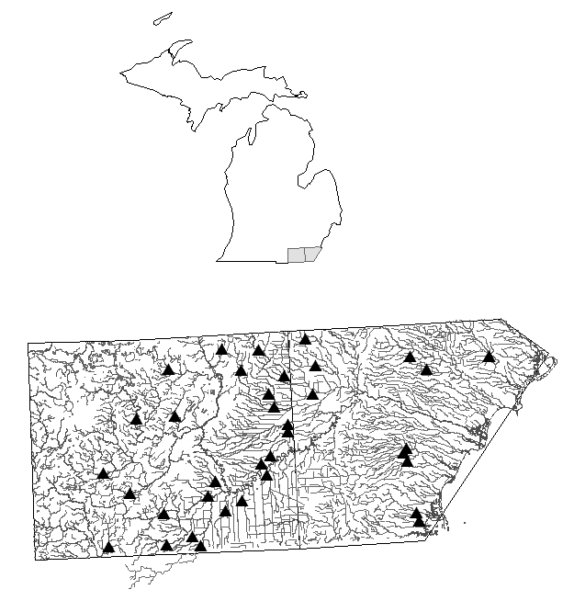

Figure 1. Location of study sites in Monroe and Lenawee Counties of Michigan, USA.

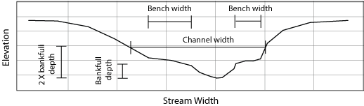

Figure 2. Representative cross-section depicting channel morphology measurements.

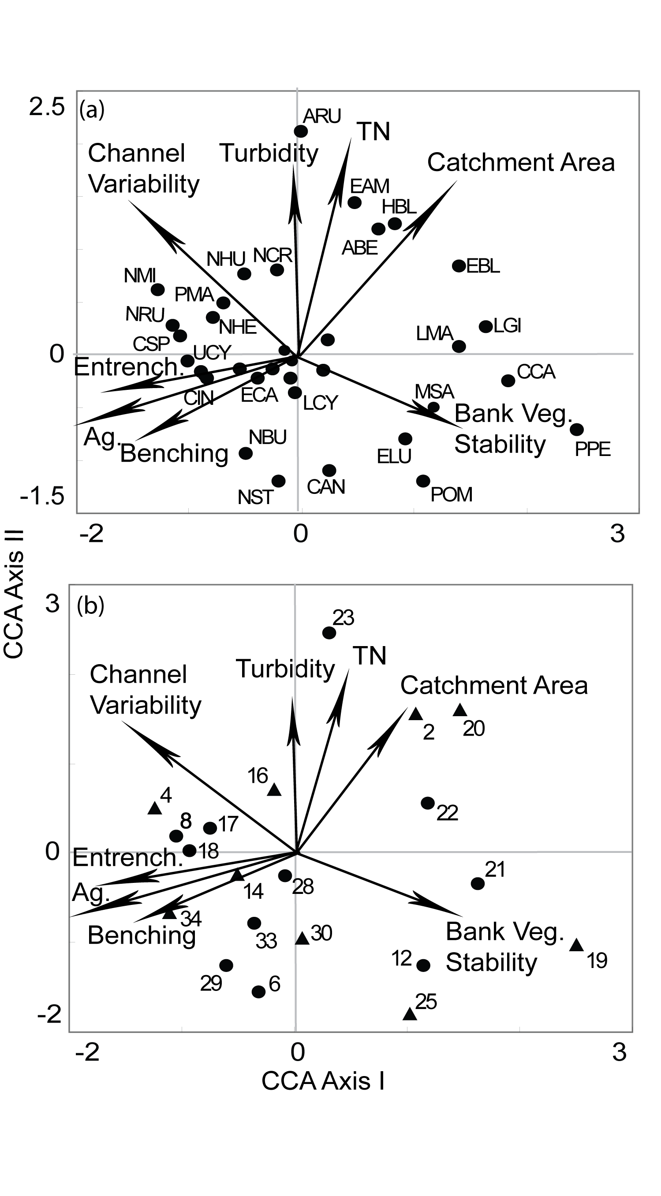

Figure 3. Biplot of the first two axes from canonical correspondence analysis (CCA) of fish presence or absence data showing associations of (a) environmental gradients (arrows) and fish species (points), and (b) environmental gradients (arrows) and drain sites (points).

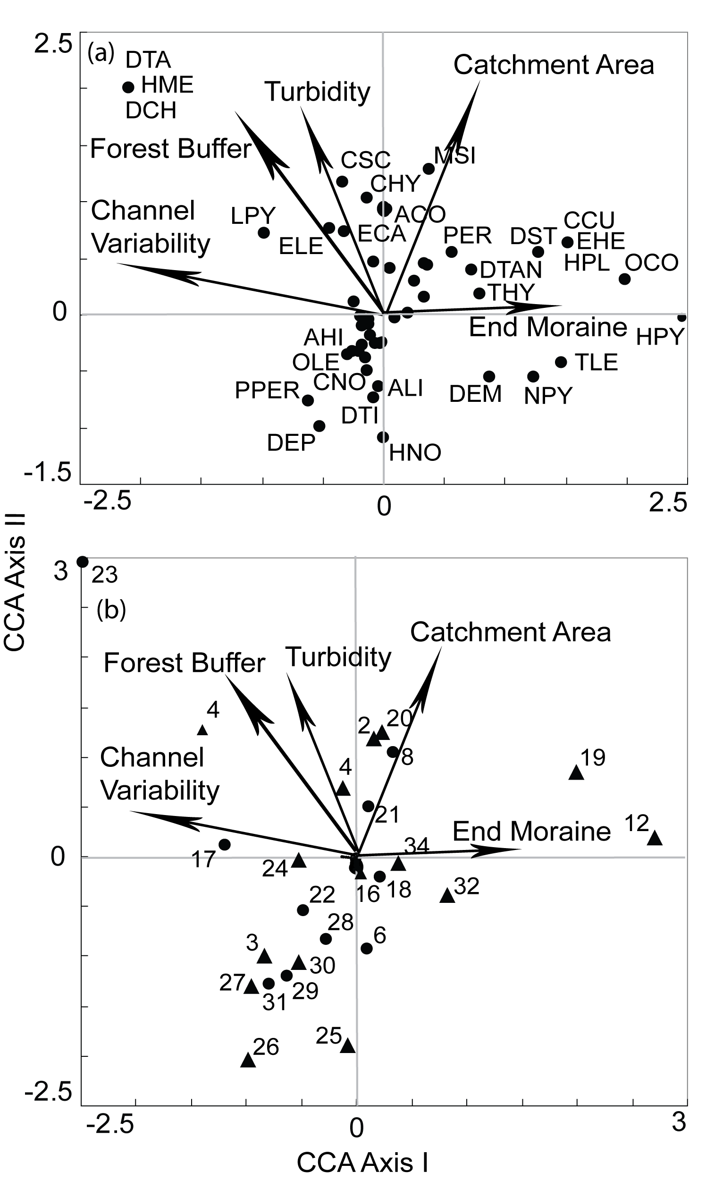

Figure 4. Biplot of the first two axes from canonical correspondence analysis (CCA) of invertebrate presence or absence data showing associations of (a) environmental gradients (arrows) and invertebrate families (points), and (b) environmental gradients (arrows) and drain sites (points).

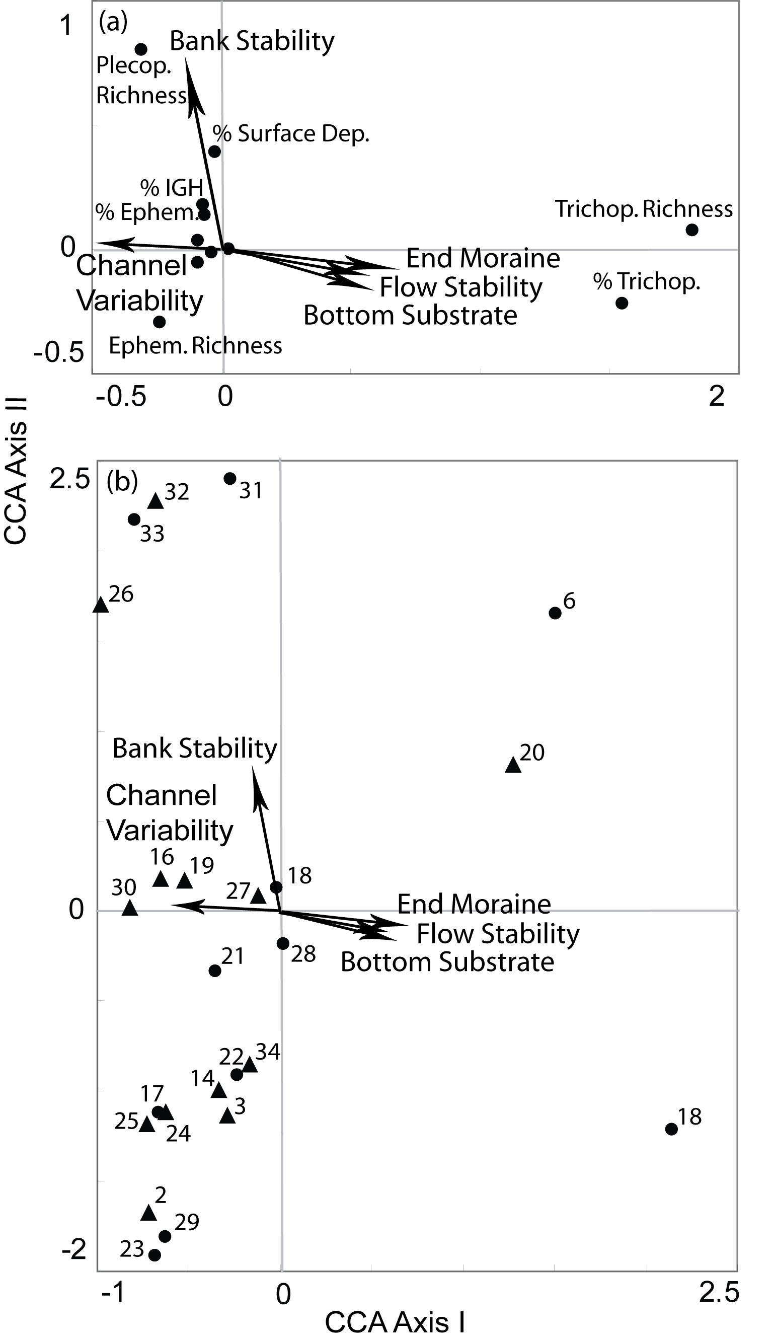

Figure 5. Biplot of the first two axes from canonical correspondence analysis (CCA) of invertebrate community characteristic data showing associations of (a) environmental gradients (arrows) and metrics (points), and (b) environmental gradients (arrows) and drain sites (points).
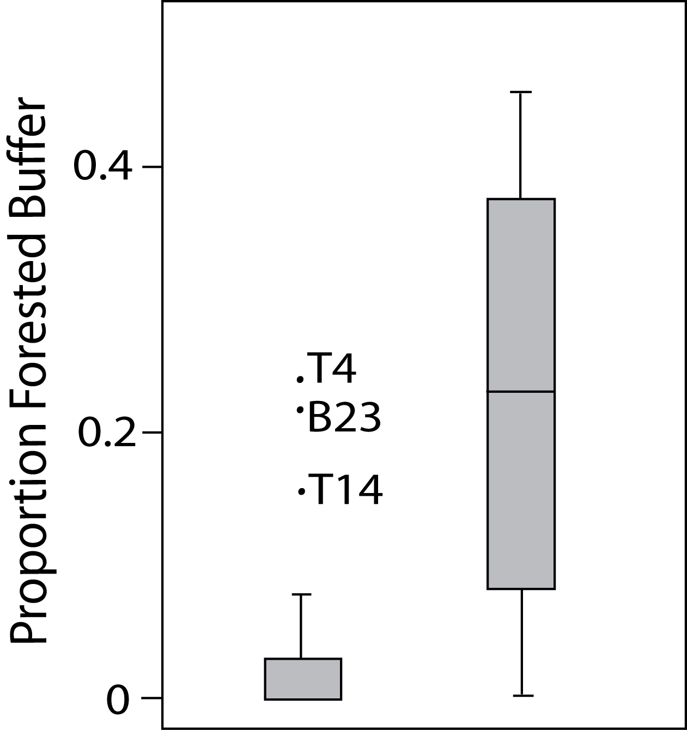
(a)

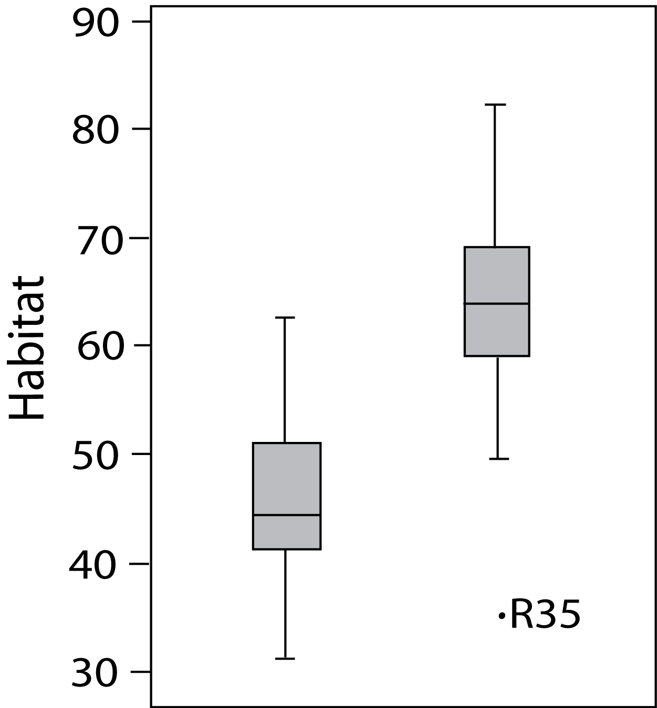
(b)

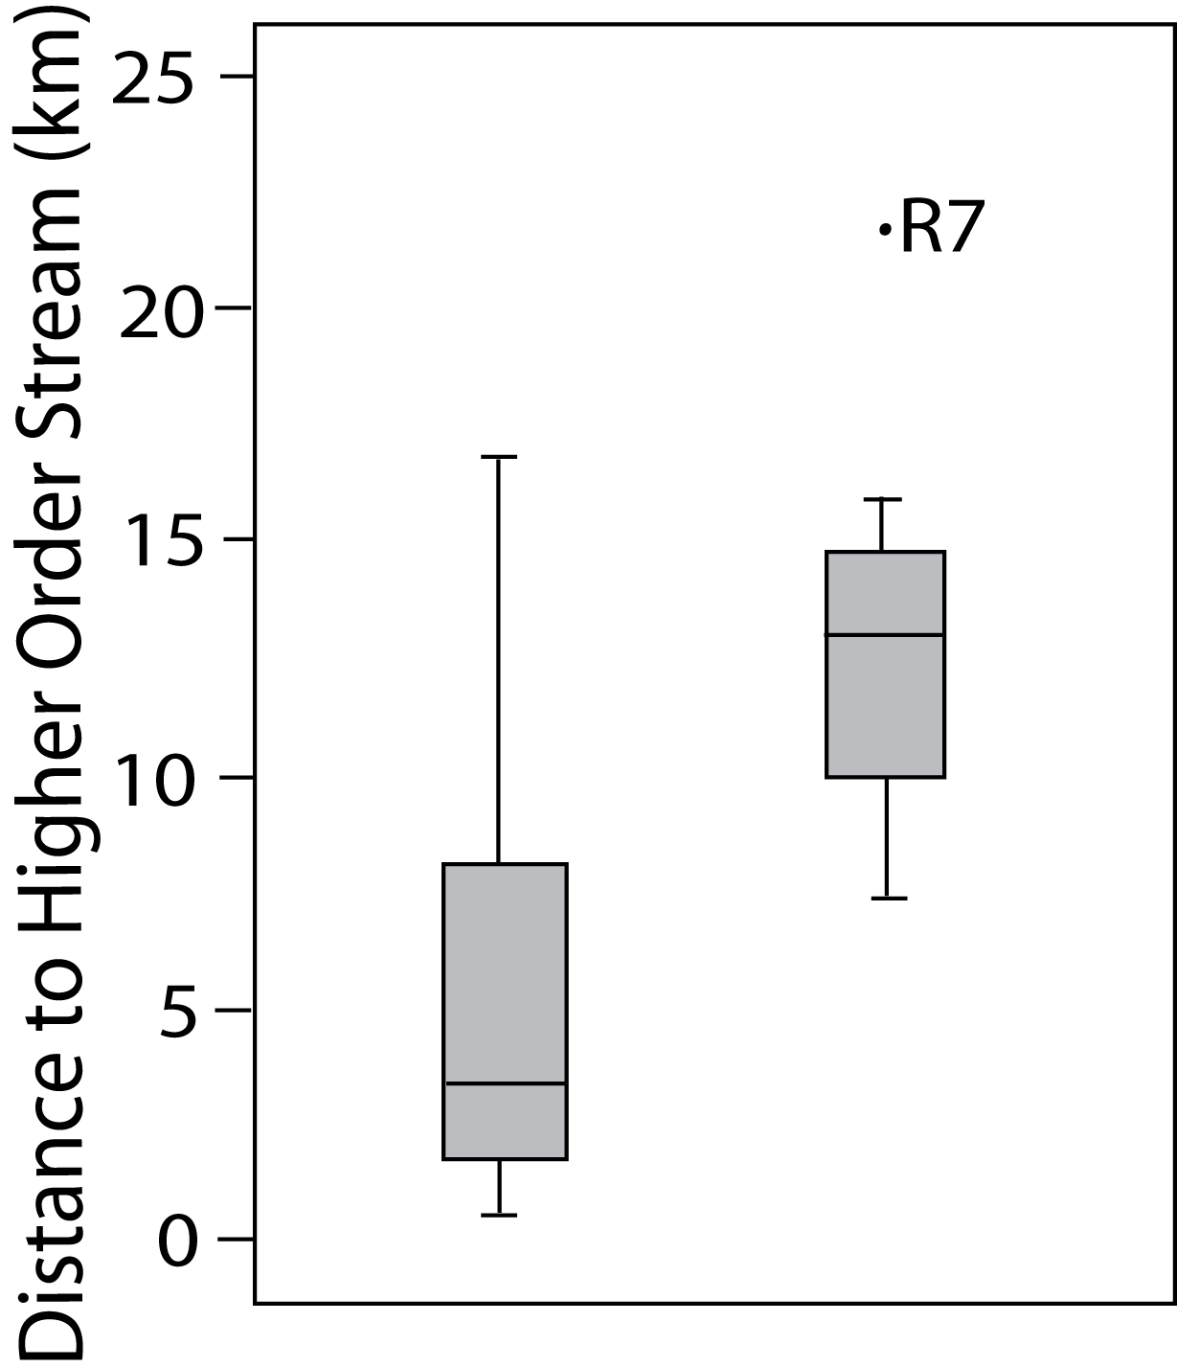
(c)

Drain
Reference

Fig. 6. Boxplots of comparing physical characteristics of drains and reference sites. Differences between groups are significant (Mann-Whitney U significance levels were (a) p=.002, (b) p<.0001, and (c) p=.003. Bonferroni corrected significance level of 0.017 was used.

Table 1. List of fish species (by family), showing the common name, code, and trait classifications of each (Sun. = sunfish, Intol. = intolerant, Omn. = omnivore, Ins. = Insectivore, Carn. = top carnivore, and S.S. = simple spawner).

Family Species |  | Common Name | Code | Native | Darter | Sucker | Sun. | Intol. | Tol. | Omn. | Ins. | Carn. | S.S.
Catostomidae
 | Pomoxis nigromaculatus | Black crappie | PNI | 1 |  |  | 1 |  |  |  |  | 1
Centrarchidae
 | Ameiurus nebulosus | Brown bullhead | ABE | 1 |  |  |  |  | 1 |  | 1
 | Culaea inconstans | Brook stickleback | CIN | 1 |  |  |  | 1 |  |  | 1
 | Lepomis macrochirus | Bluegill | LMA | 1 |  |  | 1 |  | 1 |  | 1
 | Notropis heterolepis | Blacknose shiner | NHE | 1 |  |  |  | 1
 | Percina maculata | Blackside darter | PMA | 1 | 1 |  |  |  |  |  | 1 |  | 1
 | Pimephales notatus | Bluntnose minnow | PNO | 1 |  |  |  |  | 1 | 1
 | Rhinichthys atratulus | Blacknose dace | RAT | 1 |  |  |  |  | 1 |  |  |  | 1
 |  | Unkown hybrid bluegill | HBL | 1 |  |  | 1
Cottidae
 | Umbra limi | Central mudminnow | ULI | 1 |  |  |  |  | 1 |  | 1
Cyprinidae
 | Ambloplites rupestris | Rock bass | ARU | 1 |  |  | 1 | 1 |  |  |  | 1
 | Campostoma anomalum | Central stoneroller | CAN | 1
 | Cottus cognatus | Mottled sculpin | CCOG | 1 |  |  |  | 1 |  |  | 1
 | Cyprinella spiloptera | Spotfin shiner | CSP | 1 |  |  |  |  | 1 |  | 1
 | Cyprinus carpio carpio | Common carp | CCA |  |  |  |  |  | 1 | 1
 | Esox americanus vermiculatus | Grass pickerel | EAM | 1 |  |  |  |  |  |  |  | 1
 | Esox lucius | Northern pike | ELU | 1 |  |  |  | 1
 | Etheostoma caeruleum | Rainbow darter | ECA | 1 | 1 |  |  | 1 |  |  | 1 |  | 1
 | Etheostoma nigrum | Johnny darter | ENI | 1 | 1 |  |  |  |  |  | 1
 | Etheostoma blennioides | Greenside darter | EBL | 1 | 1
 | Lepomis cyanellus | Green sunfish | LCY | 1 |  |  | 1 |  | 1 |  | 1
 | Lepomis gibbosus | Pumpkinseed | LGI | 1 |  |  | 1 |  |  |  | 1
 | Luxilus cornutus | Common shiner | LCO | 1 |  |  |  |  |  |  | 1

Table 1. Continued.

 | Micropterus salmoides | Largemouth bass | MSA | 1 |  |  |  |  |  |  |  | 1
 | Nocomis micropogon | River chub | NMI | 1
 | Notemigonus crysoleucas | Golden shiner | NCR | 1 |  |  |  |  | 1 | 1
 | Notropis rubellus | Rosyface shiner | NRU | 1 |  |  |  | 1 |  |  | 1 |  | 1
 | Notropis stramineus | Sand shiner | NST | 1 |  |  |  |  |  |  | 1
 | Percina caprodes | Logperch | PCA | 1 |  |  |  | 1
 | Pimephales promelas | Fathead minnow | PPR | 1 |  |  |  |  | 1 | 1
 | Semotilus atromaculatus | Creek chub | SAT | 1 |  |  |  |  | 1
 | Unknown Cyprinid | Unknown cyprinid | UCY | 1
Esocidae
 | Notropis hudsonius | Spottail shiner | NHU | 1 |  |  |  | 1 |  |  | 1
Percidae
 | Catostomus commersonii | White sucker | CCOM | 1 |  | 1 |  |  | 1 | 1 |  |  | 1
 | Perca flavescens | Yellow perch | PPE | 1 |  |  |  |  |  |  | 1
Percopsidae
 | Percopsis omiscomaycus | Trout perch | POM | 1

Table 2. Tolerance values of invertebrate families collected. From Hilsenhoff (1988).

Order | Family | Tolerance
Isopoda |  | 8
Amphipoda | Gammaridae | 4
Decapoda | Cambaridae | na
Decapoda | Palaemonidae | na
Ephemeroptera | Baetidae | 5
Ephemeroptera | Baetiscidae | 3
Ephemeroptera | Caenidae | 7
Ephemeroptera | Ephemerillidae | 1
Ephemeroptera | Ephemeridae | 4
Ephemeroptera | Heptageniidae | 4
Ephemeroptera | Leptophlebiidae | 4
Ephemeroptera | Siphlonuridae | 7
Odonata | Calopterygidae | 5
Odonata | Coenagrionidae | 8
Odonata | Lestidae | 9
Odonata | Aeshnidae | 3
Odonata | Cordulegastridae | 3
Odonata | Corduliidae | 5
Odonata | Libellulidae | 9
Plecoptera | Perlidae | 1
Plecoptera | Perlodidae | 2
Heteroptera | Notonectidae | na
Heteroptera | Corixidae | 10
Heteroptera | Pleidae | na
Heteroptera | Mesoveliidae | na
Heteroptera | Pyralidae | na
Megaloptera | Corydalidae | 0
Megaloptera | Sialidae | na
Neuroptera | Pyralidae | na
Trichoptera | Hydropsychidae | 3
Trichoptera | Hydroptilidae | 4
Trichoptera | Leptoceridae | 4
Trichoptera | Limnohpilidae | 4
Lepidoptera | Pyralidae | na
Lepidoptera | Noctuidae | na
Coleoptera | Dytiscidae | na
Coleoptera | Curculionidae | na

Table 2 continued.

Order | Family | Tolerance
Coleoptera | Elmidae | 4
Coleoptera | Gyrinidae | na
Coleoptera | Haliplidae | 7
Coleoptera | Hydaerinidae | na
Coleoptera | Hydrophilidae | na
Coleoptera | Lampyridae | na
Coleoptera | Noteridae | na
Coleoptera | Psephenidae | 4
Coleoptera | Sciomyzidae | na
Diptera | Chaoboridae | na
Diptera | Ceratopogonidae | 6
Diptera | Chironomidae | 6
Diptera | Empididae | 6
Diptera | Ephydridae | 6
Diptera | Sciomyzidae | na
Diptera | Simuliidae | 6
Diptera | Stratiomyidae | na
Diptera | Tabanidae | 6
Diptera | Tanyderidae | na
Diptera | Tipulidae | 3
Gastropoda |  | na
Bivalvia |  | na

Table 3. Summary of data from all 33 sites sampled in 2006 or 2007.

Variable |  | Minimum | Maximum | Mean | Unit
Fish Assemblage
 | WI Index of Biotic Integrity | 0 | 55 | 16.39 | --
 | Hilsenhoff Biotic Index | 4.55 | 8.78 | 6.18 | --
 | MI Invertebrate P51 | -7 | -1 | -4.21 | --
Landscape and Reach Scale Properties
 | Drainage Area | 0.60 | 27.82 | 22.82 | km²
 | Stream Order | 1 | 4 | 2.64 | --
 | Distance to Higher Order Stream | 0.06 | 2.2 | 0.66 | km
 | Agriculture in Catchment | 44 | 95 | 79 | %
Habitat
 | Sum Qualitative Habitat Score | 31 | 82 | 48.79 | --
 | Bottom Substrate /Available Cover | 0 | 14 | 6.27 | --
 | Embeddedness/ Siltation | 1 | 10 | 4.95 | --
 | Habitats Represented | 1 | 8 | 3.18 | --
 | Flow Stability | 2 | 11 | 6.09 | --
 | Sedimentation | 1 | 7 | 3.45 | --
 | Channel Features (Pool-Riffle-Run-Bend) | 0 | 9 | 4.18 | --
 | Bank Stability | 1 | 9 | 4.50 | --
 | Bank Vegetative Stability | 1 | 10 | 8.09 | --
 | Streamside Cover | 3 | 9 | 5.14 | --
Channel Shape
 | Benching Ratio | 0 | 0.35 | 0.12 | --
 | Entrenmchment Ratio | 1.2 | 2.45 | 1.64 | --
 | Cross-sectional Area | 0.52 | 6.15 | 2.07 | m²
Water Chemistry
 | Total Nitrogen | 0.67 | 10.33 | 3.65 | mg/L
 | Total Phosphorus | 21.16 | 1235.72 | 185.51 | ug/L
 | Dissolved Oxygen | 1.2 | 12.6 | 8.11 | mg/L
 | Temperature | 19.6 | 26.05 | 22.55 | ºC
 | pH | 7.1 | 8.3 | 7.83 | --
 | Turbidity | 1.5 | 49.8 | 16.35 | NTU
 | Electrical Conductivity | 6.33 | 391 | 303.04 | µS/cm

Table 4. Invertebrate abundances from all 23 sites sampled in 2006 and all 12 sites sampled in 2007.

Class | Order | Family | 2006 | 2007
Oligochaeta |  |  | 210 | 314
Hirudinea |  |  | 33 | 24
Crustacea
 | Isopoda |  | 3186 | 171
 | Amphipoda |  | 730 | 1091
 | Decapoda
 |  | Cambaridae | 1 | 0
 |  | Palaemonidae | 12 | 3
Insecta
 | Ephemeroptera
 |  | Baetidae | 136 | 63
 |  | Caenidae | 29 | 3
 |  | Ephemerillidae | 2 | 0
 |  | Ephemeridae | 3 | 0
 |  | Heptageniidae | 1 | 0
 |  | Leptophlebiidae | 5 | 0
 |  | Siphlonuridae | 1 | 1
 | Odonata
 |  | Calopterygidae | 23 | 4
 |  | Coenagrionidae | 105 | 10
 |  | Lestidae | 15 | 2
 |  | Aeshnidae | 9 | 10
 |  | Cordulegastridae | 0 | 1
 |  | Corduliidae | 5 | 0
 |  | Libellulidae | 11 | 5
 | Plecoptera
 |  | Perlidae | 53 | 0
 |  | Perlodidae | 1 | 28
 | Heteroptera
 |  | Notonectidae | 0 | 1
 |  | Corixidae | 137 | 14
 |  | Pleidae | 7 | 0
 |  | Mesoveliidae | 3 | 0
 |  | Pyralidae | 1 | 0
 | Megaloptera
 |  | Corydalidae | 3 | 0

Table 4 continued.

Class | Order | Family | 2006 | 2007
 |  | Hydropsychidae | 5 | 4
 |  | Hydroptilidae | 0 | 0
 |  | Leptoceridae | 2 | 1
 |  | Limnohpilidae | 0 | 12
 | Lepidoptera
 |  | Pyralidae | 4 | 2
 |  | Noctuidae | 2 | 0
 | Coleoptera
 |  | Dytiscidae | 151 | 1112
 |  | Curculionidae | 1 | 0
 |  | Elmidae | 19 | 22
 |  | Gyrinidae | 7 | 0
 |  | Haliplidae | 24 | 0
 |  | Hydaerinidae | 1 | 0
 |  | Hydrophilidae | 5 | 0
 |  | Lampyridae | 1 | 0
 |  | Noteridae | 2 | 0
 |  | Psephenidae | 2 | 0
 |  | Sciomyzidae | 10 | 0
 | Diptera
 |  | Chaoboridae | 2 | 0
 |  | Ceratopogonidae | 16 | 71
 |  | Chironomidae | 4598 | 2065
 |  | Empididae | 2 | 3
 |  | Ephydridae | 5 | 1
 |  | Sciomyzidae | 68 | 79
 |  | Simuliidae | 19 | 1
 |  | Stratiomyidae | 22 | 0
 |  | Tabanidae | 11 | 3
 |  | Tanyderidae | 1 | 0
 |  | Tipulidae | 9 | 50
Mullusca
 | Gastropoda |  | 338 | 860
 | Bivalvia |  | 304 | 350
Sum of Individuals |  |  | 10353 | 5396

References

