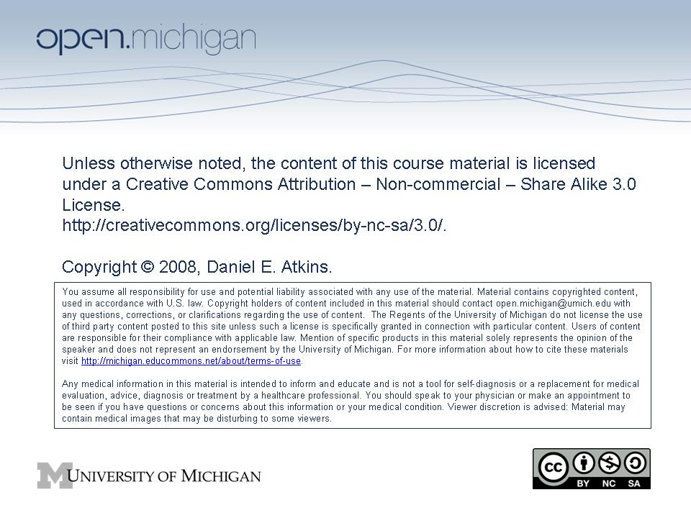

SI 575 Community Information Corps Seminar

Fall 2008

Professor Daniel E. Atkins

School of Information, University of Michigan

Schedule

Week 1: September 5, 2008
Speaker: Daniel E. Atkins
Topic: Overview of the CIC program and seminar
As time permits begin self-introductions and recording of them.

Week 2: September 12, 2008
Speaker: Greg Grossmeier and Lisa McLaughlin, second year MSI students, School of Information, University of Michigan
Topic: Student introductions and Summer 2008 Community Informatics Internships
Readings:
- Frequently Asked Questions - Creative Commons
- "Wanna Work Together?" Video
- Tim Brown. "Design Thinking." Harvard Business Review. June 2008
Self introductions and video recording of them.
Greg Grossmeier will be giving a presentation about his experience interning at Creative Commons (CC) in San Francisco last summer. Read the FAQ section and background video on CC for the Seminar Friday.
Lisa McLaughlin will also be presenting about her work with Nigel Melville, a BIT Professor at the Business School, on using Design Thinking methods in Business. I will be presenting the method we used and suggesting applications for the Nonprofit Sector. Read the following recent Harvard Business Review piece on Design Thinking methods written by IDEO CEO Tim Brown, as background material on the method.
NOTE: Atkins is participating this day in the Oxford eResearch Conference 2008. This conference brings together an interesting set of papers and people around socio-technical issues of e-science, aka cyberinfrastructure-enabled science. The following link with take you to the conference homepage. Suggest you browse the titles of the talks and panels: Oxford Internet Institute - eResearch 08 - Home.

Week 3: September 19, 2008
Speaker: Vlad Weilbut, Director of Informatics and Computing Services, University of Michigan School of Public Health
Topic: Pushing IT: $15,000 Phone Bill and Other Adventures With Technology in a Global(izing) Context
Readings: Marsha Maidoo. "ICAM Learning Centre 1st Quarterly Report." International Co-ordination and Management (ICAM). 2008. (on CTools)
Vlad will talk about the various projects he has been involved with: Reprolatina, Global Product Development, GIS Seminar, IARC, Regional Learning Centres, etc., with a focus of what worked well and what didn’t (and why) in terms of technology.

Week 4: September 26, 2008
Reading: Google challenge: Got an idea to help the world? Here is $10 million.
Moderated by Dan Atkins, we will explore the definition of community informatics through the class literature search. Goal is to prepare an initial taxonomy of a field and build a reference database that will inform refinement and details of curriculum options at SI. We will also brainstorm some about a response to the Google challenge.

Week 5: October 3, 2008
Speaker: Kevin B. Thompson, Senior Program Manager, Corporate Citizenship and Corporate Affairs, IBM Corporation
Topic: Corporate Citizenship
Readings: Michael E. Porter and Mark R. Kramer. "Strategy and Society: The Link Between Competitive Advantage and Corporate Social Responsibility." Harvard Business Review. December 2006.

Week 6: October 10, 2008
Speaker: Dr. Thomas Zurbuchen, Director of the Center for Entrepreneurship at the University of Michigan College of Engineering
Topic: Social Entrepreneurship
Reading:
- Watch the talk by Larry Brilliant at http://www.youtube.com/watch?v=MNhiHf84P9c
- John Thompson, Geoff Alvy and Ann Lees. "Social entrepreneurship - a new look at the people and the potential." Management Decision Vol 39, Issue 5. 2000.
We will be joined by Professor Thomas Zurbuchen, Director of the Center for Entrepreneurship at the UM College of Engineering. He will give an overview of the Center and its programs and entrepreneurship in general to help inform a discussion about social entrepreneurship and how it might more persistently link with CIC.

Week 7: October 17, 2008
Speaker: Dr. Allen Hammond, Senior Entrepreneur in Residence, Ashoka International
Topic: Rural Connectivity and the Transformation of Poverty
Readings: Allen Hammond, William J Kramer, Julia Tran, Rob Katz, Courtland Walker "The Next 4 Billion: Market Size and Business Strategy at the Base of the Pyramid." World Resources Institute. March 2007.
- Read Executive Summary and All of Chapter 1, plus all of any other chapter in a sector of interest to you.
New technologies and innovative approaches promise to make rural broadband nearly ubiquitous and affordable in developing countries within the next decade. That in turn will make access to financial services, such as mobile banking, widespread--connecting billions of people to the global economy--and enabling "last-mile" access to a disruptive set of new world-class diagnostic technologies that can deliver quality healthcare.

Week 8: October 24, 2008
Speaker: Cathy Casserly, Director of Open Education Resources Programs, The William and Flora Hewlett Foundation
Topic: The OER Movement: Status and More Opportunities
Readings: Toru Iiyoshi and M. S. Vijay Kumar, ed. Opening Up Education The Collective Advancement of Education through Open Technology, Open Content, and Open Knowledge. September 2008.
- Read Chapter 17 "Revolutionizing Education through Innovation: Can Openness Transform Teaching and Learning?" starting on page 261 and the concluding chapter on page 429.

Week 9: October 31, 2008
Speaker: Dr. Steve Jackson, Assistant Professor, School of Information, University of Michigan
Topic: IT and International Development
Readings: There are two papers you should read BEFORE this session. They are posted on our CTools site.
- Kerry S. McNamara. "Information and Communication Technologies, Poverty and Development: Learning from Experience". World Bank. March 2003.
  - This report is a quite thoughtful piece by someone with long involvement in the World Bank's information programs - it's a nice honest assessment, and also a useful summary of work in the field circa 2004.
- Percy Barnevik and Maria Borelius. "Growing Out of Poverty." Innovations: Technology, Governance, Globalization. Summer 2008, Vol. 3, No. 3, Pages 3-20.
  - The second reading is just out and more general, and is a better review not so much of IT & development, but new directions in development thinking, esp. social entrepreneurship-type stuff. It de-centers IT, i.e., reminds people that IT is a relatively small piece within a much wider development story. It's also easily readable and touches on some empirical projects. Although SOME of the claims of the social entrepreneurship / base of the pyramid crowd are vastly oversold, this particular piece is a bit more moderate in the way it balances large-scale government / aid endeavors with the importance of market forces. This would be good for us to talk through with the seminar as a whole.

Week 10: November 7, 2008
Speaker: Dr. Joseph Hardin, Ted Hanss, Garin Fons, Pieter Kleymeer from Open.Michigan
Topic: Panel on status and impact of Open Educational Resources movement at the University of Michigan
Readings:
- Open.Michigan Initiative (please explore!)
  - What are the most interesting aspects of the open initiatives at the University of Michigan?
  - What does the Open.Michigan site project as its message? What should this site project as its message (i.e, what would be its most effective message)? Who is it targeted at? Who should it be targeted at?
  - What are the most engaging aspects of the site? What are other engaging aspects you can imagine?
- OCWC - OER in Health
- Ted Hanss. Article on Health OER (on CTools)
- 2009 Health OER Design Phase Proposal to Hewlett Foundation Education Program – Open Educational Resources Priority (on CTools)
  - How can we best to maximize access by the largest number of healthcare workers at the lowest cost? This includes media (CD, paper), format (language translation, packaging for different levels of knowledge), and means (internet, XO, mobile phone)?
  - How can we grow the materials by getting contributions from practitioners who aren't at academic institutions?
  - How can we assess whether we're making a (positive) difference?
- dScribe Process
- Open.Michigan Wiki and associated resources
  - What messages and incentives might effectively garner strong student participation - both undergraduate and graduate? Strong faculty participation?
  - Would you be willing to participate as a dScribe?
  - What sort of educational resources might you find useful as a student, as an alumni, as a professional?
  - How do you think we could effectively scale the dScribe project across the university to a variety of departments?
The panelists will run their presentation in a way that presents them as a client and asks you to participate in your future roles as social entrepreneurs, community managers, educators, consultants, software developers. As such, they will present on Open efforts at U-M, discuss their interest in Health OER, and lay out some of the more specific aspects of clearing and publishing U-M OER materials using the dScribe process. They will then ask for feedback on your thoughts around scaling, sustainability, promotion, buy-in, participation, project directions, etc.

Week 11: November 14, 2008
Speakers: Dr. Paul Resnick, Professor, Michael Hess, Research Computer Specialist / Adjunct Lecturer at the School of Information, University of Michigan
Topic: Experience with analytic work with the Obama campaign
Readings:
- MyBarackObama
- David Talbot. "How Obama Really Did It: The social-networking strategy that took an obscure senator to the doors of the White House." MIT Technology Review. September/October 2008.
- Smearbusters website (no longer active as of January 2009)

Week 12: November 21, 2008
Speakers: Gail McClure, VP for International Programs, and Ted Chen, Program Officer, W. K. Kellogg Foundation
Topic: The W. K. Kellogg Foundation's International Activities
Readings: van Rensburg, JFJ, Veldsman, A and Lahde, K. 2008. "Social entrepreneurship: A foundation for 'creative capitalism' in rural African communities." Science real and relevant: 2nd CSIR Biennial Conference, CSIR International Convention Centre Pretoria, 17-18 November 2008, pp 9.

Week 13: December 5, 2008
Presentation of your retrospective.

