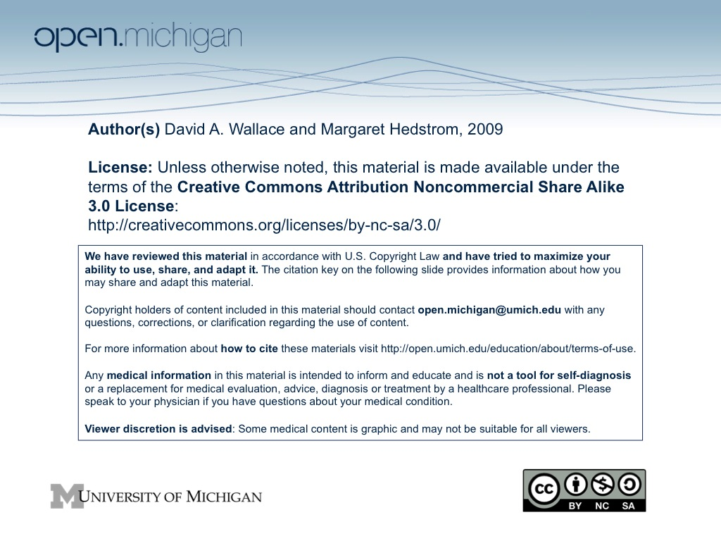
School of Information
University Michigan
SI 655
Management of Electronic Records

Winter 2009
Credits: 3 (1 PEP point for pre-Fall 2007 SI admits)
Prerequisite: Old SI 540 or new SI 502 or Permission of Instructor
Instructor: David A. Wallace

Overview
Records are the corporate and cultural memory that provide proof of actions and decisions, build a knowledge-base for reflection and learning, and form a perspective on today's society that we will pass on to future generations. As organizations create and maintain more of their records electronically, they are struggling to develop effective policies, systems, and practices to capture, maintain, and preserve electronic records.
This course examines the ways in which new information technologies challenge organizations' capacities to define, identify, control, manage, and preserve electronic records. Students learn how different organizational, technological, regulatory, and cultural factors affect the strategies, practices, and tools that organizations can employ to manage electronic records. Problems of long-term preservation and continuing access to electronic records are analyzed and addressed.
An accumulating series of organizational and institutional breakdowns across sectors implicate electronic records and provides the opportunity for a concentrated focus on Records and Accountability. Failures of accountability in private corporations (ENRON, etc.); governments (Iraq reconstruction, etc.); and international organizations (the UN Oil for Food Program, etc.) are ushering in important reforms that require a heightened awareness of the infrastructure for accountability and the significant role of authentic, reliable, and accessible records for these reforms to work effectively. The course will pay particular attention to the social, legal, and policy requirements for records and recordkeeping to support accountability. It will provide students with knowledge and skills to investigate recordkeeping requirements, to identify options for implementing such requirements, and to lead efforts to introduce accountability frameworks in a wide variety of organizations.

CTools: The official version of the Syllabus will be on CTools: https://ctools.umich.edu/. All course readings are available on CTools.

Course Objectives

This course introduces students to the conceptual, legal, social, and cultural issues and practical problems of managing electronic records and record-keeping systems. It builds upon basic methods of records management and information resource management. It acquaints students with techniques for ensuring that electronic records are captured, preserved and usable over time.

The course will provide students with:

Familiarity with the role of electronic records in accountability and sensitivity to what can go wrong if recordkeeping systems are inadequate or fail.

Knowledge of the legal, administrative, and financial issues related to electronic records and recordkeeping.

Awareness of standards and best practices for creation, retention, authenticity, security, and accessibility of electronic records.

Familiarity with systems, technologies, and tools that support electronic records management, and knowledge of criteria to evaluate their effectiveness.

An understanding of the institutional variables (e.g., corporate culture, business activities, and information technology environments) that affect the implementation of recordkeeping and accountability requirements.

Skills in evaluating information systems for compliance with recordkeeping and accountability requirements.

- Most classes will consist of a lecture followed by a class discussion. Students are expected to read the required readings for each class, be prepared to discuss the issues they address, and raise questions pertaining to their content. Note: Active (and informed) participation in class discussions constitutes 20% of your grade. You are encouraged to question the assumptions of the readings, your instructor, and your fellow students. Ideas are presented in order for you to analyze and critique them.

Assignments

Active Participation in Class Sessions. Students are expected to complete all readings, provide insights, raise questions and issues for clarification, and participate actively in the class sessions (20%).

Short Essay: Philip Bantin in “Electronic Records Management: A Review of the Work of a Decade and a Reflection of Future Directions” (assigned Week 1 January 12) outlines many of the important debates among archivists and records managers about electronic records during the 1990s. After reading this article thoroughly, select one issue and write a short 5-page essay that summarizes the debates (in your own words) and presents your own position on the issue. Note: For each issue, Bantin cites many other articles and reports. Please locate and read at least three of the sources that he cites (and that are not assigned readings for this course) to build your own position on the issue. Some of these sources are available online, but you will have to use the library to find many of them. Due: Week 3 (February 2) (15%).

Midterm Exam: (Take Home). Around the midpoint of the course we will have covered the generic issues and general best practices for electronic records management. The take home mid-term will evaluate your understanding of these issues and practices. The take home exam will be composed of two essays totaling approx. 8-10 pages. Distributed Week 6 (March 2). Due Week 7 (March 9) (20%).

Problem Solving Exercise: You will receive examples of the three types of problems confronting decision makers in regards to electronic records management. You will develop and submit a 5-7 page proposed solution to a problem of your choice. Assigned Week 8 (March 16). Due Week 11 (April 6) (15%).

Course Project: We are blessed with countless scandals, legal cases, and allegations that revolve around improper management of records and information. Select a case from the list below (or identify your own issue – with instructor approval).
Conduct your own investigation into
1) the relevant environment for accountability and
2) the laws, rules, regulations, and/or policies that were broken or are alleged to have been broken.
Then summarize the consequences of inadequate recordkeeping for
1) the principals directly involved in the case,
2) victims of the failure of recordkeeping systems, and
3) the public at large.
Finally, identify recordkeeping policies, technologies, tools, and best practices that, if implemented, would have prevented or minimized the damage. Approximately 15 pages. Due Week 13 (April 20) (30%, 1 PEP point for pre-Fall 2007 SI admits).

List of Candidate Cases:
Enron accounting scandal
Worldcom accounting scandal
HealthSouth accounting scandal
Valerie Plame identity leak
UN Oil-for-Food Program
Red Cross governance, accounting, and compensation policies
FEMA accounting for hurricane relief
Afghanistan/Iraq Contracts
Tom Delay Indictment
Vioxx and other pharmaceutical lawsuits
Election/Voter Fraud [pick (almost) any country and (almost) any
election]
Choicepoint (inappropriate release of personal information).
Jack Abramoff scandal
FBI’s Virtual Case File
Missing White House email

General Resources

The Resources section of the CTools Site has a folder called “Useful Websites and Resources.” Use this to find additional information and reference materials. Feel free to suggest additional resources.

Assignments and Expectations – Key Dates

Active Participation in Class Sessions |  | 20%
Short Essay | Due: Week 3 (February 2) | 15%
Midtern Exam (Take Home) | Distributed Week 6 (March 2) Due Week 7 (March 9) | 20%
Problem Solving Exercise | Assigned Week 8 (March 16) Due Week 11 (April 6) | 15%
Course Project | Due Week 13 (April 20)  1 PEP pt. - pre-Fall 07 admits) | 30%,

Course Outline

Week 1 (January 12) Introduction, Course Logistics, Key Concepts
What is an electronic record? The difference between recordkeeping systems and information systems. Why do electronic records present special challenges? Issues, problems and principles of electronic records management.

READ

Bantin, Philip. “Electronic Records Management: A Review of the Work of a Decade and a Reflection of Future Directions,” In Encyclopedia of Library and Information Science (New York: Marcel Dekker, 2002): pp. 47-81.
www.indiana.edu/~libarch/ER/encycloarticle9.doc

January 19 – NO CLASS – Martin Luther King, Jr. Day Observation

Week 2 (January 26) Recordkeeping Requirements in Law, Policy, and Practice
This session will examine the labyrinth of laws, policies, and practices that provide the warrant and justification for creation, retention, and use of electronic records.

READ

Duff, Wendy, “Harnessing the Power of Warrant," American Archivist 61 (No. 1, 1998): 88-105.

Lemieux, Victoria L. “Two Approaches to Managing Information Risks” Information Management Journal 38 (September/October 2004): 56-63.

The Sedona Conference, THE SEDONA GUIDELINES: Best Practice Guidelines & Commentary for Managing Information & Records in the Electronic Age (September 2005.) (Pages i-12).

Friedman, Lee S. and Linda Forst, “The Impact of OSHA Recordkeeping Regulation Changes on Occupational Injury and Illness Trends in the US: A Time-Series Analysis,” Occupational and Environmental Medicine 64 (2007): 454-460.

Week 3 (February 2) Trust in Records and Recordkeeping Systems
Digital records are easy to alter, but people using records need to trust that the records are reliable and authentic evidence of transactions and communications. In this session we will discuss the concepts authenticity, reliability, and trust, and examine various methods to support trusted repositories.

Short Essay Assignment Due

READ

MacNeil, Heather. “Providing Grounds for Trust: Developing Conceptual Requirements for the Long-Term Preservation of Authentic Electronic Records” Archivaria 50 (Fall 2000): 52-78.

Cliff Lynch, “Authenticity and Integrity in the Digital Environment: An Exploratory Analysis of the Central Role of Trust.” In Authenticity in a Digital Age (Washington: CLIR, 2000): 32-50 http://www.clir.org/pubs/reports/pub92/lynch.html

Dennis D. Steinauer, Shukri A. Wakid, Stanley Rasberry, "Trust and Traceability in Electronic Commerce," StandardsView 5 (No. 3, September 1997): 118-25.

Trusted Digital Repositories: Attributes and Responsibilities An RLG-OCLC Report (2002) http://www.rlg.org/longterm/repositories.pdf Browse

Moore, Reagan W. and MacKenzie Smith, “Automated Validation of Trusted Digital Repository Assessment Criteria,” Journal of Digital Information 8 (No. 2, 2007). http://journals.tdl.org/jodi/article/view/198/181

Week 4 (February 9) Evidence, Discovery, and Admissibility
Legal and auditing procedures set rules for what constitutes evidence, which practices are permissible for discovering evidence during an investigation. Forensic evaluation of evidence also determines its reliability and how much weight the evidence may hold in an investigation, hearing, or legal case. This session will explore the general rules and practices for defining admissible evidence in a variety of investigation procedures.

READ

The Sedona Conference, The Sedona Principles: Second Edition - Best Practices Recommendations & Principles for Addressing Electronic Document Production (June 2007): i-10. (Review Principles and Commentaries).

The Sedona Conference, Commentary on ESI Evidence &
Admissibility (March 2008).

Adam Wolfson, "Electronic Fingerprints: Doing Away with the Conception of Computer-Generated Records as Hearsay,” Michigan Law Review 104 (No. 1, Oct 2005): 151-73.

Lynn III, Cecil and Alexandra Hicks, “E-Discovery Rulings: 2008 in Review, Law Technology News (January 9, 2009). http://www.law.com/jsp/legaltechnology/pubArticleLT.jsp?id=1202427312737

Week 5 (February 16) Promoting Accountability: Standards and Best Practices
Standards and Best Practices offer critical guidance for electronic records management and they offer a framework for program development and compliance auditing.

READ

Pember. Margaret, “Sorting Out the Standards: What Every Records and Information Professional Should Know,” Records Management Journal 16 (No. 1, 2006): 21-33.

Lavoie, Brian F., The Open Archival Information Systems Reference Model: Introductory Guide (Dublin, Ohio: OCLC, January 2004).

The Sedona Conference, THE SEDONA GUIDELINES: Best Practice Guidelines & Commentary for Managing Information & Records in the Electronic Age (September 2005.): 13-50.

McLeod, Julie and Sue Childs, “Consulting Records Management Oracles—a Delphi in Practice,” Archival Science 7 (No. 2, 2007):147–166.

February 23 – NO CLASS – Winter Break

Week 6 (March 2) Promoting Accountability: Tools and Technology
This session will examine some of the tools and technologies available to support accountability and electronic records management. We will also discuss the limitations of available tools.

Midterm Exam Distributed

READ

Margaret L. Hedstrom, “Building Recordkeeping Systems: Archivists Are Not Alone on the Wild Frontier, “ Archivaria 44 (Fall 1997): 44-71.

Ugonwa Ekweozor; Babis Theodoulidis, "Review of Retention Management Software Systems," Records Management Journal 14 (No. 2, 2004): 65-77.

Sprehe, J. Timothy, A Framework for EDMS/ERMS Integration," Information Management Journal 38 (No. 6, Nov/Dec 2004): 54-61.

Chet Hosmer, “Proving the Integrity of Digital Evidence with Time,” International Journal of Digital Evidence 1 (No.1, Spring 2002): 1-7.

U.S. National Archives and Records Administration, Recommended Practice: Analysis of Lessons Learned for Enterprise-wide ERM Projects (June 2006). http://www.archives.gov/records-mgmt/policy/lessons-learned.html

Week 7 (March 9) Promoting Accountability: Compliance and Audit
Standards, policies, and guidelines are of little value if there is no way to monitor compliance. This session will cover some of the methodologies for monitoring compliance with electronic recordkeeping requirements.

Midterm exam due

READ

Williams, Robert F. and Lori J. Ashley, 2005 Electronic Records Management Survey: Call for Collaboration (Chicago: Cohasset Assoc., 2007).

Gable, Julie, “Navigating the Compliance Landscape,” Information Management Journal 39 (No. 4, July/August 2005): 28+.

Gable, Julie, “Compliance: Where Do We Go From Here?,” Information Management Journal (May/Jun 2006): 29+.

Randolph A Kahn. "Records Management & Compliance: Making the Connection," Information Management Journal 38 (No. 3, May/June 2004): 28+.

Week 8 (March 16) Promoting Accountability: Social Demand / Incentives for Records-based Accountability
Numerous forces are creating a social demand for increased accountability and new accountability mechanisms. Three important factors are 1) reestablishing the legitimacy of institutions following a series of scandals and malfeasance, 2) globalization and the ineffectiveness of national regulatory mechanisms; 3) pressure from consumers and some investors for socially responsible policies and practices. This session will examine the implications of demand-driven accountability for creation and management of electronic records.

Problem Solving Assignment Distributed

READ

Archon Fung, Mary Graham and David Weil, Full Disclosure: The Perils and Promise of Transparency (Cambridge University Press, 2007), pp. xi-18.

Witte, Jan Martin, Multisectoral Networks in Global Governance: Towards a Pluralistic System of Accountability (Government and Opposition Ltd 2004, Malden, Mass.: Blackwell Publishing, 2004).

Allen L. White, New Wine, New Bottles: The Rise of Non-Financial Reporting, (Business for Social Responsibility, June 20, 2005).

Simon Zadek, Reinventing Accountability for the 21st Century, (openDemocracy.net, September 12, 2005). www.opendemocracy.net/globalization-accountability/peer_to_peer_2823.jsp

Global Reporting Initiative, Sustainability Reporting Guidelines, G3 Version for public comment, 2 January 2006 - 31 March 2006, (Global Reporting Initiative, 2006).

Week 9 (March 23) Sorting Out Contradictions: Freedom of Information, Privacy, Secrecy, and Accountability
Access to records is an essential tool for holding organizations and individuals accountable. But free access to information is complicated by legal requirements and ethical concerns over personal privacy, national security, trade secrets, and other restrictions on access. In this session we will discuss the labyrinth of regulations that govern rights to access information, require disclosure, and likewise restrict access to records.

READ

Vaughn, Robert G., “Transparency -- The Mechanisms: Open Government and Accountability,” Issues of Democracy 5 (U.S. Department of State, International Information Programs, no. 2, August 2000).
http://web.archive.org/web/20080205000249/http://usinfo.state.gov/journals/itdhr/0800/ijde/vaughn.htm

Leahy, Patrick, "Recent Developments in the Electronic Freedom of Information Act," 50 Administrative Law Review 339 (1998): 339-344.

Aftergood, Steven, “The Age of Missing Information: The Bush
Administration's Campaign Against Openness,” Slate Magazine
(Posted Thursday, March 17, 2005, at 7:23 AM ET). http://www.slate.com/id/2114963/

Jaeger, Paul T., John Carlo Bertot, and Charles R. McClure, “The Impact of the USA Patriot Act on Collection and Analysis of Personal Information under the Foreign Intelligence Surveillance Act,” Government Information Quarterly 20 (2003): 295–314.

Albert Jacob Meijer, “Trust This Document: ICTs, Authentic Records, and Accountability,” Archival Science 3 (2003): 275-290.

Week 10 (March 30) Records and Accountability Environments: Government Accountability / International Organizations and Human Rights
This session will focus on the mechanisms that are intended hold governments accountability to their citizens. It will also explore breeches in this process. Records play an increasingly important role in monitoring human rights violations and in supporting truth and reconciliation processes. This session will also cover the policies and practices for electronic recordkeeping in international organizations and in support of human rights.

READ

O’Shea, Greg, The Transition to Electronic Government: The Challenge for Records Management (IRMT Case Studies).

The Victorian Electronic Records Strategy (VERS), Management of Electronic Records PROS 99/007, Version 2 (July 2003).
http://www.prov.vic.gov.au/vers/standard/

Citizens for Responsibility and Ethics in Washington, Record Chaos: The Deplorable State of Electronic Record Keeping in the Federal Government (April 16, 2008) http://www.citizensforethics.org/files/FINAL%20REPORT.pdf

Trudy Huskamp Peterson. Final Acts: A Guide to Preserving Records of Truth and Reconciliation Commissions (Washington, D.C. Woodrow Wilson Center Press, 2005). Read pages 1-73. Skim remainder.

Week 11 (April 6) Records and Accountability Environments: Corporate Accountability
After countless corporate scandals, regulatory agencies and governments have implemented more rigorous accounting standards with records management implications. This session will examine records and accountability in the corporate sector.

Problem Solving Assignment Due

READ

Lemieux, Victoria, “Let the Ghosts Speak: An Empirical Exploration of the Nature of the Record,” Archivaria 51 (2001): 81-111.

Patzakis, John, "New Accounting Reform Laws Push For Technology-Based Document Retention Practices," International Journal of Digital Evidence 2 (No. 1, Spring 2003).

Lansing, Paul, and Christopher Grgurich, "The Sarbanes-Oxley Act: New Securities Disclosure Requirements in the United States," International Journal of Management 21 (No. 3, September 2004): 292-99.

Montaña, John C., J. Edwin Dietel, and Cristine S. Martins, “Strategies for RIM Program Compliance with Sarbanes-Oxley,” Information Management Journal (November/December 2006): 54+

Week 12 (April 13) Records and Accountability Environments: Health Care
Electronic medical records hold out the promise of reducing health care costs, improving medical decision making, and enhancing patient’s access to their own medical information. However, the promise of electronic recordkeeping in health care has been hard to realize. This session will examine some of the particular requirements that make electronic medical records difficult to implement.

READ

Heath, Christian, and Paul Luff. “Documents and Professional Practice: ‘Bad’ Organisational Reasons for ‘Good’ Clinical Records,” In Mark S. Ackerman (ed.) Proceedings of the ACM 1996 Conference on Computer Supported Cooperative Work November 16-20, 1996 Boston, Massachusetts, (New York: ACM Press, 1996), 354-363.

Baumer, David, Julia Brande Earp, and Fay Cobb Payton, “Privacy of Medical Records: IT Implications of HIPAA,” Computers and Society (December 2000): 40-47.

Choi, Young B., Kathleen E. Capitan, Joshua S. Krause and Meredith M. Streeper, “Challenges Associated with Privacy in Health Care Industry: Implementation of HIPAA and the Security Rules,” Journal of Medical Systems 30 (No. 1, February 2006): 57-64.

Week 13 (April 20): Wrap Up: Towards Transparency, Accountability, and Governance

Summary of themes and ideas in the course.
Course Project Paper Due

