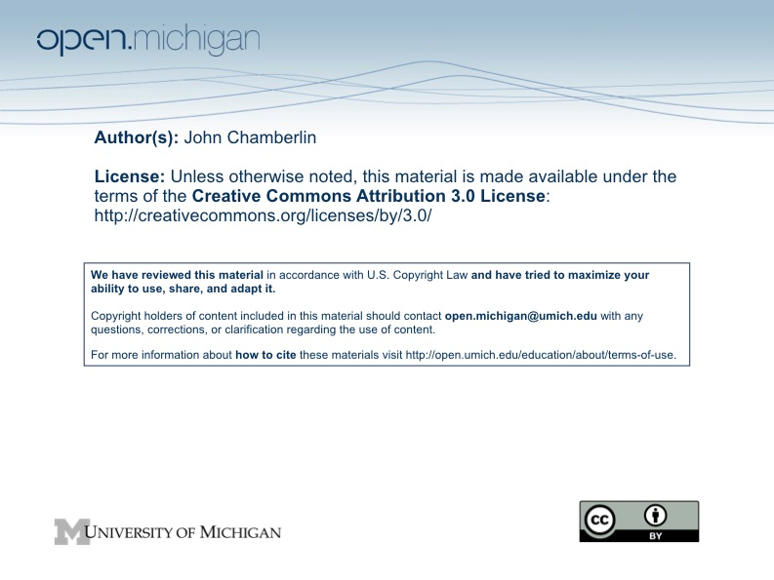

Values, Ethics and Public Policy Fall 2009

Policy Memo #2

Your final writing assignment is a policy memo on one of the following topics. If you have previously written about one of them (or something close to one of them), pick a different topic this time.

- Mandatory Medicine. An entry earlier this year on the American Prospect Blog http://www.prospect.org/csnc/blogs/tapped_archive?month=03&year=2009&base_name=mandatory_medicine) comments on a variety of policy proposals involving mandatory procedures, including HPV vaccinations for immigrants and HIV testing for pregnant women. Suppose you work for a member of a state legislature who serves on the health committee. He asks you to provide an analysis of the ethical issues in such proposals. Select one of the proposals mentioned in the blog entry and focus your analysis on it. What stand would you recommend to your boss, and why?

- Global Climate Change. Suppose you work for a member of Congress who comes to you and says she wants to develop her public stance on climate change as the US prepares for the next round of international negations. A colleague has suggested she might consider adopting the views of Peter Singer in his column “A Fair Deal on Climate Change.” She asks you for your evaluations of his arguments and your conclusion about them.

- Health Care and Justice. Some years ago Oregon found itself with funding that would allow it to increase by 7000 the number of uninsured individuals who were covered by the state’s Medicaid program. According to the New York Times (http://www.nytimes.com/2008/03/13/us/13bend.html) there were 600,000 Oregonians without health insurance. The state decided to hold a lottery to decide which 7000 people would receive coverage. 91,000 people entered the lottery. Suppose you are an aide to a governor of a state that cut back its Medicaid funding when the recession hit and who has just found out that some economic stimulus funding could be used to provide health insurance coverage for several thousand additional people in the state. The fairness of a plan to use these funds is uppermost in her mind and she asks what you think she should do. In particular, she wants your views on Oregon’s plan, which she heard a lot about at a recent governors’conference, and whether you think there is a fairer way to proceed (and, if so, what it is and why it’s fairer).

- Sex Offender Registries. Suppose you are an aide to a legislator who is chair of the committee that oversees the sex offender registry in her state. Pick a particular state and write a memo to the legislator that addresses the appropriate goals of a sex offender registry and the extent to which the state’s registry promotes them in an ethical manner.

- Carrots and Sticks in Social Programs. The readings for the program evaluation class discussed two such programs—Opportunity NYC and immunization study in Georgia. Both of these programs are social experiments, with careful program evaluations built into them. The article on the Georgia promotes notes that “Because the imposition of a monetary sanction was a state-level welfare innovation, the US Department of Health and Human Services waived the need for IRB review or informed consent.”

Suppose you are a Congressional staffer who has been asked by your boss to give him your analysis of the ethical issues surrounding such waivers. What are the appropriate ethical standards for enrolling subjects in social experiments like these? Are they different for programs involving carrots and sticks? You can focus on these two programs or on another program that raises similar issues.

The Details

- The deadline is 11:59 PM on Tuesday, December 15.
- Submit the memo via email, putting your name somewhere in the name of the file so we can identify it with you.
- The memo should be 600-650 words long (not including the memo layout (Date, To, From, Re:)., double-spaced, with a type size comparable to 12 point Times New Roman, with one-inch margins all around.

The Substance of the Memo

- Quickly explain the problem as you see it, the values at stake, and how you would resolve the conflict among values if that is applicable, keeping in mind the context in which you are writing the memo (e.g., the organization you work for, what the policy choices are, etc.).
- The memo should be attentive to the views of those who would disagree with your recommendation, anticipating and responding to the most likely argument they would present. It is OK to acknowledge uncertainties about or weaknesses in your argument; better your boss should learn them from you than be surprised later.

Pointers Concerning Memos

- Use a standard memo format (Date, To, From, Re:).
- Assume the reader is well informed about the background of the issue, so don't use up space with an introduction the way you might if you were writing a public document for a broader audience.
- Write a strong introductory paragraph that serves as an executive summary and makes clear the purpose of the memo and what the reader can expect to find in the memo. I prefer to know the writer’s bottom line from the beginning. Don’t keep me in suspense about your stance on the issue.
- Rather than make the memo one long string of paragraphs, provide some structure with section headings that help the reader to understand the flow of the memo. This will help readers the first time through and it is really helpful later if they pull it out and want to find a particular point. Use (but don't overuse) section headings, bullets, and similar devices that provide visual structure to the memo at the same time they organize your argument.
- Focus your short conclusion on the message you want to stick in the reader’s mind.
- Your memo should focus on arguments about what’s right and wrong, not on giving political advice. If you think it’s unrealistic to separate the two (and there is sometimes more than a little truth in that), then be clear about when you’re saying “you ought to do X” because it’s the right thing to do and when you’re saying it because there is political advantage or protection in acting that way.
- This is professional writing—dramatic flair is less important than clear, concise, well-organized prose.
- Don’t demonize opponents. Focus on their arguments, not their character.
- Simplicity, brevity, and clarity are critical. Think about the order of your arguments. Do a benefit-cost analysis on every phrase and sentence. Is it doing important work? Is there a shorter way to say it as effectively? Is the sentence in the right place? Is this the right word?
- Grammar, punctuation, word choice, spelling and so on matter. Take them seriously and don’t trust Microsoft Word’s spellchecker and grammar checker to find all the items that need your attention. Avoid the passive voice. Avoid long sentences when short ones will do. Avoid long paragraphs. Use section headings to organize the memo.

