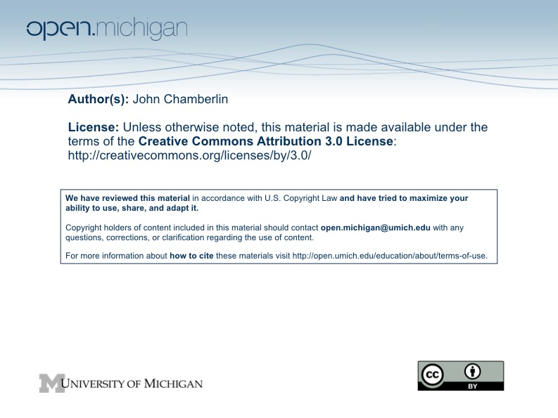

Values, Ethics and Public Policy Fall 2009

Op-Ed Assignment

Your next writing assignment is an op-ed essay on a policy proposal related to one of the following topics:

- Equality in education
- Global climate change
- A WTO case
- Rationing in pandemics
- Sex offender policies
- Restriction on the liberty of adults

Pick a particular policy proposal or propose one of your own. Be specific--don’t tackle the general topic area. You can argue either side of the policy proposal you select, but you need to take a stand and defend it. Pay particular attention to values at stake in the matter. If you wonder whether the topic you’re thinking about is one that I think fits the assignment, ask.

Assume you are writing the op-ed for a major daily newspaper (including, if you wish, a paper published outside the US). That is, write for an audience that takes public affairs seriously, is interested in thinking through issues, etc., but is not one that will know all the facts or care about professional jargon.

The firm guidelines for the essay are:

- It should be between 500-550 words. Use the “word count” tool in Word to count the number of words in the body of your essay and include that number at the end (so I don’t have to figure this out for myself).
- Write the headline you’d want your essay to have—this is your chance to grab the attention of your readers and get them interested (and maybe to get them tilting in the direction on this issue that you want them to).
- Argue a point of view. Op-ed pages usually feature opinion and advocacy, not straightforward news reporting. The idea is to persuade readers.
- Double-spaced, one inch margins all around, 12 point type.

Some suggestions for successful essays:

- Minimize jargon, esoteric citations, obscure words, etc. No footnotes. No section headings. Citations should be built into the text (e.g., “As a recent ACLU report argued,…”)
- Remember that you are addressing a voluntary audience. They can stop reading anytime you’re boring them or confusing them, so write in a way that will grab and hold the audience’s attention.
- Your goals should be to win over your audience, not (just) entertain them. Don’t preach to the converted; address your essay to readers who might hold different views than yours but who are open to persuasion.
- Keep in mind the usual guidelines for effective writing
- develop a strong introduction
- write a strong conclusion, one that drives home your central point
- avoid the passive voice, long sentences, long paragraphs, and complicated syntax
- use compelling and realistic examples
- identify the critical parts of the argument (and maybe a critical counterargument) and stick to them—don’t get into long lists of considerations that you don’t have space to discuss
- be analytical—focus on reasoning, not just on labeling things right and wrong
- avoid sarcasm
- don’t ridicule opponents; criticize their arguments but be respectful of them as people
- As preparation, read a half dozen op-eds in good newspapers and think about what makes them effective (or not). You might also read some columns in the Michigan Daily. They are usually less polished and their weaknesses are easier to identify. Think about how you would edit or rewrite one of them as practice for doing the same to your own work.
- The Assignments folder on CTools has some examples of op-eds from previous terms that I thought were particularly successful.

The essay is due by 11:59 PM on Tuesday, November 24. Send it via email, with copies to the instructor and GSI. Include your name in the name of the file.

