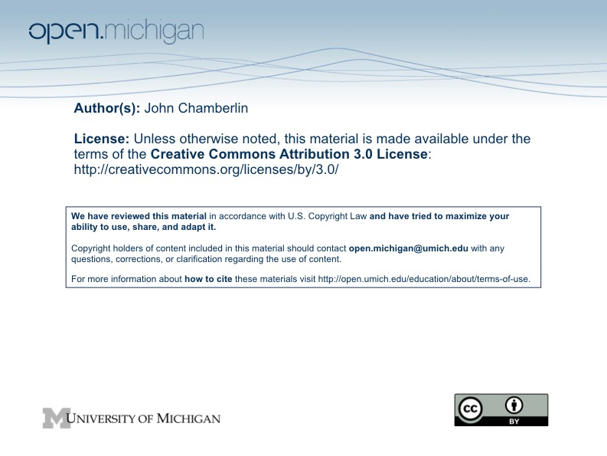

PubPol 580: Reading Notes for Class 13 (October 22, 2009)

Next Thursday we’ll continue our discussion of justice at the international level by looking at the relationship between globalization and justice. The theorems of international economics tell us that free trade makes the world better off (on average). But there are winners and losers and the process of moving to free trade is full of twists and turns, so the theorems don’t resolve the question of whether globalization promotes justice. The readings for Thursday provide some perspectives on this question.

The WTO is the major international institution that attempts to oversee and regulate globalization. Some of you may be WTO junkies who know all its features and procedures. Most of you aren’t. I hope the international policy folks will share their wisdom on this, but everyone ought to familiarize themselves to some extent with the way the WTO works. One place to start is http://www.wto.org/english/thewto_e/whatis_e/tif_e/fact1_e.htm.

The WTO can be seen as a social contract among autonomous parties (nations, in this case) to ensure the mutual benefits of cooperation. The WTO operates by consensus (which is what nations have to do when there is no international government with coercive powers). Social contracts should put you in mind of Rawls’ work, but there is an important distinction—the WTO is an actual social contract, not a hypothetical one arrived at in an original position behind a veil of ignorance. The latter features were key to Rawls’ argument that the terms of his social contract were fair. As you think about the WTO keep in mind this distinction and the relative bargaining power of the parties to actual contracts and their relative abilities to benefit from arrangements.

There are several ways to think about fairness in connection with the WTO. One is to think about having substantive principles of justice that can be used to assess outcomes (e.g., patterned principles that assess inequality, relative gains from arrangements, impacts on the trajectory of development, etc.). Another is to think about fair procedures; that is, procedures that all parties accept as fair. In this case the fairness of outcomes isn’t assessed directly, but by reference to the process that gave rise to them.

There is also the issue of the international equivalent of the natural and social lotteries that Rawls believes we must deal with when we’re considering a national-level social contract. How does this figure into your thinking about justice and globalization?

A challenging feature of this topic is that proposals can be presented in highly normative terms and look (and be) self-serving at the same time. Environmentalists and labor rights activists have asked that the WTO build into its procedures ways to protect the environment and to reduce violations of basic labor rights (such as the spread of sweatshop labor). For the most part, developing nations take a dim view of these proposals, claiming that they are protectionist policies dressed up in fancy rhetorical garb. Similarly, EU members’ desires to protect its agricultural sectors as part of their national heritages look protectionist from elsewhere in the world. And their rejection of GMOs looks protectionist from the US’s perspective. These challenges limit what one can hope to get from a voluntary international organization that has to progress through consensus.

Presenters on Thursday: I would like each of you to identify a dispute that was decided through the WTO dispute resolution process that you think illustrates an important way in which the WTO structure is unfair (in your own mind or in the mind of some reasonable observer). And explain your reasoning. Check with the other presenter (Sameer and Yanin in 1220, Justin and Devi in 123) to make sure you pick different cases. And figure out who goes first (either by flipping a coin or by deciding that some order of the two cases makes most sense).

You can find information on the dispute resolution process at http://www.wto.org/english/thewto_e/whatis_e/tif_e/disp1_e.htm.

A catalog of cases is available at http://www.wto.org/english/tratop_e/dispu_e/find_dispu_cases_e.htm.

