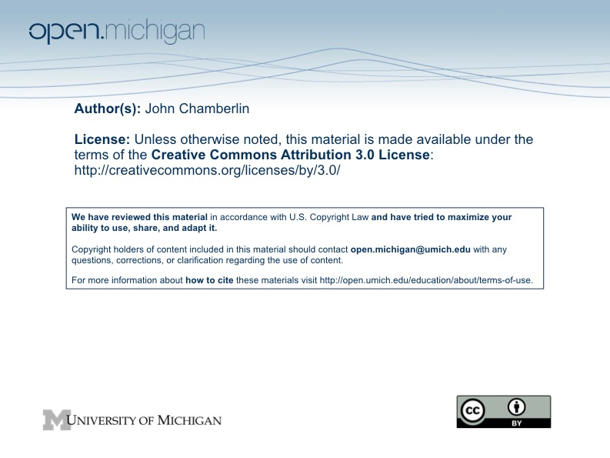

PubPol 580: Reading Notes for Class 21 (November 19, 2009)

On Thursday we move into the final phase of the course, which focuses on professional ethics. We move from the world of moral arguments about policy to consideration of the everyday professional behavior of non-elected government officials who formulate, advocate and implement public policy. It is the challenges in this arena that you are most likely to encounter early in your careers and it is important to think about them ahead of time so that you're not caught unawares when a dilemma arises. This section differs from the opening section of the course--on political morality--by focusing on professional government employees, not elected officials or other officials appointed by elected officials.

We have a series of five related classes on this topic. Thursday provides an opportunity to discuss the basic structure of professional ethics for public servants—how role morality for them differs from role morality of elected officials or candidates for office. Next Tuesday we’ll talk about codes of ethics and their role in the profession. Then we’ll move on to the ethics of program evaluation. We’ll finish this segment with two classes on professional ethics and bureaucratic politics, taking up issues like guerilla government (working to undercut the effectiveness of a boss whose policy stands you disagree with), lying (not the kind where you lie to protect yourself, but where you lie to promote the public good (at least as you see it), and other uses of the discretion that comes with professional positions.

PROFESSIONS

A preliminary question: What does it mean to be a professional? To what extent do you consider public policy or public administration a "profession?" How important is this question? Think about professions that you think are "real" and the consequences for members of the profession and the public of having a strong profession. What makes them "real?" Where does public administration fit on the continuum from "real" professions to "non-professions?" Do you identify with your profession as much as your friends in law school or medical school identify with theirs? What are the key moral features of public administration as a profession? What are the key competencies or virtues associated with the profession? Do they differ across countries? For those of you in dual degree programs, how do you compare your two programs when it comes to them being professions?

ROLES

Professional ethics has a lot to do with the ethics of roles. Professional roles usually authorize and require a focus on consequences. They also authorize occupants to pay attention to only part of the problem (the part that affects the agency for which they work). This division of labor across organizations is often accompanied by a division of labor within the hierarchy of a single organization, with people at the top thinking that the normative issues are something they deal with, not those further down in the organization. This is a descriptive statement--whether this structure leads to better public policy is another matter. In addition, public administration takes place in close proximity to politics (and partisan politics, in particular), which presents a challenge other professions aren't faced with. All told, this makes professional ethics in public administration a difficult matter.

David Luban’s article on professional ethics provides some important food for thought for our discussion. He suggests a four-level structure: acts, rules, roles, and institutions. The institution in our case is a professional civil service within a democratic political system. We can then ask what the key roles are for professionals in such an institution, and having identified them, move on to the rules that should apply and so on. Luban recognizes the tensions between role morality and “common morality,” and he doesn’t see any way to resolve the tensions:

TRAINING, CERTIFICATION, OATHS, CODES OF ETHICS, PERSONAL INTEGRITY

There are several general strategies for promoting ethical behavior on the part of professionals. The first is professional training and in some professions licensing exams and official entry into the profession. In the US civil service, we don't have licensing and entry into and exit from civil servant roles is pretty much unregulated.

A second strategy is administer an oath of office that is intended to keep the professional’s eye focused on the norms associated with his/her role. All federal government officials except the President take the following oath of office:

''I, ______, do solemnly swear (or affirm) that I will support and defend the Constitution of the United States against all enemies, foreign and domestic; that I will bear true faith and allegiance to the same; that I take this obligation freely, without any mental reservation or purpose of evasion; and that I will well and faithfully discharge the duties of the office on which I am about to enter. So help me God.''

I hadn’t thought much about oaths (or even realized that employees took such an oath) until I was called for jury duty a couple of summers ago. I was struck in the courtroom by the apparent power of an oath to transform ordinary citizens (with all their opinions, personal idiosyncrasies, etc.) into jurors capable of carrying out one of the most fundamental tasks in a society governed by the rule of law. I may well be romanticizing this situation, but it got me to thinking about the power of oaths and whether they do important work in professions that use them. The Hippocratic Oath in medicine is the most salient example of a professional oath (it is evidently featured in many commencement ceremonies at medical schools). If oaths have the power to shape behavior, where does that power come from? Does an oath amount to anything more than a promise to do the right thing (with “right” not being very well defined)? There is a strong religious dimension to oaths (including the “so help me God” that is tacked onto the oath of a juror). Does that limit their power in the secular sphere? Last year, some MBA students started a movement on behalf of an MBA Oath. You can find it at http://mbaoath.org/. What do you think of it?

A third approach is to rely on a code of ethics that spells out professional responsibilities. In the case of the profession of public service in the US, you might get a couple of classes ahead and take a look at the Code of Ethics from the American Society for Public Administration (ASPA) at http://www.aspanet.org/scriptcontent/index_codeofethics.cfm and think about the extent to which it can do the work that you think a code of professional ethics needs to do. Do you find the ASPA code helpful in informing you about the expectations that operate in our profession? Which kinds of questions are they most helpful with? Which kinds would you find them least helpful with? Are they of any help when it comes to conflict between the elements of a code? How important is an enforcement mechanism to the likely success of a code? What kinds of codes, if any, do other countries use in these circumstances?

Another strategy is to rely directly on the virtue and character of officials. The chapter by Michael Pritchard in the readings addresses this strategy. What do you think are the “virtues” that are most critical to the role of a policy analyst or manager in government?

