The Northeast Michigan Integrated Assessment: Ecological Assessment Component

by
Brian Colleran & Kensuke Mori

A practicum submitted
in partial fulfillment of the requirements
for the degree of
Master of Science
(Natural Resources and Environment)
at the University of Michigan
April 2007

Faculty advisors:
Professor Donald Scavia, Chair
Dr. Jennifer Read

Table of Contents:

Abstract: ……………………………………………………………………………….…2

Introduction: ……………………………………………………………………………...3

Materials & Methods: ………………………………………………………………….....6

Results and Discussion: ………………………………………………………………....11

Human infrastructure map discussion: ………………………………………………….11

Natural resource maps discussion ……………………………………………………… 15

Opinion maps discussion: ……………………………………………………………….22

Geological features map discussion: ……………………………………………………30

Ecotourism map discussion: …………………………………………………….………33

River map discussion: ………………………………………………………..………….36

Working landscapes map discussion: …………………………………..……………….40

Migratory bird model discussion: ……………………………………………………….44

Summary & Conclusion: ………………………………………………………………...50

Bibliography: ……………………………………………………………………………54

Ecological features survey - Appendix A: ………………..……………….…………….56

Sources for all GIS layers used in the ecological assessment - Appendix B: ………...…58

Poster of ecological areas of concern, based on Figures 4 and 5- Appendix C: ...………65

Preparatory layer development for Figures 11, 12, 13, and 14- Appendix D: ……….….66

Certainty Assessment - Appendix E: ……………………………………………………70

Abstract:

The following report is the ecological assessment component of the Northeast Michigan Integrated Assessment. The goal of the ecological assessment team was to document the environmental status and trends in the region to inform long-term planning and decision making. The ecological assessment was carried out primarily using Geographic Information Systems (GIS) software and produced a number of maps of the region’s ecological features. These maps visually summarize a variety of natural features and human influences on natural features, and will be used to inform other portions of the integrated assessment. Results of this assessment have influenced the development of policy options for this integrated assessment, the work of the planning and zoning assessment team, and have been used as educational materials at stakeholder meetings during the final stages of this process.

Introduction:

Overview:

This work is the report of the ecological assessment team for the work done on the northeastern Michigan counties of Alpena, Alcona, and Presque Isle for Sea Grant’s Northeast Michigan Integrated Assessment (NEMIA) process. The ecological assessment portion of the NEMIA process focused on how these counties can move forward into the 21st century with a better understanding of the impact human activity, (e.g., development), may have on the landscape and the role that planning and other pro-active actions can play in mitigating it. The region is home to endangered plants, animals, and ecosystems, rare geological features, special cultural features, and a valued way of life. The ecosystems team’s goal was to ensure that important natural features in the region were identified clearly for policy makers.
The report is organized as follows: The Introduction provides background on Integrated Assessments (IA) and the NEMIA process. The Materials and Methods portion describes the region itself and the Geographic Information Systems (GIS) software used to perform the ecological assessment. The Results and Discussion section describes the development, content, potential uses, and limitations of each GIS based map. The Summary and Conclusions piece summarizes the work that was done, the work that still needs to be done, and concludes with a summary of why regional decision makers needed the work to be done, and the lessons learned during the process. The appendices show the survey used (Appendix A), to produce some of the maps (Figures 4 and 5) the sources of the layers used in the maps (Appendix B), and a poster developed through the use of some of these maps, that was presented at a work group meeting during the later stages of this process. (Appendix C). Appendix D describes the layer transformation process in the development of a migratory bird stopover site model, and Appendix E contains the certainty assessment portion of this report.

Integrated Assessment overview:
To ensure that proposed solutions to a policy or management problem are as well informed as possible, information from a broad range of fields is brought together in an integrated assessment. Information is then synthesized, and presented to the relevant decision makers. The working definition for an IA process reflects the goal of collecting information pertaining to a management problem, effectively synthesize it, and providing the resulting information to decision makers. The definition of an IA is:
“Integrated assessment is a formal approach to synthesizing and delivering relevant, independent scientific input to decision making through a comprehensive analysis of existing natural and social scientific information in the context of a policy or management question” (MSG, 2005).
The NEMIA process sought to do this in a slightly different fashion from most other IAs. While most formal IAs to date have been conducted on a national or international scale to address difficult problems (CENR, 2000 and NAST, 2001), the NEMIA project may be the first one to attempt to apply this process on a more regional scale to address problems that might be solved through local actions, rather than through national or international bureaucracies. A further difference in this IA is the extent to which stakeholders have an influence over the process itself. No work was undertaken during this process that was not deemed worthwhile by regional stakeholders that formed the group guiding the IA process. Guided by the input of regional decision makers, a guiding policy question was developed during the initial stages of the NEMIA process. The question is:
“How can coastal access be designed, in a regional context, for sustainable tourism that stimulates economic development while maintaining the integrity of natural and cultural resources, and quality of life” (MSG, 2006)?
To best address the policy question, four technical teams were created to target different aspects of the question. The four teams focused on regional economics, planning & zoning, cultural heritage, and ecology. The following pages represent the work of the ecological assessment team from the NEMIA process. The ecological team was composed of two students, Brian Colleran and Ken Mori, master’s students at the School of Natural Resources and Environment at the University of Michigan, and the completion of the ecological assessment for the NEMIA process was an integral part of their graduation requirements. The guiding policy question and a few terms in particular guided the work done by this team. The guiding question identified concerns over coastal access, sustainable tourism, and maintaining the integrity of natural resources, which ensured that these topics received sufficient attention during the ecological assessment. The ecological team chose to approach the issue by making extensive use of GIS software. A GIS-based assessment was decided upon because of the ease with which this effort could bring together data that could then be passed on to decision makers who would be in a position to update and improve the information for future use after the assessment process itself was over. The most attractive feature of the GIS-based assessment was that easily distributable maps could be produced and used to inform the public about a variety of projects, thereby ensuring that the public could be easily and effectively informed about the process. The main drawback to using this approach was that ecological information had to be in a GIS format to be of use. While this choice of medium does not allow for an analysis of every possible environmental feature, it does provide a means to collect, analyze, and display essential environmental features to decision makers.

Materials & Methods:

Study Area:

The study area for the NEMIA project consisted of Alcona, Alpena, and Presque Isle counties in the state of Michigan. The three counties are located on the northeastern side of the state’s Lower Peninsula, are heavily forested, contain a large number of wetlands, and have extensive undeveloped Great Lakes shoreline on the northwest coast of Lake Huron. The three counties total about 1,973 square miles, with roughly 685, 694, and 594 square miles of land in Presque Isle, Alcona, and Alpena counties, respectively. There are 4 cities in the region; Onaway, Alpena, Roger’s City, and Harrisville. About 57,500 people live in the area and the region in and around the city of Alpena has a population of about 20,000, making it the most populous part of the region in the assessment. The rest of the population is spread throughout the region, with roughly 14,400, 11,700, and 31,400 residents in Presque Isle, Alcona, and Alpena counties, respectively (US Census, 2007). Historically, mining and forestry have been the staples of the regional economy, but have decreased in importance, though the area still has several large quarries. Manufacturing, agriculture, and the military have also been important in the past, but the majority of these jobs have been lost, and the region is facing economic challenges. The current major attractions to the area include Great Lakes cultural tourism, and hunting and fishing activities. However, these industries are currently addressing their own problems such as health concerns in some of the popular game species, and a lack of shoreline amenities such as hotels.

Site Selection:

The northeastern coast of Michigan’s Lower Peninsula was selected as the site for this process due to a combination of suggestions and local interest in the potential of such a process to improve the local decision making process. The Director of the Michigan Sea Grant program introduced the IA process to the regional directors of the Michigan State University Extension program since the IA process was going to serve as the new template for Sea Grant research (Brandon Schroeder, personal communication). The directors suggested that such a process could be very useful in the northeastern section of the Lower Peninsula. The Sea Grant representative in that region then began discussing the idea with potential local partners and stakeholders in the process in late 2004, all of whom took an interest in the idea, and helped suggest focus areas. To discuss the IA process, a meeting was convened of all of the federal, state, regional, and local groups who would be interested in participating in the process, where the Sea Grant Director again discussed the IA process in September 2005. The policy question was proposed, discussed, and refined by the stakeholders, before the data-gathering and analysis finally began in June of 2006 (Brandon Schroeder, Personal Communication).

Overview of Process:

An integrated assessment seeks to bring together existing information related to a particular area in response to a specific policy question, identify the status and trends in the region, why those status and trends exist, formulate a set of policy options and forecasts to address those trends, and the technical knowledge necessary to implement those policies. The primary goal of the ecological assessment team was to locate as many GIS layers representing natural features in the study region as possible to best display the ecological status and trends in the area. The secondary goal was to find information on different features that could influence the natural world. To accomplish this the ecological team needed to find and gain access to both public and private GIS information relating both to the natural and human history of the region, and to the current state of the built environment as well as the natural environment. Due to the lack of GIS layers representing ecological features at a variety of points in time, accurate trends in regional environmental status or ecological function through time could not be determined. The work that was done instead focused on the current ecological status of the region and on producing maps that would be of use in local planning and decision making efforts. To accomplish the secondary goal, we focused our efforts on finding layers depicting how humans impact the land around them through construction, destruction, contamination, and property designations.
The data standards for this assessment were to have all layers use the 1983 North American Datum and to be projected according to the Michigan Georef projection. Because the ecological team used the Michigan Georef projection, when converting individual shapefile layers to and from the raster format, the projection file in each shapefile format had to be manually adjusted to make up for a flaw in how ArcGIS 9.1 converts shapefiles from rasters in the Michigan Georef projection. This flaw involves the misreading of decimal-degrees and degrees-minutes-seconds by the program in the conversion process. Once standardized, each layer was altered to express the correct geographic area of interest, in this case, the region encompassing Presque Isle, Alcona, and Alpena counties. Because the Michigan Online Geographic Data Library packages data on a county scale, data obtained from this source had to be combined (“unioned”) to display information for the entire region in a single layer. Many other sources provided data for the entire state, and were made smaller (“clipped”) to display only the three county region. To summarize, we “clipped” data down to the right region, “unioned” smaller layers to create a layer for the entire three county area, converted files between formats as needed, and manually converted spatial data after file conversions.
The products developed through this process were a set of maps displaying a variety of features related to the ecology of the region, both directly and indirectly. These maps were generally created by defining a category, and displaying all related GIS information. The “River Map” (Figure 9) for instance, displays all rivers in the region and some forms of human impact on them, while the “Geological Features Map” (Figure 7) displays all GIS information related to surface geological features in the region.
One particular set of maps, designed to compare workgroup attitude about importance of various layers with professional ecologists’ regarding the natural environment, was done in a slightly different fashion from the other maps and the general outline of that process can be seen in Figure 6. These “Opinion Maps” (Figure 4 and 5) were developed according to results of the survey presented in the appendix to this report, and the details of their development are discussed further in the “Opinion Maps” portion of the Results and Discussion section. The use of opinions in GIS is well established, and has been used in a variety of contexts; from modeling perceptions of groundwater contamination, to modeling the distribution of flora and fauna (Pierce, 2001, Clevenger 2002, Theriault, 2002). Using the opinions of residents to help in the planning of a community’s future is known as participatory Geographic Information Systems (Hawthorne, 2005). It gives residents’ views a new vitality by changing them into a tool for decision makers. While the opinion maps produced for this assessment do not accurately reflect local sentiments, since the only opinions polled were at workgroup meetings, the opinion mapping done does represent an important first step in gauging local sentiment (Geertman, 2002).

Acquisition of materials:

The process of acquiring the required layers consisted of first identifying a feature of interest, and then finding an agency that may have converted the geographic information to a GIS format. A full list of all layers used and their sources is available in Appendix B of this report. The layers representing the six ecological features that formed the basis of our analysis are: endangered ecosystems, endangered animals, endangered plants, wetlands, interior forests, and pre-settlement landcover. These layers were developed by and acquired from the following sources:

- Forest cover data was downloaded from the United States Geological Survey website
- The National Wetlands Inventory (NWI), developed by the United States Fish and Wildlife Service
- Pre-settlement landcover, developed by Michigan Natural Features Inventory (MNFI) based on data Michigan Department of Natural Resources (DNR) data.
- The endangered ecosystems and species information was acquired from the MNFI.

Results and Discussion:

Results and Discussion Overview:

The following portion of this report is organized around individual maps developed over the course of this ecological assessment project, and each shows particular aspects of the natural or built environment. The maps display the human infrastructure, ecological features, the opinions of ecologists and local decision makers regarding those ecological features, geological features, potential ecotourism attractions, working landscapes, a model of potential migratory bird stopover sites, and human impacts on rivers. For each map, we describe its purpose, what it does and does not display, its potential use, and suggestions for improvements. For the maps for which the ecological team developed specific layers, the layer development is explained directly following the description of the map’s purpose.

Figure 1 - Human Infrastructure map:

While not part of the natural environment, existing human infrastructure is an important piece of any ecological assessment. Knowing the distribution of the human

Figure 1 – Map of human infrastructure in the three-county region:
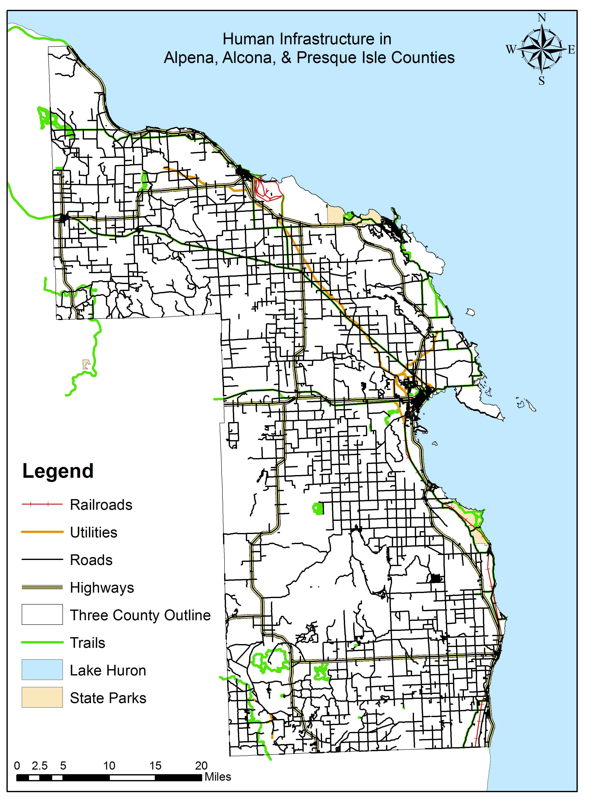

infrastructure is an important step in understanding human interaction with the environment, and this map was constructed to aid in that understanding.

Purpose of this map:

This map was developed to show the current human infrastructure in place in the region and to help highlight areas of interaction between human infrastructure and the natural world. This map may serve as a reference or be used as an overlay with other GIS layers of natural features in order to aid in describing the influence of human infrastructure on local ecosystem functions. This map may also be used to extrapolate information about urban/suburban development based on the concentration of small streets and identify current access points to the Lake Huron shoreline.

What this map shows:

This map displays the roads, train tracks, utility lines, and trails in the region. State parks are also displayed as points of reference. Although large towns are not displayed explicitly, the concentration of road, rail, and utility corridors does identify areas of concentrated development. Roads may also be used as indicators of residential development and the spread of towns and villages. Roads or utilities passing through sensitive areas, ease of access to sensitive areas, and the effect of potential future development can all be illustrated using this map in conjunction with other GIS layers or maps.

What this map does not show:

Not shown in this map are brownfield areas, mining operations, farmland, or any of the other land uses. Brownfield areas were omitted due to the lack of available information on this feature in a GIS format. Mining operations and farmlands were left out of this map, but are displayed in Figure 10, “Working Landscapes”. An explicit display of residential development was left out of this map because there was no way to formalize the boundary of residential development accurately using the layers available.

Potential map uses:

By having this map available, and by using it in conjunction with other information, future growth of local infrastructure may be directed in such a way as to avoid impacting natural features. By including natural features of interest in the planning process early on, potential conflicts could be avoided entirely. This map might also be used to identify and preserve large areas that do not have any roads, utilities, or other human artifacts present.

Potential improvements:

Any layers that might be able to designate the extent of residential development, the existence of brownfields, and any other intense land uses that would not otherwise qualify as “working landscapes” would greatly improve this map. For brownfields, there is some information available, though it is not in a GIS format. The state of Michigan maintains a list of all state properties that qualify as brownfields, and there are a few in the study region. Converting the information into a GIS format would greatly enrich this map.
A layer that shows all potential construction projects in the region would also be of great use for anyone using this map. It would allow map users to see anticipated projects and take them into consideration for planning, even though nothing may currently exist on the potential worksite. Distinguishing which projects are at different stages in the permitting process would also be a very helpful aspect of a layer showing pending construction projects.

Figures 2 and 3 - Ecological Features Maps:

These ecological features maps have been constructed to display the type and extent of the important natural features in the region, such as endangered species and ecosystems or sensitive areas such as wetlands. Although a layer showing every natural feature in the region was not available for display in this map, the features displayed well represent the region’s ecological wealth.

Purpose of these maps:
The purpose of these maps is to ensure that current and future decision makers know about the location and distribution of the significant natural features in this region. By making this information easily accessible and visible, planners and decision makers may look more closely at potential environmental concerns that future projects may create. These maps may also stimulate the consideration of measures to preserve and protect areas that may be threatened by home construction, additions to the local infrastructure such as road, utility, or sewer expansion, and large developments for parks, shopping, offices, or mining and forestry activities.

What these maps show:

The ecological features displayed in these maps are endangered plants, animals, and ecosystems, large “interior” forests, pre-settlement land cover, “reference ecosystems”, wetlands, groundwater based ecosystems, and protected lands. A layer
Figure 2 – Ecological Features overlay map for the 3-county region:
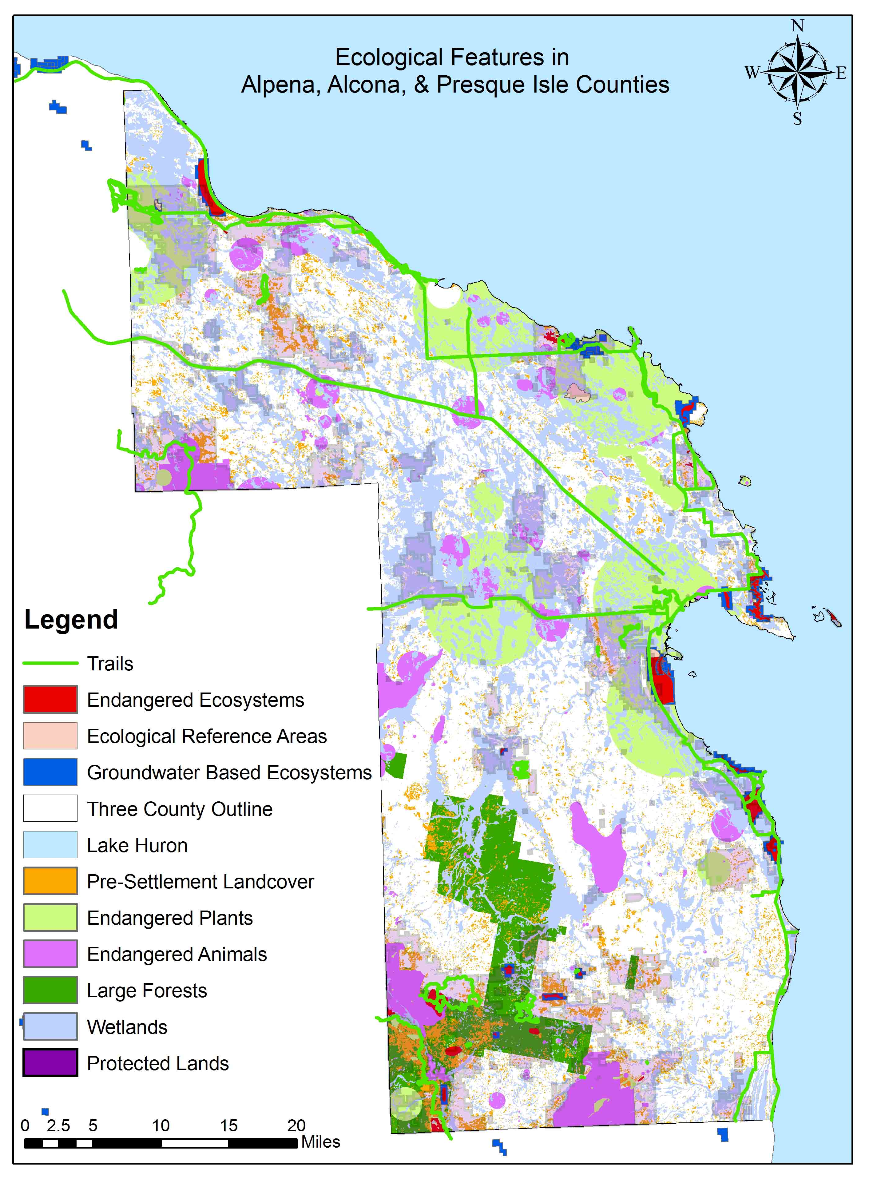

Figure 3 – Map of overlapping ecological features, using the same features as Figure 2:
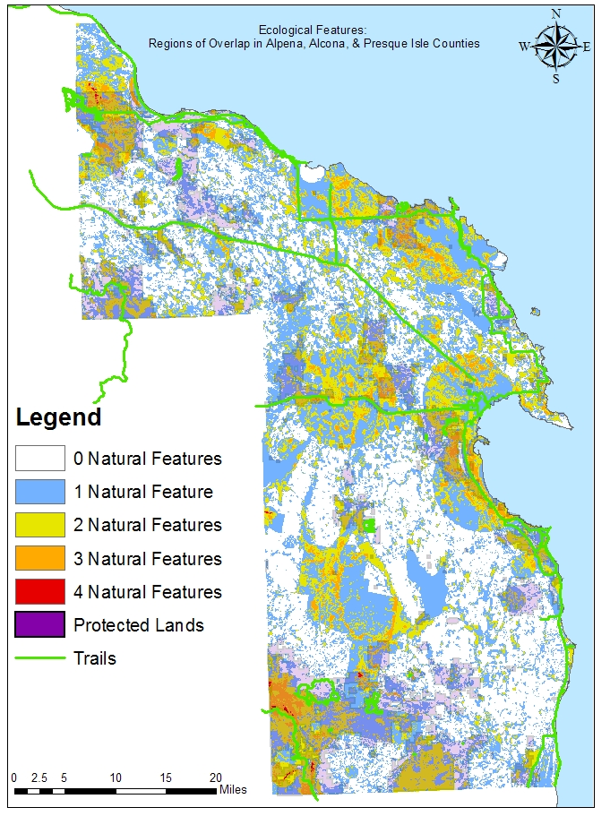
displaying trails has been included to demonstrate the accessibility of some of these important areas, both for access purposes and as an indicator of potential vulnerability. Additionally, the protected lands layer was made partially transparent in order that features within these areas may be identified. In places where feature layers overlap, only the GIS layer on the very top can be displayed. The ecological team has attempted to alleviate the problem by creating a complementary map that showing the number of areas where the six ecological features overlap (Figure 3). While the actual features themselves cannot be displayed, using the two maps in conjunction provides a more complete picture of the region. Because Figure 3 does not identify individual features, the following explanations only apply to Figure 2, which does distinguish between individual features.
The endangered plants, animals, and ecosystems information is derived from the Michigan Natural Features Inventory (MNFI), and represents the best knowledge available at this time regarding these features. Additionally, although many of the features are listed for their global status, some species and ecosystems rare in Michigan and plentiful elsewhere are displayed by this map. Interior forest areas are determined by the USGS based on the dominant land cover for a region on a 1000 meter by 1000 meter grid. To be considered an “interior” forest, a forest grid must be fully surrounded by other cells that qualify as either interior or edge forests. Pre-settlement land cover areas are defined as having maintained their ecological character even though they may have been lumbered, farmed, burned over, or otherwise altered by humans before the development of this layer. The value of such sites is that an ecological continuity exists: these areas may serve as a species refuge and help to maintain the mosaic of land cover types and habitats necessary in an ecologically healthy region. The areas that the Michigan DNR has labeled as “ecological reference areas” are considered to be ideal examples of how a particular ecosystem should function. When performing restoration work, or trying to distinguish between similar ecosystems, these designated ecosystems are used as reference to a systems integrity and function. Although sites in the region have been selected, the formal approval process had not been completed, and the official status of these areas is currently unknown to the ecological assessment team.
The National Wetlands Inventory (NWI) wetlands layer was developed for the United States Fish & Wildlife Service (USFWS), and it is the same wetlands layer used by the Northeast Michigan Council of Governments (NEMCOG) for their GIS projects. Areas from the NWI that are flooded on a permanent or seasonal basis by human activity were excluded due to their anthropogenic origins, though they are not a part of Figure 1, since they are not a part of the regional infrastructure. Groundwater based ecosystems are a subset of wetlands, and the layer displays ecosystems whose existence are dependant on the upwelling of groundwater. This information was also derived from the MNFI, and has been highlighted to display the special nature of these wetlands.
The protected lands layer was developed by Ducks Unlimited (DU), and combines state, county, and town parks, forests, and preserves. Also included are lands controlled by the federal government, such as national forests. Although all the properties are not managed according to the same guidelines, all the properties displayed are held in the public trust and it is unlikely they will be developed. These lands may therefore serve as a guide to where habitat patches will receive the greatest protection from human activity.

What these maps do not show:

The MNFI layers in these maps do not show current species populations or distributions, nor do they show the range a particular species or ecosystem may have had or could have. Information from the MNFI also only shows those regions where confirmed sightings of endangered plants, animals, or ecosystems have occurred. The potential for a species or ecosystem of interest to be present is not displayed. The absence of a feature on the map does not mean that it is not there, it means that no one has reported any endangered species in the region. In other words, an “absence of presence” of a feature on this map does not confirm the “presence of absence.” As for more common plants, animals, and ecosystems, these maps show neither ranges nor population data. Even though a group of organisms may be valuable in some way, if it is not considered threatened or endangered by the MNFI, we did not display it, due to the detail in the MNFI layer, the ecological value of the species, and their use as potential tourist attractions. These maps also do not display the potential for any locally extirpated species to re-establish a presence.
These maps also lack references to migratory routes for birds or land animals, and aquatics information. This assessment has a separate map (Figure 9) that has been developed for rivers, and does not specifically address Lake Huron ecological features. While ecological GIS information for Lake Huron does exist, the ecological team was unable to collect sufficient information to create an adequate map, and such a map would greatly aid in regional decision making.
These maps show only the location of specific, confirmed features and/or species, and do not show potential threats to these features. These maps do not show any natural features which have been lost or destroyed since the data was collected, and the MNFI information placing rare species in a specific location does not ensure their current presence. Any natural or human induced threats to the natural environment were also left off of this map, including those posed by invasive species, pollution, deforestation, and habitat fragmentation. However, the extent of some of these problems may be inferred from other maps. These ecological features maps (Figures 2 and 3) display only the “positive” pieces of the terrestrial environment that are present in the study area, omitting features that may be construed as “negative.”
As has already been stated, some features in Figure 2 may be hidden from view by other features that overlap it. To compensate, the order of display for each contributing layer was arranged in such a way as to place features with a smaller spatial extent above layers with larger spatial extents. The effect is that the smaller layers are effectively “on top” of the larger ones, and can be seen. However, there are still features that are obscured and if Figure 2 is used in conjunction with Figure 3, it should be possible to identify areas where features overlap that may not be otherwise visible.

Potential map uses:

The information provided by these maps will aid the planning of future development and zoning ordinances, ensure that decision makers are aware of the location of sensitive ecological areas, and stimulate protection and restoration of sensitive and important areas that may have already been compromised in some way. The information in these maps may be used alone to identify areas of concern, or it may be used in conjunction with other maps and layers to develop a stronger understanding of current threats to ecological features and those that may develop in the future.
Potential map improvements:
There is a large amount of data related to the natural environment in the three county region that was not in a GIS format when this project was undertaken. Yet to convert and include them in Figures 2 and 3 would reduce the clarity of the figures, and information would not be communicated as effectively. No improvements to the current maps are suggested at this time. However, all of the missing information should be found or created, and used to develop new theme-based maps that could be used in conjunction with the data in this map. Suggested map themes include invasive species, pests and diseases, and Lake Huron natural features. Additionally, the MNFI is regularly updated and new areas of importance throughout the state are constantly being identified. The MNFI and other component layers should be updated as frequently as possible to ensure that the information in this map does not become too old or irrelevant for decision makers.

Figure 4 and 5 - Opinion maps:

The opinions of the IA work group and a group of ecologists from the University of Michigan about the six ecological features mentioned in the “Acquisition of materials” section of the “Materials and Methods” portion of this paper, and displayed in figure 2, are displayed in these two maps. The opinions of these two groups, while interesting, do not fully represent the opinion of all regional decision makers or of all ecologists. These maps are designed to serve as conversation starters and to highlight the geographic areas that regional decision makers and ecologists would agree need to be protected (Hansen,

Figure 4 – Relative importance of ecological features according to expert opinions:
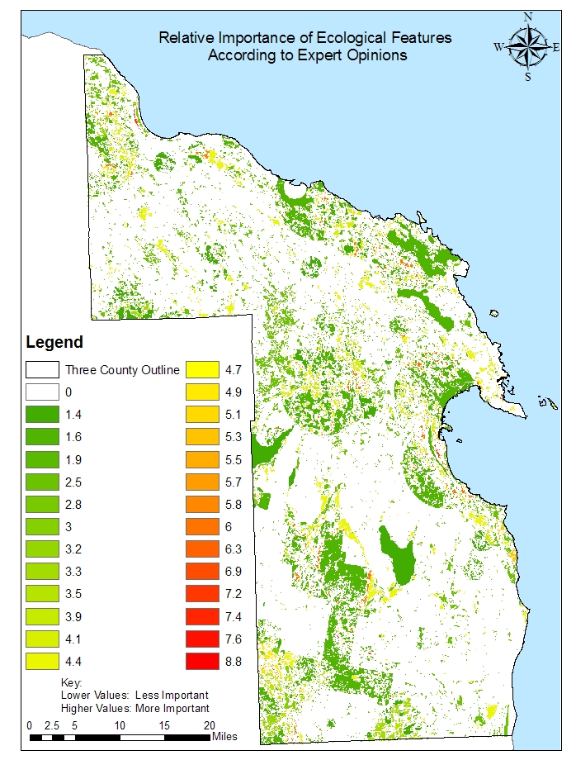

Figure 5 – Relative importance of ecological features according to local opinions:
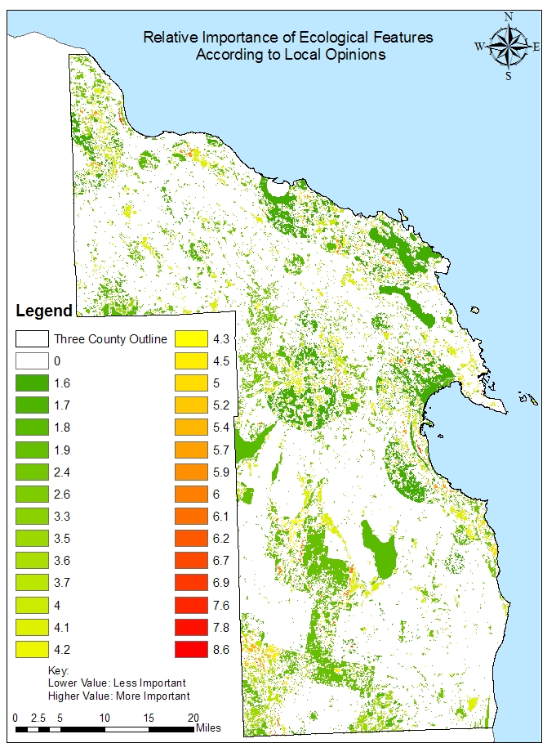

2004, and Balram, 2004). The opinions displayed were generated using a simple survey consisting of the ranking exercise displayed in Appendix A. The respondent was asked to
rank each of the six ecological features of interest based on their understanding of the importance of the feature relative to the other features in the survey. The results of the survey were standardized and then used to weight each layer. Using the results from both the local and the expert opinion surveys, Figures 4 and 5 were developed. Both groups indicated that wetlands and endangered ecosystems were the most important features; therefore it could be reasoned that the areas where these two features overlap can be used to determine areas of primary concern for both groups.

Purpose of these maps:

The opinion maps were designed to compare regional decision maker and expert opinion about the relative importance of different natural features. The opinions were used to rank each feature relative to the others. The purpose is twofold: to gauge the feelings about important ecological features relative to other important ecological features within the two groups, and to identify locations where agreement between the two groups was high, in order to target these areas for protection (Kyem, 2004 and Theriault 2002). They may also serve as a springboard to gauging the sentiment of residents on the issue of protecting specific places or natural features.

Figure 6 – Flowchart for the development of the opinion maps (Figures 4 and 5):
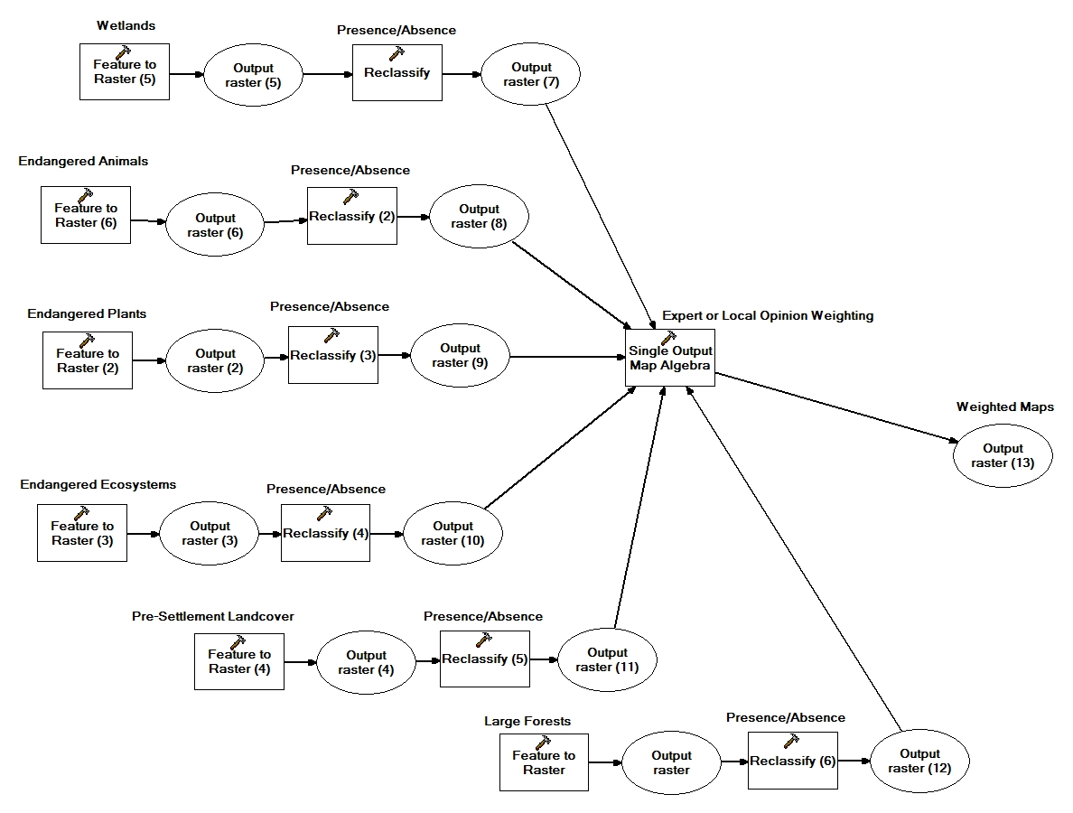
Layer development:
The opinion layers for these maps were developed by converting each of the six component natural features displayed in Figure 2 from their shapefile format to a raster format. The rasters were then reclassified for presence and absence for the feature of interest. Each of the newly reclassified rasters was then weighted according to the survey results displayed in Table 1 from the survey displayed in Appendix A, and combined mathematically using the raster calculator function of the ArcMap software (Figure 6).
To create the opinion map, the ecologically relevant layers that were acquired in the initial search for data displayed in Figure 2 had to be converted into raster layers that displayed presence and absence mathematically as a “1” or a “0” respectively. Then, based on the survey results displayed in Table 1, the raster calculator function in the ArcGIS software was used to weight each layer accordingly and combine them. The raster calculator carried this out by multiplying each cell in the raster by the weight it was assigned, and then adding the results. For each cell that represented a particular location in the region, six results were generated in this fashion, and summed. Each cell in the final layer was thus a composite of the same cells from each of the six contributing layers. The resulting layer was a display of the weighted and summed component layers, and was able to mathematically create a visual summary of the opinion survey.

What these maps show:

In addition to showing the opinions of regional decision makers and SNRE ecologists, these maps blend all features of interest into a single layer on both maps, and individual features may therefore be difficult to perceive. While the rankings are based on which
Table 1 – Results of the Natural Features Survey:
Local Opinions | "3 points" | "2 points" | "1 point" | Votes | "Total Points" | Weight=total points/votes
Endangered Ecosystems | 18 | 3 | 3 | 24 | 63 | 2.6
Wetlands | 14 | 5 | 4 | 23 | 56 | 2.4
Forests | 6 | 9 | 9 | 24 | 45 | 1.9
Endangered Animals | 4 | 10 | 10 | 24 | 42 | 1.8
Old growth | 4 | 7 | 12 | 23 | 38 | 1.7
Endangered Plants | 1 | 12 | 9 | 22 | 36 | 1.6
Expert Opinions
ecosystems | 10 | 3 | 0 | 13 | 36 | 2.8
wetlands | 9 | 2 | 1 | 13 | 32 | 2.5
old growth | 3 | 7 | 2 | 13 | 25 | 1.9
forests | 2 | 4 | 7 | 13 | 21 | 1.6
plants | 1 | 6 | 6 | 13 | 21 | 1.6
animals | 1 | 3 | 9 | 13 | 18 | 1.4

area has the highest mathematical average ranking based on the results of the opinion survey, all ecological features are of great importance, and this map is only displaying relative rankings. Just because the layer displayed in a certain area is ranked as being less important than another layer in a different area does not mean that the area is of less concern or is less important.

What these maps do not show:

These maps do not show how the decision-makers or ecologists would rank natural features against regional development projects. Potential economic gains compared to potential ecological losses are not addressed by this map. This map is only meant to show how experts and regional decision makers compare a specific set of natural features to each other. These maps do not display or provide insight into potential conflict over priority of use for the areas where these features are located. The opinions are strictly related to an internal ranking of the features.
These maps do not represent the opinion of all regional decision makers or ecologists, but rather, they illustrate the opinions of those decision-makers in attendance at the August 2006 NEMIA meeting where the survey was administered, and those ecologists at who were surveyed at SNRE. Therefore, these maps are not a truly representative sample of the opinion of the region, or even of all regional decision-makers or ecologists. While these maps may be used as a guide, they should not be considered authoritative on the subject of regional decision maker or ecologist opinion.

Potential map uses:

These maps are intended to demonstrate how local decision makers and ecologists view the regional natural environment. Figures 4 and 5 are meant to highlight areas that would have greater support for protection, since decision makers and experts identified many of the same areas as being ecologically important. Some of the areas identified by both groups as being of greater concern have already been used to generate a poster depicting greater detail for specific areas (Appendix C), and other products like this could be developed (Ceccato, 2000). These maps may also be used to generate additional feedback from residents, which would lead to a more accurate portrayal of local opinion about regional natural features. These maps could also be used as a baseline for future opinion surveys to determine changes in public opinion over time.

Potential map improvements:

Because these maps were developed to display a set of opinions about regional natural features, a more in-depth survey of regional decision makers should be undertaken to accurately reflect sentiment about the region. Additionally, a survey of residents should be carried out to further improve the understanding of how people feel about the environment in the region, exploring the possibility that regional decision makers and residents have different views on environmental topics. The survey methodology could also be improved to better reflect resident’s feelings about specific places and regions in the area, and include features not included in the original survey.
To complement this set of maps, a survey of truly local opinion regarding the local environment, economic development, and quality of life should be developed. By performing another survey focused on these issues, areas that would be unanimously supported for conservation, restoration, or preservation could be readily identified. In this manner, important ecological areas with strong public support for protection could be identified and protected.

Figure 7 - Geological features:

The ecological team developed this map recognizing that the northeast Michigan region possesses geological features which serve unique ecological functions. While these features may or may not have direct influences on local ecological functions, they are a part of the natural world that can serve as unique habitats and exert indirect influences on ecological processes. Because of these unique characteristics, the surface geology of the region has been included in this assessment.

Purpose of this map:

The purpose of this map is to ensure that as much information as possible is made available about local geological features. It is also meant to call attention to the lack of GIS-based information about geological surface features, and to the potential for the
Figure 7 – Map of regional surface geological features:
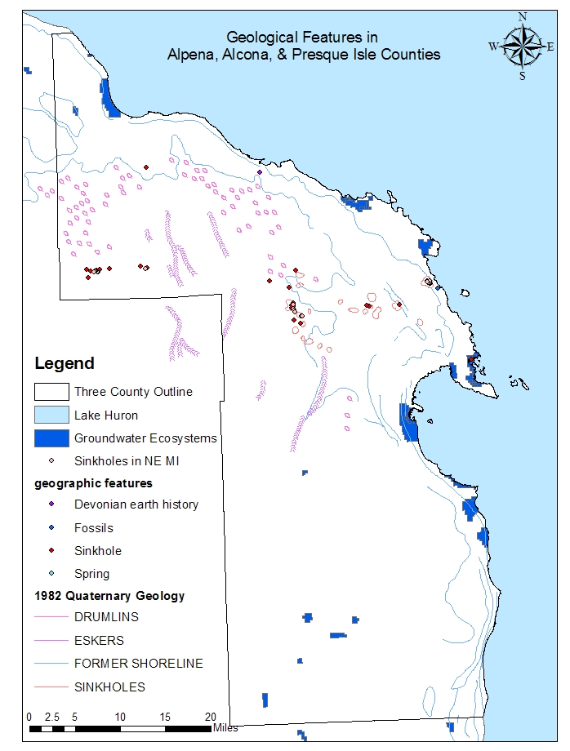
development of other soil and subterranean feature maps. Such maps would further complement a surface features map, and could be tailored to suit specific needs in the community.

What this map shows:

This map shows aboveground geological features. These features often possess unique historical, social, and ecological importance in their own right, and should be treated accordingly. Groundwater dependant ecosystems are also displayed, since they are areas where geology and hydrology directly influence the land cover.

What this map does not show:

This map does not display subterranean geological features. Subterranean features affect the environment through their influence on the depth of the water table, the direction an aquifer flows, and the composition of the soil. This map also does not have any information relating to soil types, compositions, or depth of top soil. Information about these layers is publicly available through the state of Michigan, and should be developed into additional maps based on perceived local decision-making or planning needs at a later date.

Potential map uses:

This map would be helpful in identifying areas of ecological and historical importance that might be overlooked using other methods. Because unique geological features often create unique biological habitats, there are plant and animal communities in these areas that do not occur anywhere else, and this information could be used to supplement information contained in the MNFI derived layers. In addition, some geological features have important historical and cultural meanings and so deserve special attention.

Potential map improvements:

This map has relatively little information on it, and should call attention to the relative lack of data regarding geological features in the area. Creating complementary maps tailored to local needs would greatly increase the range of uses for which this map may be used. Of special note is the lack of agreement in the karst information – three separate sources were required to display all karst features in the region. While multiple layers agree on the location of some features, all layers have sinkhole regions that the other does not, and this inconsistency should be accounted for in future geological surveys.

Figure 8 - Ecotourism Map:

To better protect important natural features, a number of strategies need to be considered. By identifying these areas as economically valuable rather than simply ecologically important, alternative uses for these areas can be developed, and protection of these resources may be able to benefit nearby communities or residents. Though tourism is not necessarily the best or only option for protecting these resources, it is an option, and this map displays those areas that have the best chance of attracting tourists.

Purpose of this map:

The purpose of this map is to highlight those natural areas or features that may be of greatest economic value by being left undeveloped. By drawing features from a variety

Figure 8 – Potential Ecotourism Attractions in the region:
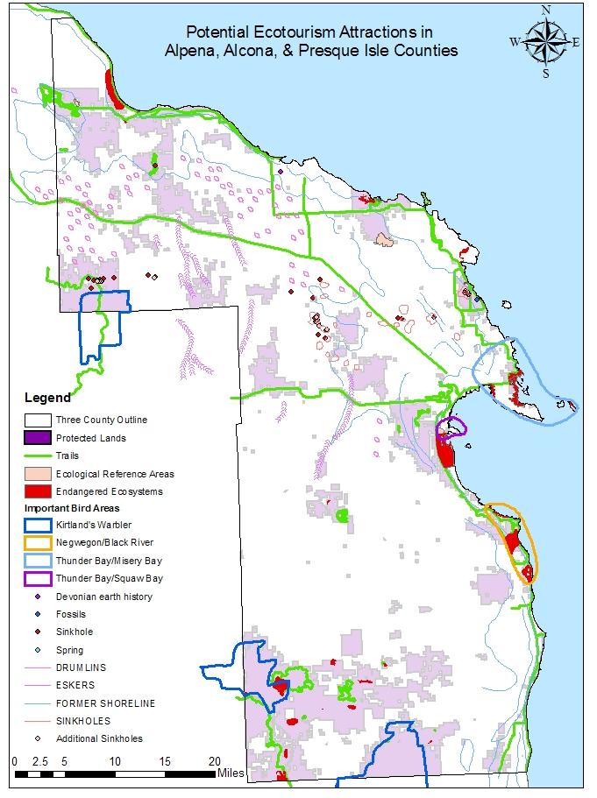
of the maps developed for this assessment to produce Figure 8, the natural features that may serve an economic role in addition to their current ecological role may be displayed.

What this map shows:

This map shows all the areas which may be used as ecotourism sites, based on the available GIS data. These potential sites include areas of high migratory bird concentrations, regions with endemic or endangered plants, animals, and ecosystems, as well as some of the geological features in the region that may be of interest, such as sinkholes and fossils. Also included are the protected lands, which offer a variety of opportunities for hiking, hunting, camping, and other outdoor activities.

What this map does not show:

This map does not highlight any areas along the shoreline with potential for ecotourism. While Lake Huron access certainly qualifies as an ecotourism possibility, it was not focused due to a lack of relevant environmental GIS data, and the difficulty of displaying the data available. However, some Lake Huron attractions are indirectly highlighted through the display of coastal protected areas, where camping and beach use are easily accessible. Figure 8 also does not show areas that are being used for their ecological value by private owners. Hunt clubs and private beaches for example, are not displayed on this map.

Potential map uses:

This map could be used to plan a regional ecotourism campaign, or to aid the development of brochures highlighting natural attractions. Envisioned uses are all focused on the idea of sightseeing and sustainable uses. Potential applications include the creation of a self-guided trail system to tour the region and creating guided tour packages to help support local business.

Potential map improvements:

A layer that shows game species habitat would be of use in this map since many hunters from outside the region come for the hunting seasons. Designating areas for game management purposes on a map like this would greatly increase the amount of land that would need protection from more extractive uses. It would also be useful to see where timber harvesting and mineral extraction activities are possible, so that any conflicts between extractive industries and sustainable use may be identified and avoided.

Figure 9 – human impact on rivers map:

Reaches of regional rivers that have been most affected by human activities were identified using information on the location of dams, areas listed as impaired under section 303d of the Clean Water Act, and road crossings. This was done to create a partial visualization of the human impact on regional rivers and to identify river systems that are potential conservation targets.

Purpose of this map:

The ecological team developed this map to show the reaches of rivers that are most affected by human activity and to show river systems that have escaped serious human induced changes. This map is meant to be a relatively crude indication of human impacts on rivers by identifying those locations in river systems where human effects are most noticeable.

Figure 9 – Map of selected human impacts on regional rivers:
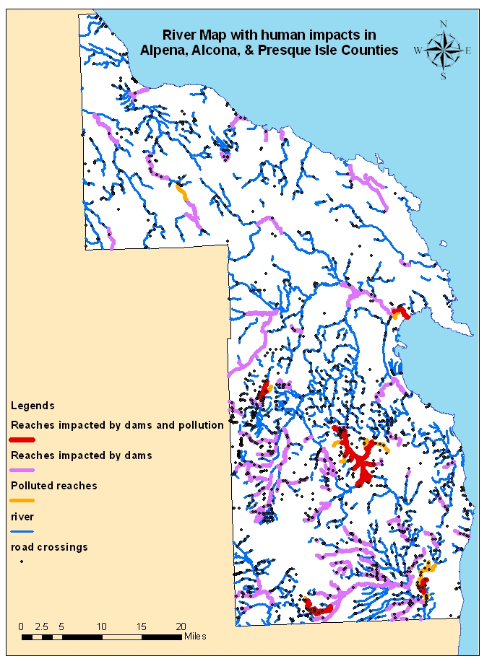

Layer development:

To identify river reaches with dams and areas listed as polluted according to the standards set forth under Section 303d of the Clean Water Act, the ecological team created additional fields in the attribute table of the layer depicting regional rivers. Much like the development of the opinion maps, these new fields show whether a feature is present or not. Those fields indicated the presence of the corresponding features in that section of river by the value of “1”, and indicated the absence by the value of “0.”
The extent of the “dam” and “303d” fields were determined by using the “select by location” tool of ArcGIS. Using the layer on dams provided by the Institute for Fisheries Research (IFR), reaches of rivers that were within half a mile of dams were identified and given the value of “1”, and the reaches themselves may extend beyond the half-mile buffer used to highlight these stretches of river. For the reaches of river that are listed as polluted under Section 303d of the Clean Water Act, data developed by the EPA were used, and a similar process was carried out. Since the EPA data were spatially accurate, no estimates of affected areas had to be performed by the ecological team. Finally, using the “select by attribute” tool, new layers were created that displayed the recently created fields. The new layers depicted river reaches within a half mile upstream or downstream of dams, reaches listed as polluted under Section “303d” of the Clean Water Act, and reaches where the fields intersect.

What this map shows:

This map depicts river reaches that are affected by dams, reaches that are listed as impaired waters under Section 303d of Clean Water Act, and reaches where these elements overlap. Road crossings are also displayed to indicate locations where flow modification or road run-off may pose a threat. Road crossings that are not located on a river indicate roads that pass over streams too small for this display. These crossings have been left in the display since their impact remains, even though the impacted stream is not shown.

What this map does not show:

This map does not accurately show the extent of the influence that dams may play in a river system. Each dam is assumed to have an effect one half mile upstream and downstream of its location, which is only an estimate on the part of the ecological team. The real impact may be much more or much less significant. Additionally, while the creation of these layers by their source agencies did include quantitative data, our analysis of these features did not make use of that data, and should not be considered quantitative analyses. This map is also limited by the availability of data, and therefore it will not show dams that were not listed by the IFR, or impaired river reaches not listed according to the regulations in Section 303d of the Clean Water Act.
This map does not display all bodies of water in the region. Lakes have been excluded since pollution or regime modifications for lakes could not be found for the region in a GIS format. Uncertainty about how to display potential effects of dams or pollution on lakes led to the ecological team’s decision to exclude them from Figure 9. Though the influence of dams on reaches one half mile upstream and one half mile downstream of each dam is displayed, the dams themselves are not a part of the map display. Also missing from this map are small streams. By not showing these features, the display is more clear and concise than if these features had been included.

Potential map uses:

This map may be used to aid policy formation and regional planning, to educate residents and decision-makers about freshwater resources in the region, and as a basis for more detailed study. Importantly, it may serve as a tool to protect river systems that have so far avoided being heavily impacted by human activity. These rivers would be the targets of conservation efforts to ensure they remain unimpaired.

Potential map improvements:

Some potential improvements to this map would include additional information about the size and influence of the dams on this map, and their impact on the hydrologic regime of the river and on aquatic species distributions. Further information on pollution that is not listed in Section 303d of the Clean Water Act such as dioxins, solid waste, or endocrine disruptors would also improve the utility of this map. Developing quantitative data about the impact of road crossings would also be extremely useful. To complement this map, a map showing the extent of development within each river’s floodplain would be useful in understanding the full impact of human activity on each river system.

Figure 10 – potential land uses map:

This map shows potential locations for a variety of designated land uses. The land use divisions displayed are based on the conceptual framework used by the American Institute of Architects (AIA) (AIA, 2007) as their proposal for regional land use.

Purpose of this map:

This map was developed in order to identify and display a variety of land use classifications, and to help formulate regional planning decisions by showing how sensitive area preservation and land uses such as forestry and farming can simultaneously occur in the region (AIA, 2005).

Layer development:
To create the coastal corridor displayed in Figure 10, the buffer tool from the ArcGIS tool box was used on the Lake Huron shoreline. This created a new layer that represented the entire region within five miles of the shoreline. This layer was then used to highlight the land in the region within five miles of the shoreline. A similar process was used to emphasize the land within half a mile of either side of the coastal highway, US23. To highlight the agricultural and forestry land uses, a slightly different process was used. For agricultural lands, the DNR 2001 Integrated Forest Monitoring Assessment and Prescription (IFMAP) land cover/land use map was utilized. Areas classified as non-vegetated farmlands, row crops, forage crops, non-tilled herbaceous, and orchards/vineyards/nursery were reclassified as agricultural lands. Forestry lands were developed from the same IFMAP layer and a set of maps depicting quarter-quarter sections where the Michigan DNR owned land. Once forested areas were identified in the IFMAP layer, regions that overlapped DNR owned areas were highlighted as being likely places for forestry activities to occur. The sensitive natural resources were identified using the “natural features map” that is discussed earlier in this report. Each
region identified as having a high concentration of agricultural activities, forestry
activities, or sensitive features were then used as a basis for creating a “shape” outline on
the map. The source layer was then removed, and the “shapes” remained.

Figure 10 – Map of potential regional land uses:
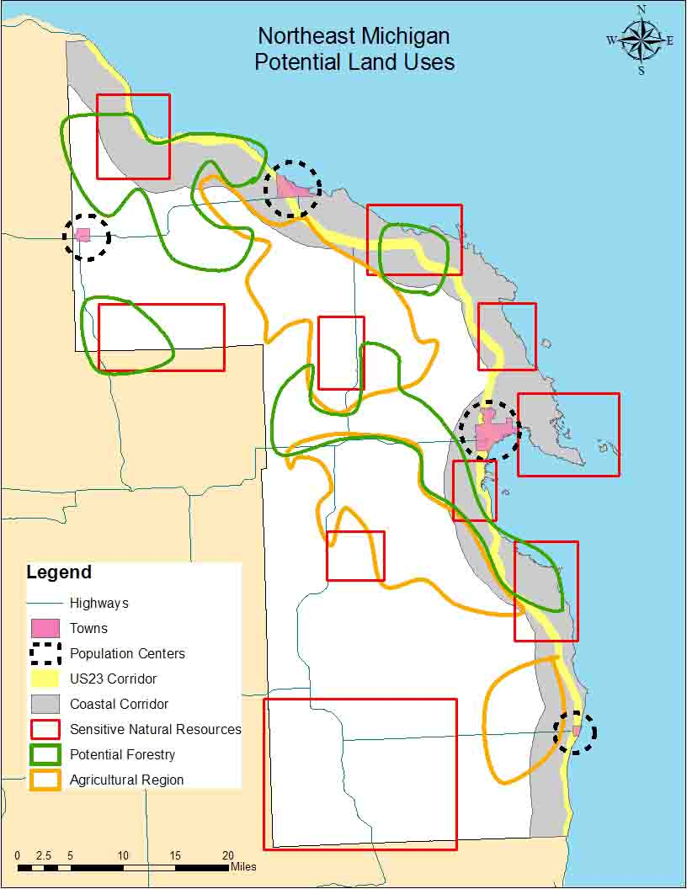
What this map shows:

The map shows the general location of areas where forestry, farming, and sensitive natural resource preservation could be concentrated. Also displayed are the towns, the coastal highway corridor, the inland highways, and a coastal corridor highlighting all the land within a few miles of the Lake Huron coast.

What this map does not show:

This map does not identify every sensitive resource or every potential use for the land. For the land uses identified, this map only shows areas where these land uses have the potential to be concentrated. Forestry and farming activities do occur outside the bounds of the highlighted areas, and are not displayed. Land that would be exceptionally suited for farming or forestry activities were not included due to the lack of time and resources necessary to identify such areas, and would greatly improve the usefulness of this map.

Potential map uses:
This map would find its greatest use in long-term planning efforts. By focusing particular land uses in the areas best suited for the each land use, the potential conflicts over the preservation of sensitive natural features could be greatly reduced. The coastal and highway corridors help to identify those areas likely to face the greatest development pressure over time, since they are the areas that are most easily accessible as well as closest to Lake Huron.

Potential map improvements:

This map can be greatly improved by creating an accurate data set of all forestry, mining, and agricultural lands that have been abandoned, are currently being used, or may be utilized in the near future. This would create a more complete and accurate picture of regional forestry activity, and indicate trends in the two land use forms. Additionally, depicting the extent of residential and/or commercial development, or development patterns would greatly aid long-term planning efforts.

Figure 11, 12, 13, and 14 - migratory bird model maps:

Using methodology developed by The Nature Conservancy (TNC) to model stopover sites for migratory birds in the western Lake Erie basin (Ewert et al. 2006), a set of migratory bird stopover site maps was developed for northeast Michigan. This was done to identify migratory bird “hot spots” both for consideration in conservation, and as potential ecotourism sites. Although the model was developed for the western Lake Erie basin, most of the priority species of concern were also found in northeast Michigan, and therefore it is assumed the model is also applicable there. These maps show areas that are most likely to be the stopover site for migratory birds; no ground truth study has been done to verify the model’s accuracy.

Purpose of these maps:

These maps were developed to identify likely locations of migratory bird stopover sites that would be a priority for conservation. They are also potential ecotourism attractions. This information will help decision-makers develop policy so that the natural resources identified in this map can be utilized or protected in a sustainable manner.
Figure 11 – Migratory Bird Model:
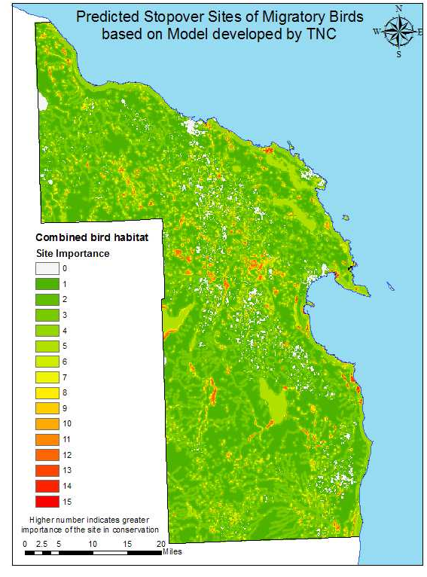
Figure 12 – Land bird Component of Migratory bird Model:
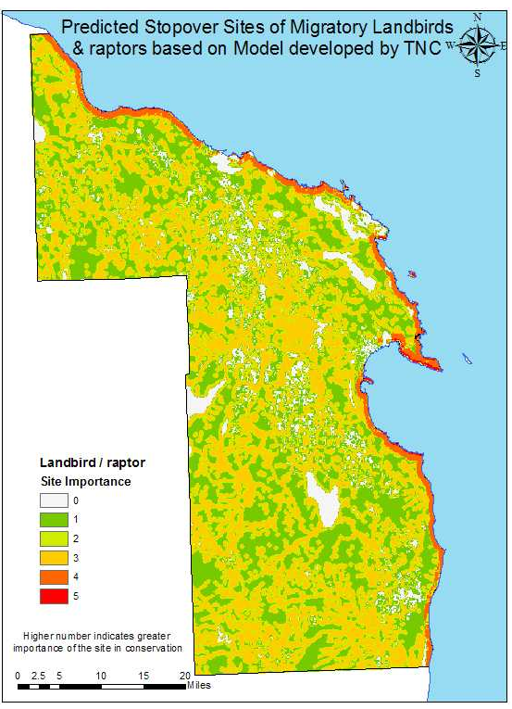

Figure 13 – Shorebird component of migratory bird model:
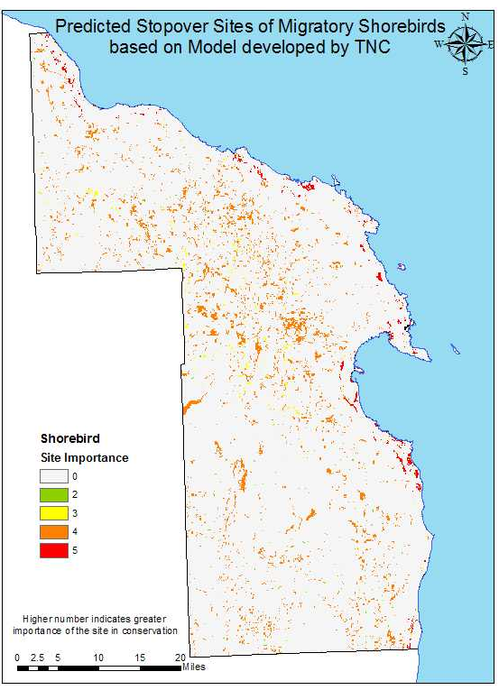

Figure 14 – Waterfowl component of migratory bird model:
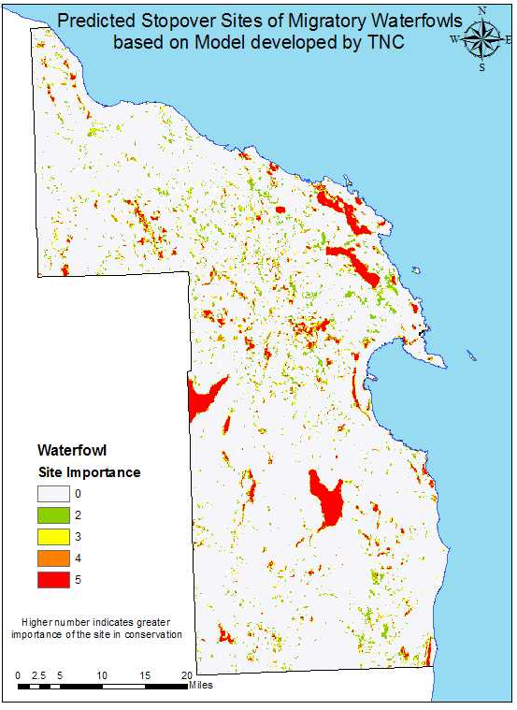

Layer development:

For this model, several map layers were used. These included the coastal change analysis program (CCAP) land cover map developed by the National Oceanic and Atmospheric Administration (NOAA), the NWI, a soil moisture index map developed by Ducks Unlimited, a Lake Huron layer, and regional lakes and rivers. From these layers, three maps of bird habitats were developed, each corresponding to the habitat for waterfowls, shorebirds, and land birds/raptors. Each of the three maps consists of several components, or attributes. Each attribute has a different score associated with its conservation importance. The scores range from “0” to “5”, where “0” represents non-habitat, and “5” represents critical habitat, as shown in Appendix C, and based on the original TNC methodology. After these attributes were developed, they were overlaid with each other, with higher scores taking priority in overlapping areas. This resulted in a set of maps displaying stop over site importance by bird type, and one map of combined stop over site importance. The details of the specific layers used in this model are shown in Appendix C. The preparation process that went into converting layers for use in this model in displayed in Appendix D.
What these maps shows:

These maps show areas that are likely to be stopover sites for migratory birds based on landscape attributes. The model was composed of three components, namely land bird/raptor habitat (Figure 12), shorebird habitat (Figure 13), and waterfowl habitat (Figure 14). Those areas that score higher in these maps are more likely to be the stopover sites for migratory birds.

What these maps do not show:

This map does not show whether or not birds will prefer one habitat patch to another, or how often patches are utilized, it only shows which areas are more likely to be utilized than others. The map is a prediction of potential bird presence based on a landcover map and related GIS layers. No ground-truthing has been done to verify the model outcome in this region, due to lack of time and resources. Nor does the map show the actual bird species composition of the region. Additionally, the model was developed for migratory bird species that TNC considers to be priority species, and therefore it is likely that the map does not cover habitats for every important species of bird.

Potential uses:
This map may be used to guide future studies of migratory bird habitats in the region, and it can also be used to provide guidance in land conservation, restoration, or ecotourism decisions.

Potential improvement:

This map would be greatly improved by the ground-truthing of the model predictions to verify the accuracy of the model.

Summary & Conclusion:
As part of the larger NEMIA process, this ecological assessment has gathered existing pertinent GIS data relating to the environment in Alpena, Alcona, and Presque Isle counties. Performing this task entailed contacting a variety of sources in local, state, and federal agencies to gather the necessary information. As information was collected, themes in the data were identified, and maps were created to illustrate these themes. Maps such as those depicting human infrastructure (Figure 1), natural features (Figure 2), or geological features (Figure 7) were developed using existing layers, while the opinion maps used layers developed specifically for this effort. For the development of the opinion maps (Figures 4 and 5), regional decision makers and University of Michigan ecologists completed surveys prioritizing natural features in the region (Appendix A). Survey results were then used to determine the relative weights of the endangered species, interior forest, pre-settlement landcover, and wetland layers displayed in Figures 2 and 3 to produce Figures 4 and 5. These maps highlight areas the surveyed groups of regional decision makers and ecologists agreed were the most ecologically important. Additionally, a poster was produced for the working group meeting in January of 2007. This poster (Appendix C) was developed using locations with similarly high scores from the two opinion maps (Figures 4 and 5), and the previously mentioned layers from the natural features map (Figure 2). The poster highlights the regional areas of interest and displays the natural features as well as human land uses and infrastructure to illustrate the layout of the region (Ceccato, 2007).
This assessment is intended to inform the policy making process in this region of northeast Michigan. It is a difficult task to properly develop policy, improve the regional economic outlook and maintain the quality of life while conserving the natural features that make the region so attractive. The environment cannot be considered separately from the forces that are acting on it, and neither can its management. To best manage natural resources in the area, decision makers must consider human infrastructure, public opinion, local geology, and the potential economic value of ecological services. Not considering these factors would be ignoring major influences on local ecology.
Managing the environment is a complex and difficult task, and those responsible for management decisions need to know as much as possible about the environment in the region before making their decisions. This ecological assessment maps some of the many factors that should influence regional decisions. By using the information in these maps, decision makers can be better informed about the status of the region’s environment. Though this information will ensure that management decisions regarding the environment are better informed, it does not mean that all necessary information for decision making is contained within this document. There are some regional features of the environment that have not been fully documented with GPS technology, and many that have not been documented at all. Future work should focus on the features that this document lists as either missing or incomplete to further inform management decisions in the region.
Though these maps have all been created according to display different features, all of these features are important parts of the region’s natural environment, and this assessment was carried out in an attempt to document the current state of the natural world in the region. Without this work, data on the region would have been scattered among a variety of sources, and none would have a clear picture of the state of the region’s natural features. By developing these maps, the ecological team can show what ecological features have been documented and how accessible or inaccessible these features are. The development of these maps also gives decision makers access to the most complete visual representation of the natural features in the region available at this time. In doing this, this assessment removes some of the uncertainty of managing the natural features in this portion of northeastern Michigan. Additionally, this ecological assessment will be incorporated into the final NEMIA document so as to ensure that regional decision makers can access this information in concert with a more complete knowledge of the regions economy, cultural resources, and planning and zoning practices.
Though the product developed through this assessment was a set of maps developed through GIS software, each map represents more than simple spatial information. The maps developed though this process can also be seen as representations of how people relate to the environment. Figures 1, 4, 5, 9, and 10 all display particular aspects of how people influence the natural world as well as how much they care about certain parts of it. By showing where people have farmed, polluted, built roads, and established ecological refuges, as well as how certain groups feel about the regional environment, someone looking through these maps can get a good idea of how the local population has interpreted, valued, and related to the local environment up to this point. With this information in hand, decision makers will be able to decide if this is the type of relationship that they want to maintain with the environment, or whether it is time to re-evaluate the current relationship.

Bibliography:
[AIA] American Institute of Architects. 2004. Best Practices. Innovations in Zoning

[AIA] American Institute of Architects. 2007. Sustainable Design Assessment Team (SDAT) program. AIA Communities by Design

Balram S., S. Dragicevic, and T. Meredith. 2003. A collaborative GIS method for integrating local and technical knowledge in establishing biodiversity conservation priorities. Biodiversity and Conservation 13: 1195–1208

Ceccato V. A., and F. Snickars. 2000. Adapting GIS technology to the needs of local planning. Environment and Planning B: Planning and Design 27: 923-937

[CENR] Committee on Environment and Natural Resources. 2000. Integrated Assessment of Hypoxia in the Northern Gulf of Mexico. National Science and Technology Council. Washington, DC.

Clevenger, Anthony P., J. Wierzchowski, B. Chruszcz, and K.Gunsuns. 2002. GIS-Generated, Expert-Based Models for Identifying Wildlife Habitat Linkages and Planning Mitigation Passages. Conservation Biology 16: 503-514

Ewert, D.N., G.J. Soulliere, R.D. Macleod, M.C. Shieldcastle, P.G. Rodewald, E. Fujimura, J. Shieldcastle, and R.J. Gates. 2005. Migratory bird stopover site attributes in the western Lake Erie basin. Final report to The George Gund Foundation.

Geertman S. 2001. Participatory planning and GIS: a PSS to bridge the gap. Environment and Planning B: Planning and Design 29: 21-35

Hansen H. S. 2004. Public participation GIS: an important tool in environmental planning. Chapter 11 GIS and Public Participation – Part I. pg. 27-38

Hawthorne T. L. 2005. Participatory GIS for Growth Management in the Cheat Lake Planning District of Monongalia County, West Virginia. Thesis submitted to the
Eberly College of Arts and Sciences at West Virginia University in partial fulfillment of the requirements for the degree of Master of Arts in Geography. 64 pages

Kyem, P. A. K. 2004. Of Intractable Conflicts and Participatory GIS Applications: The Search for Consensus amidst Competing Claims and Institutional Demands. Annals of the Association of American Geographers 94: 37-57

[MSG] Michigan Sea grant. 2005. Causes and Consequences of Environmental Change: Fact sheet

[MSG] Michigan Sea Grant. 2006. Visioning a Sustainable Future for Northeast Michigan

[NAST] National Assessment Synthesis Team. 2001. Climate Change Impacts on the United States: the Potential consequences of Climate Variability and Change

Pearce J. L., K. Cherry, M. Drielsma, S. Ferrier and G. Whish. 2001. Incorporating expert opinion and fine-scale vegetation mapping into statistical models of faunal distribution. Journal of Applied Ecology 38: 412-424

Thériault M., J. Rouffignat, R. Landry, P. Levallois, C. Chiasson, S. Tessier, M. Girard and C. Prévil. 1999. Combining opinion survey, GIS and spatial statistics to model perceptions of ground water pollution caused by agriculture: application to the county of portneuf, Canada. Proceedings of the 2nd Inter-Regional Conference on Environment-Water, September 1-3

Thériault M. 2002. Modelling People’s Perceptions of Environmental Issues Within GIS
A Case Study Using Opinion Polls in the County of Portneuf, Canada. 5th AGILE Conference on Geographic Information Science, Palma (Balearic Islands, Spain) April 25th-27th

U.S. Census Bureau. 2007. State and County quick facts http://quickfacts.census.gov/qfd/news.html (accessed 3/15/07)

Appendix A – Ecological features survey:
Opinion Survey:
The opinion survey was conducted at the August 2006 meeting of the NEMIA working group, and the beginning of the fall 2006 semester at the University of Michigan’s School of Natural resources and Environment (SNRE). At the working group meeting, each member of the working group was given three colored stickers, told what vote each color represented, and directed to place their votes on a large chart at the front of the room. For the survey of ecologists in SNRE, the request was phrased in the same terms as it had been presented to the working group. This request was distributed by email, and responses were collected in the same manner. The survey used at the working group meeting and distributed to the SNRE ecologists is displayed below.

Survey:
As part of our master’s practicum involving the Northeast Michigan Integrated assessment under the guidance of Don Scavia and Jen Read, we have been collecting GIS layers for important land based ecological features. At our most recent meeting with local stakeholders, we put the features we had already collected up for the community to rank in terms of importance, with the goal of showing them ecologically important areas that were not simply important, but that they knew were important. The goal was to try to help the local residents and their representatives feel that they have a place in the ecological decision making. Now, I would like to ask you to rank the same things. The goal of this is to be able to draw parallels between public opinion and expert opinion.

I would ask you to rank these six ecological features in terms of ecological importance, based on your professional opinion. The six layers are:

- Endangered animals – as defined by the Michigan Natural Features Inventory
- Endangered plants - as defined by the Michigan Natural Features Inventory
- Endangered communities/ecosystems - as defined by the Michigan Natural Features Inventory
- Wetlands – as defined by the USFWS and their National Wetlands Inventory
- Pre-settlement landcover – an analysis done by the Nature Conservancy using DNR models of circa 1800 land cover patterns
- Large forest interiors – as defined by the USGS, on the scale of 1000 square meter parcels

I would like you to rank the 6 layers by giving out two votes each of High importance (H), medium importance (M), and low importance (L) in the spaces below:

Animals:
Plants:
Ecosystems:
Wetlands:
Old growth:
Forests:

Appendix B – Sources for all GIS layers used in the ecological assessment:
This appendix lists all of the sources for the layers used in all of the maps created for this assessment. Layers and sources are given according to the map they were used in, and maps are listed in order of appearance in the text. For each map, the feature that the layer displays is given followed by the source for the layer and when the data was acquired from the source. In cases when the layer displayed was a composite of multiple layers from the same source, all source layers are grouped together as one common source. In cases where the layer displayed was extracted from a larger layer, the larger source layer is listed. If the layer used was created by one agency and obtained from another, only the source agency is listed. For Figure 4, 5, and 10 the layers used to produce the display are listed as well as the layers that are actually depicted on the map. The URL’s for our two online sources, the Michigan Online Geographic Data Library (MiGDL), and the United States Geological Survey (USGS) are also listed at the end of this section.

Common layers for all maps:
- Lake Huron: Institute for Fisheries Research (IFR). July 2006
- Three county outline: Created from the Michigan Geographic Framework for Alcona County, Alpena County, & Presque Isle County, MiGDL. May, 2006

Figure 1 – Infrastructure map:
- Railroads: Created from the Michigan Geographic Framework for Alcona County, Alpena County, & Presque Isle County, MiGDL. May, 2006
- Utlities: Created from the Michigan Geographic Framework for Alcona County, Alpena County, & Presque Isle County, MiGDL. May, 2006
- Roads: Created from the Michigan Geographic Framework for Alcona County, Alpena County, & Presque Isle County, MiGDL. May, 2006
- Highways: Created from the Michigan Geographic Framework for Alcona County, Alpena County, & Presque Isle County, MiGDL. May, 2006
- Trails: Northeast Michigan Council of Governments (NEMCOG). October, 2006
- State Parks: Protected lands layer, Ducks Unlimited (DU). June, 2006
- Rockport: Protected lands layer, Ducks Unlimited (DU). June, 2006

Figures 2 - Ecological Features map:
- Endangered ecosystems: Michigan Natural Features Inventory (MNFI). May, 2006
- Endangered plants: MNFI. May, 2006
- Endangered animals: MNFI. May, 2006
- Groundwater dependant ecosystems: MNFI. May, 2006
- Pre-settlement land cover: Land cover change map, The Nature Conservancy (TNC). June 2006
- Wetlands: National Wetlands Inventroy (NWI), MiGDL. May, 2006
- Protected lands: DU. June, 2006
- Interior forests: USGS. June, 2006
- Trails: NEMCOG. October, 2006
- Unweighted overlay: created from overaly of endangered ecosystems, endangered plants, endangered animals, pre-settlement land cover, wetlands, and interior forest

Figures 3 - Ecological Features map:
- Trails: NEMCOG. October, 2006
- Unweighted overlay: created from overaly of endangered ecosystems, endangered plants, endangered animals, pre-settlement land cover, wetlands, and interior forest
- Protected lands: DU. June, 2006

Figures 4 – Opinion map (expert):
- Endangered ecosystems: MNFI. May, 2006
- Endangered plants: MNFI. May, 2006
- Endangered animals: MNFI. May, 2006
- Interior forests: USGS. June 2006
- Pre-settlement land cover: extracted from land cover change map, TNC. June 2006
- Wetlands: NWI, MiGDL. May, 2006
- Expert opinion display layer: created from weighted versions of the above layers based on the surveys results listed in Table 1. August, 2006

Figures 5 – Opinion map (local):
- Endangered ecosystems: MNFI. May, 2006
- Endangered plants: MNFI. May, 2006
- Endangered animals: MNFI. May, 2006
- Interior forests: USGS summer 2006
- Pre-settlement land cover: extracted from land cover change map, TNC. June 2006
- Wetlands: NWI, MiGDL. May, 2006
- Local opinion display layer: created from weighted versions of the above layers based on the surveys results listed in Table 1. August, 2006

Figure 7 - Geological Features map:
- Sinkholes: NEMCOG. October, 2006
- Geological Features: MNFI. May, 2006
- Groundwater dependant ecosystems: MNFI. May, 2006
- Quaternary geology: MiGDL. July, 2006

Figure 8 – Ecotourism map:
- Protected lands: DU. June, 2006
- Trails: NEMCOG. October, 2006
- Ecological reference area: MNFI. September, 2006
- Endangered ecosystems: MNFI. May, 2006
- TNC migratory bird stopover sites: TNC. September, 2006
- Sinkholes: NEMCOG. October, 2006
- Geological Features: MNFI. May, 2006
- Quaternary geology: MiGDL. July, 2006

Figure 9 – Rivers map:
- River: IFR. July, 2006
- Dams: IFR. July, 2006
- 303d impaired water: IFR. July, 2006
- Road crossings: IFR. July, 2006
- Polluted reaches: Created from river and 303d impaired water layers, IFR. August, 2006
- Reaches with dams: Created from river and dams, IFR. August, 2006
- Polluted reaches with dams: Created from river, dams, and 303d impaired water, IFR. August, 2006

Figure 10 - Potential land uses map:
- US23: Created from the Michigan Geographic Framework for Alcona County, Alpena County, & Presque Isle County, MiGDL. May, 2006
- Highway: Created from the Michigan Geographic Framework for Alcona County, Alpena County, & Presque Isle County, MiGDL. May, 2006
- IFMAP: MNFI. May, 2006
- Quarter-quarter sections of DNR land ownership: MiGDL. June, 2006
- Interior forests: United States Geological Survey (USGS). June, 2006
- Pre-settlement land cover: Land cover change map, The Nature Conservancy (TNC). June 2006
- Wetlands: National Wetlands Inventroy (NWI), MiGDL. May, 2006
- Endangered ecosystems: Michigan Natural Features Inventory (MNFI). May, 2006
- Endangered plants: MNFI. May, 2006
- Endangered animals: MNFI. May, 2006
- US23 Corridor: Developed using the US23 layer, MiGDL. May, 2006
- Coastal Corridor: Developed using the Lake Huron layer, IFR. July, 2006

Figures 11, 12, 13, and 14 - Bird model:
- coastal change analysis program (CCAP) landcover (2000): IFR. July, 2006
- NWI: MiGDL May, 2006
- Soil moisture index (SMI): DU. August, 2006
- Inland lakes: IFR
- River: Great Lakes GIS Project, IFR
- Undeveloped land: extracted from CCAP 2000
- Agricultural land: extracted from CCAP 2000
- Hydric soil: extracted from SMI
- Agricultural hydric soil: overlay of agricultural land and hydric soil
- Emergent wetland: extracted from NWI
- Emergent wetland complex: extracted from emergent wetland
- Waterfowl attribute 1, 2, 3, 5, 6, 7, 8: adopted from TNC model
- Shorebird attributes 1~6: created from TNC model
- Land bird/raptor attributes 1, 2, 3, 4, 6: adopted from TNC model
- Migratory bird stopover sites: Overlay of waterfowl, shorebird, and land bird/raptor attributes.

Web Links:
United States Geological Survey (USGS): (http://nationalatlas.gov/)
Michigan Online Geographic Data Library (MiGDL): (http://www.mcgi.state.mi.us/mgdl/)

Appendix C – Poster of ecological areas of concern, based on Figures 4 and 5:
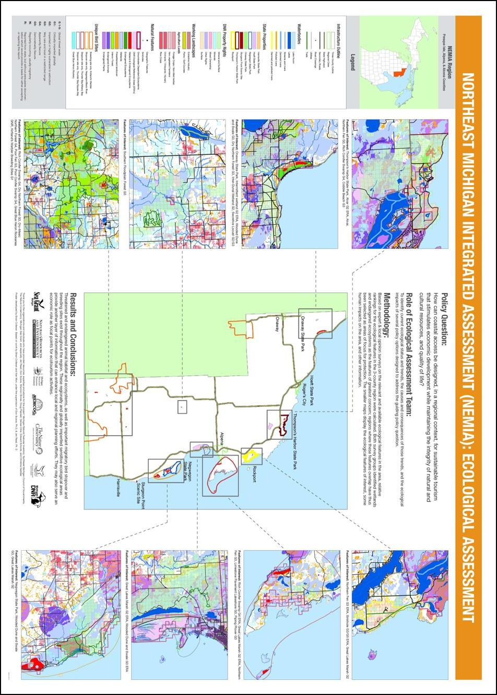
Appendix D - Preparatory layer development for Figures 11, 12, 13, and 14:

All models:
Layer name | Source layers | Method of layer development
Undeveloped land | Coastal change analysis program (CCAP) land cover | The CCAP classifications of “grassland”, “forests”, “scrub/shrub”, “wetlands”, and “unconsolidated shore” were reclassified as “undeveloped land”.
Agricultural land | CCAP land cover | The CCAP classifications of “cultivated lands” were reclassified as “agricultural land”.
Hydric soil | Soil Moisture Index (SMI) | Areas classified as “very wet” or “wet” were reclassified as “hydric”.
Agricultural hydric soil | Agricultural land  Hydric soil | Agricultural lands were clipped with the hydric soil layer to extract areas that were both agricultural land and had hydric soil.
Emergent wetlands | NWI | Areas that were classified as “emergent” or “scrub-shrub” according to NWI were turned into a new layer called “emergent wetlands”.
Emergent wetland complex | Emergent wetlands | The emergent wetlands layer was buffered by 0.125 kilometers and an “identify overlapping polygon” script was used to select wetlands that were within 0.25 kilometers of each other. The selected wetlands were turned into a new layer called “emergent wetland complex”.

Waterfowl:
Attribute number | Conservation  importance | Layers used | Method of layer development
1 | 5 | Emergent wetland  Inland lakes | Emergent wetlands larger than 16 hectares were selected. From that group, those that were adjacent to a body of open water larger than one hectare were selected. Wetlands selected from that group were turned into a new layer and were given the score of 5.
2 | 5 | Emergent wetland  Inland lakes | Initially, emergent wetlands and water bodies larger than one hectare were selected. For this group, those that were within 120 meters of another emergent wetland larger than one hectare were selected. The selected wetlands and lakes were turned into a new layer and were given the score of 5.
3 | 4 | Emergent wetland | Any emergent wetlands with areas larger than 1 hectare were selected and turned into a new layer. They were given the score of 4.
4 | 4 | n/a | Use expert knowledge to identify known Diving Duck concentration areas. Due to lack of time and resources this attribute was not included in our analysis.
5 | 3 | Agricultural hydric soils  Lake Huron | Any agricultural fields with hydric soil areas larger than 5 hectares were selected. Those within 24 km of Lake Huron were selected. These areas were then turned into a new layer and were given the score of 3.
6 | 3 | Agricultural hydric soil  Lake Huron  Inland lakes | Any agricultural fields with hydric soils larger than 5 hectares were selected. Within that selection those that were within 1.6 kilometers from an inland lake were selected, and those that overlapped with attribute 5 were removed. These were made into a new layer and given the score of 3.
7 | 2 | Agricultural hydric soil  Lake Huron | Any agricultural fields with hydric soil areas larger than 5 hectares that were not in attribute 5 or 6 were selected. These were turned into a new layer and were given the score of 2.
8 | 2 | NWI | NWI classification of forested class and broad-leaved deciduous wetlands were selected, and areas larger than 1 hectare were selected. These were turned into new layer and were given the score of 2.
Shorebird:
Attribute number | Conservation  importance | Layers used | Method of layer development
1 | 5 | Emergent wetland  Emergent wetland complex  Lake Huron | Emergent wetland complexes were combined with single emergent wetlands larger than 10 hectares. Those that were within 3.2 km of the Lake Huron coastline were selected. These were turned into a new layer and were given the score of 5.
2 | 4 | Emergent wetland  Emergent wetland complex  Lake Huron | Emergent wetland complexes were combined with single emergent wetlands with areas larger than 10 hectares. Those that overlapped with attribute 1 were removed. The remaining wetlands were turned into a new layer and were given the score of 4.
3 | 4 | Hydric soil  Lake Huron | Hydric soil areas within 16 km of the Lake Huron coastline were selected. These were turned into a new layer and were given the score of 4.
4 | 3 | Hydolic soil  Lake Huron | Hydric soil areas that were not selected as attribute 3 were selected. They were turned into a new layer and were given the score of 3.
5 | 3 | Emergent wetlands  Lake Huron | Emergent wetlands smaller than 10 hectares were selected. Those within 3.2 km of the Lake Huron coastline were selected. The selected wetlands were turned into a new layer and were given the score of 3.
6 | 2 | Emergent wetlands  Lake Huron | Emergent wetlands smaller than 10 hectares were selected. Those that were selected as attribute 5 were removed. The remaining wetlands were turned into a new layer and were given the score of 2.

Landbird/Raptor:
Attribute number | Conservation  importance | Layers used | Method of layer development
1 | 5 | Undeveloped land  Lake Huron | Undeveloped lands within 0.4 km of Lake Huron were extracted. These undeveloped lands were given the score of 5.
2 | 4 | Undeveloped land  Lake Huron | Undeveloped lands within 1.6 km of Lake Huron were extracted. Areas that overlapped with attribute 1 were removed. The remaining undeveloped lands were given the score of 4.
3 | 3 | Undeveloped land  Rivers  Inland lakes  Emergent wetlands | Undeveloped lands within 200 meters of rivers, lakes, or wetlands were selected. Areas that overlapped any of the above attributes were removed. The remaining undeveloped lands were given the score of 3.
4 | 2 | Undeveloped land  Rivers  Inland lakes  Emergent wetlands | Undeveloped lands within 400 meters of rivers, lakes, or wetlands were selected. Areas that overlapped any of the above attributes were removed. The remaining undeveloped lands were given the score of 2.
5 | 2 | Undeveloped land | Undeveloped lands were buffered by 2 kilometers to identify any undeveloped lands that were isolated by 4 kilometers. No such areas were found.
6 | 1 | Undeveloped land | Undeveloped lands that did not fit into any of the above classifications were turned into a new layer. They were given the score of 1.

Appendix E – Certainty Assessment:

There is a variety of information missing from these maps that would have been very useful for this assessment had it existed in a GIS format at the time this assessment was completed. What follows is a list of features that are not in the maps developed during this process, and that should be for a full assessment to be completed. Additionally, many of the missing layers could be classified into new theme groups, and used to develop additional maps. This too is a project that would greatly enhance the usefulness of this report.
While the sources of data were all reliable, some of the information used in this report does have a certain degree of built in uncertainty. The MNFI for instance, uses historical records as one of its sources, and allows each accepted historical record a certain uncertainty range. This range is displayed in the data as being an area where a species may occur. It does not however guarantee that the species will be currently present. Due to the transient nature of many organisms, the MNFI as a whole does have a certain degree of uncertainty. It is best to view the information as showing regions of high potential, rather than of actual occurrence. Though the layers used were the most up to date available, due to a lack of meta data entry by the source organizations, it is unknown how current the information displayed is, since none of the information was “ground-truthed”. The exception to this is the MNFI, which is updated on a yearly basis.

Missing layers:
Layers that could designate the extent of residential development, the existence of brownfields, and any other intense land uses that are not mining, forestry, or farming would be extremely useful in evaluating regional landuse. Complete surveys of mining, forestry, and farming should also be completed, and should be developed to show past activity, current land used for these activities, and what future land use scenarios may look like. A layer that shows all potential construction projects in the region would also be of great use for this assessment. Distinguishing which projects are at different stages in the permitting process would also be a very helpful aspect of a layer showing pending construction projects. Additional information about the size and influence of the dams and their impact on the hydrologic regime of the river and aquatic species is needed. Further information on pollution that is not listed in Section 303d of the Clean Water Act would also improve this assessment. Developing quantitative data about the impact of road crossings would also be extremely useful.
A layer that shows game species habitats, ranges, and populations would be of use since many hunters from outside the region come for the hunting seasons. Species information for common species should be developed, for both species ranges and population estimates to better understand potential species interactions. Layers depicting migratory species patterns, ranges, and times of year these species pass through this portion of Michigan should be developed.
Of special note is the lack of agreement in the karst information – three separate sources were required to display all karst features in the region. While multiple layers agree on the location of some features, all layers have sinkhole regions that the other does not, and this inconsistency should be accounted for in future geological surveys.
A more in-depth survey of regional decision makers should be undertaken to accurately reflect sentiment about the region. Additionally, a survey of residents should be carried out to further improve the understanding of how people feel about the environment in the region. The possibility that regional decision makers and residents have different feelings about different areas should be explored, and a map displaying residents’ feelings would be a strong addition to this assessment. The survey methodology could also be improved to better reflect feelings about various places and regions in the area.

Further maps to develop:
A map showing the extent of development within each river’s floodplain would be very useful in understanding the full impact of human activity on each river system. Other map themes worth developing include ones displaying terrestrial invasive species, pests and disease ranges, and a full suite of maps to complement this assessment for Lake Huron and the inland waters in the region.

Summary of potential data problems:
Unknowns:
- How old the data are. Most of our data had a statement on date of collection for information, but many did not. Because we did not collect this data, the ecological team can not verify how up to date this information is
- The positional accuracy of the information when it was gathered
- What information was not included in the attribute tables
- Data collection methodology

Summary of specific layer accuracy issues:

MNFI:
- Some of the information is historically based, and may lack spatial accuracy.
- Some of the endangered species have not been observed for many years.
- The lack of accuracy in the historical data led to widening of the habitat area to cover for the lack of accuracy.
- Most private lands were not surveyed.

USGS interior forest:
- Very large resolution. 1 km x 1 km, as opposed to 30 meter x 30 meter for most land cover maps
- 2002 data

Potential errors in our own analysis:

Methodology
- What the maps do not show
  - Lack of data makes our analysis less robust
- Potential errors with opinion maps
  - Participant bias
  - How we presented the question in the survey may have influenced participant responses

- The river map
  - The dams may not be actually in the river because half a mile radius was used to intersect the dams with rivers
  - The influence of dams may be more or less than the assumed influence on the system both half a mile upstream and downstream. This was done because the dam layer was not perfectly aligned with our rivers layer, possibly due to an error in the layer itself
  - The reaches highlighted may be further than a half mile away from the dam, depending on the length of the highlighted reach.

- Potential errors with bird model map
  - The model was originally developed for the western Lake Erie basin, not the northeastern coast of Lake Huron.
  - There are other important species in northeast Michigan such as the Kirtland Warbler that are not present in Western Lake Erie region, and were not part of this model.

- Potential errors with the envisioned land use map
  - Selecting out agricultural lands from land cover / land use map may have been too general.
  - No data on current forestry were used.
  - Does not show potential agricultural lands.
  - Other types of working landscapes are missing such as mining and fishing

