US electricity emission scenarios

# Version control

|  |  |  |  |  |
| --- | --- | --- | --- | --- |
| Version | Date | Authors | Pages | Description |
| V1 | 1/15/2024 | Yongxian Zhu | 1-5 | Original document for calculating future US electricity emissions factors based on GREET 2023 and AEO 2023. |
|  |  |  |  |  |
|  |  |  |  |  |
|  |  |  |  |  |

# Purpose of the document

The purpose of this document is to summarize the necessary data source and methods to project future US electricity emission factors (MJ primary energy or gCO2/kWh electricity delivered) under various scenarios.

*Table: 2022 electricity emission factors from GREET using EIA AEO US electricity mix (converted to SI units) based on GREET 2023 with corrected nuclear*

|  |  |
| --- | --- |
|  | Quantity |
| Total energy (MJ/kWh electricity delivered) | 8.81 |
| GHGs (gCO2eq/kWh electricity delivered) | 439.50 |

# Data and method

1. Electricity mix: how much electricity generation is from each type of power plant.
   1. **EIA Annual Energy Outlook (AEO) Table 8**
      1. <https://www.eia.gov/outlooks/aeo/data/browser/#/?id=8-AEO2023&cases=ref2023&sourcekey=0>
      2. AEO offers different electricity generation scenarios.
         1. Reference: the baseline scenario which includes the impact of IRA similar to the IRA low Uptake in AEO 2023.
         2. IRA scenario: AEO 2023 defined 3 scenarios of IRA
            1. No IRA
            2. High uptake case
            3. Low uptake case
      3. In addition to the average US mix, AEO also has a breakdown by electricity market module regions.

* 1. Need to sum the (Electric Power Sector Power Only) and (Combined Heat and Power Generation) entries to get the (total electricity generation).
  2. Divide each type of electricity generated (e.g., electricity generated from natural gas from Power Only and Combined Heat and Power Generation) by the (total electricity generation) to get the **electric generation mixes**.
  3. **EIA Annual Energy Outlook (AEO) Table 56 Renewable Energy Generation by Fuel**
     1. Get the renewable generation mix (this is what GREET uses. **Q: how is this calculated?**)
  4. The resulting **electric generation mixes** are in the same format of **GREET1 Electric Table 10.2.b) Electric Generation Mixes: Data Table for Use in GREET (From Annual Energy Outlook 2022)** and **10.2.d) Shares of Technologies for Other Power Plants: Data Table for Use in GREET (From Annual Energy Outlook 2023)**
  5. Why not use EIA AEO 2023 emission data directly?
     1. Emissions are CO2 not CO2eq, need to include impact of other GHGs.
     2. Combustion emissions only, not including feedstock (upstream) emissions.
  6. Example Electric Generation Mixes from AEO 2022
  7. For the NREL: Examining Supply-Side Options to Achieve 100% Clean Electricity by 2035 (high decarbonization) scenario, use table

*Table: GREET1 10.2.b) Electric Generation Mixes: Data Table for Use in GREET (From Annual Energy Outlook 2023)*

|  |  |  |
| --- | --- | --- |
|  | U.S. Mix | |
|  | Transportation | Stationary |
| Residual oil | 0.3% | 0.3% |
| Natural gas | 36.5% | 36.5% |
| Coal | 23.8% | 23.8% |
| Nuclear power | 19.6% | 19.6% |
| Biomass | 0.3% | 0.3% |
| Others | 19.5% | 19.5% |

1. Electricity generation emission factors by fuel type
   1. GREET1 Electric tab
   2. GREET models combustion emissions during electricity generation using EPA data (likely EPA eGRID)
      1. They call it fuel emission.
   3. GREET models fuel production emissions using its own data.
      1. They call it feedstock emission.
   4. Notes:
      1. GREET1_2022 assumes that there is no efficiency loss when converting primary energy from U-235 to electricity in Nuclear power plant.
         1. To correct for this, edit cell “B141” in GREET1_2022.xlsx “Electric” tab by a factor of 3.11 MJ primary energy per MJ nuclear electricity generated.
         2. According to the supporting information of *Kasliwal, A., Furbush, N.J., Gawron, J.H., McBride, J.R., Wallington, T.J., De Kleine, R.D., Kim, H.C. and Keoleian, G.A., 2019. Role of flying cars in sustainable mobility. Nature communications, 10(1), p.1555.*
            1. 100% does not fully account for the power-plant losses for nuclear-generated electricity
            2. To incorporate full impacts, we use the NREL U.S. LCI database.
            3. A factor of **3.11 MJ primary energy per MJ (which is equivalent to 32.2%)** of nuclear electricity is applied to the nuclear contribution.
      2. Nothing else needs to be changed on the “Electric” tabl.
         1. There may be more than one type of power plants that use the same fuel. E.g., both boiler and IGCC coal-fired power plants use coal as the fuel. GREET already defines the breakdown between power plants using the same fuel.
2. GREET1 Electric Transmission and Distribution Loss = 4.9%
3. Steps to use **GREET1** to automatically calculate future electricity emissions factors for average US mix or by different region.
   1. Calculate electricity generation mix according to “1. Electricity mix: how much electricity generation is from each type of power plants” above.
   2. On GREET1_2022 “Fuel_Prod_TS” tab, update cell C972 to P993 with calculated electricity generation mix.
   3. On GREET1_2022 “Electric” tab, increase cell “B141” by a factor of 3.11 MJ primary energy per MJ nuclear electricity generated.
   4. Find electricity emission mix results on GREET1_2022 “Results” tab Cell AN14 to AN40.
      1. To get separated feedstock and fuel cycle emissions, go to GREET1_2022 “Electric” tab Cell B204 to C222.
   5. Convert from English unit to SI unit.
   6. Repeat step b to e for all electricity mix calculated.

# Appendix A: Equations of GREET electricity emission factor calculation (derived by Yongxian)

According to the formula in GREET, Yongxian derived the primary energy and GHG emission calculations used in the GREET model.

## GHG factor:

For each 1 mmBTU of electricity generated:

$$Emission Factor_{CO_{2} fuel cycle }=\sum_{ }^{For each type of Power Plant}{}\left(\frac{1 }{(1-loss\%)}⋅ratio_{Power Plant}⋅Emission Factor_{Power Plant EPA}\right)$$

$$Emission Factor_{feedstock CO_{2}}=\sum_{ }^{For each type of Power Plant}{}\left(\frac{ratio_{Power Plant}}{(1-loss\%)⋅Power Plant Conversion Efficiency}⋅Emission Factor_{Power Plant}\right)$$

Similarly for all other emissions including CH4, N2O, CO, VOC

$$Emission Factor_{GHG in CO_{2eq}}=\sum_{ }^{For each GHG gas}{}\left(Emission Factor_{GHG gas}⋅GWP\right)$$

$${CO2}_{from VOC or CO}=\frac{Carbon ratio_{VOC or CO}}{Carbon ratio_{CO_{2}}}$$

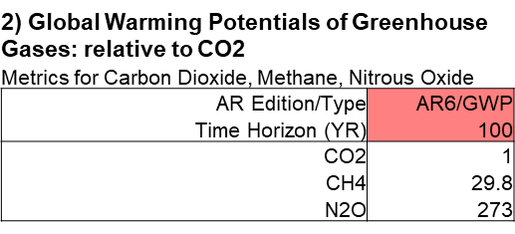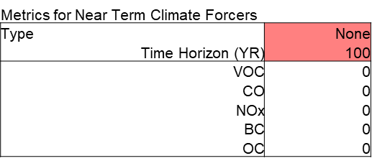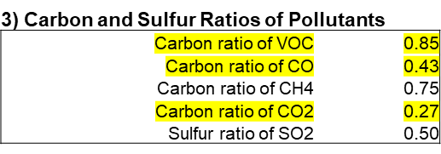

## Primary energy (cumulative energy demand) factor:

For each 1 mmBTU of electricity generated:

$$Primary Energy Factor_{fuel cycle}=\sum_{ }^{For each type of Power Plant}{}\left(\frac{ratio_{Power Plant}}{(1-loss\%)⋅Power Plant Conversion Efficiency} \right)$$

$$Primary Energy Factor_{feedstock}=\sum_{ }^{For each type of Power Plant}{}\left(\frac{ratio_{Power Plant}}{(1-loss\%)⋅Power Plant Conversion Efficiency}⋅Primary Energy_{fuel production} \right)$$

# Appendix B: other references related to electricity emission scenarios

* NREL: Cambium model <https://www.nrel.gov/analysis/cambium.html>
* NREL (2023): Evaluating Impacts of the Inflation Reduction Act and Bipartisan Infrastructure Law on the U.S. Power System
  + No New Policy scenario
  + IRA-BIL scenario
* NREL (2022): Examining Supply-Side Options to Achieve 100% Clean Electricity by 2035
  + AEO (Annual Energy Outlook) “current policy” electricity demand
  + ADE (accelerated demand electrification) includes rapid replacement of fossil fuel use with low-carbon alternatives across all sectors, including electrified end uses and low-carbon fuels and feedstocks, resulting in annual electricity demand that is 66% higher than in the Reference-AEO case in 2035.
* UCB (2020) The 2035 report
  + Achieving 90% “clean” electricity by 2035 scenario
* NREL: Cambium model <https://www.nrel.gov/analysis/cambium.html>