Morphological and phonological processing in English monolingual, Chinese-English bilingual, and Spanish-English bilingual children: Behavioral Measures (T2)
Authors
Xin Sun^{*1}, Kehui Zhang¹, Rebecca Marks², Zachary Karas¹, Rachel Eggleston¹, Nia Nickerson¹, Chi-Lin Yu¹, Neelima Wagley³, Xiaosu Hu¹, Valeria Caruso¹, Tai-Li Chou⁴, Teresa Satterfield¹, Twila Tardif¹, Ioulia Kovelman¹

Affiliations
¹ Department of Psychology, University of Michigan Ann Arbor
² Department of Brain and Cognitive Sciences, Massachusetts Institute of Technology ³ Department of Psychology and Human Development, Vanderbilt University ⁴ Department of Psychology, National Taiwan University
Corresponding author’s email address
E-mail address: isehe@umich.edu

Keywords
Children, bilingualism, morphological awareness, phonological awareness, reading
Abstract
This article documents behavioral dataset deposited in Deep Blue Data . The dataset included behavioral data from N = 245 returning children aged 5-10 with a diverse linguistic background, including children who are English monolingual, Chinese-English, and Spanish-English bilingual. Children completed a wide range of language and reading tasks. Parents filled in questionnaires to report children’s demographic information as well as their home language and literacy backgrounds. The dataset is valuable for researchers in the field of developmental cognitive neuroscience to further investigate questions such as the effects of bilingualism on children’s neural basis for literacy development.

Specifications Table
Subject | Developmental and Educational Neuroscience
Specific subject area | Behavioral data in English monolingual, Chinese-English, and Spanish-English bilingual children
Type of data | Tables, data
How data were  acquired | Participants (N = 245) completed behavioral assessments
Data format | Proficiency/demographic raw data are stored in excel sheets.
Parameters for data collection | All participants are children growing up in the US and attending English-only schools. The monolingual participants are all native speakers of English and only speak English. The bilingual participants have had Spanish or Chinese exposure from home since birth.
Description of data collection | Participants (N = 245) completed a behavioral session.  The behavioral session assessed participants’ language and reading proficiency in each of their languages.
Data source location | University of Michigan, Department of Psychology, Ann Arbor, MI.
Data accessibility | Repository: Deep Blue Data (previous project)Link to data  Persistent Identifier: https://doi.org/10.7302/kxgf-ps11
Related research  article | 1. Sun, X., Zhang K., Marks, R., Nickerson, N., Eggleston, R., Yu, C.L., Chou., T., Tardif, T., & Kovelman, I. (2021). What’s in a word? Cross-linguistic influences on Spanish-English and Chinese-English bilingual children’s word reading development. Child Development 93(1), 84-100.  http://doi.org/10.1111/cdev.13666  This article used data from the behavioral assessments of N = 283 participants from the current dataset.  2. Sun, X., Marks, R., Zhang, K., Yu, C.L., Eggleston, R., Nickerson, N., Chou, T.L., Hu, X.S., Tardif, T., Satterfield, T., & Kovelman, I. (In Press). Brain bases of English morphological processing: A comparison between Chinese-English, Spanish English bilingual, and English monolingual children.  Developmental Science Preprint available at: https://osf.io/9zx2t/ 3. Marks, R. A., Eggleston, R., Sun, X., Yu, C. L., Zhang, K., Nickerson, N., Hu, X., & Kovelman, I. (2021). The neurobiological basis of morphological processing for typical and impaired readers. Annals of Dyslexia  https://doi.org/10.1007/s11881-021-00239-9

Value of the Data
● Bilingualism research will benefit from this developmental dataset of young Spanish English and Chinese-English bilinguals, allowing for inquiries into the effects of age on acquisition, experience, proficiency, and cross-linguistic transfer in children’s emerging neural architectures for language and literacy development.
● The dataset is extensive and allows for investigations into (but not limited to) meaningful research topic: behind behavioral profiles of children from diverse backgrounds such as those with bilingual experiences, dyslexia, or reading disabilities.
1. Data Description
All data (behavioral assessment raw and standard scores, and demographics) are available in the DeepBlue repository under the name “Morphological and phonological processing in English monolingual, Chinese-English bilingual, and Spanish-English bilingual children: Behavioral Measures (T2)” For a list of the Deep Blue files and contents, see Table 1.

Table 1. Full list of the Deep Blue Data files and contents
Data/Measure File Name in Deep Blue | File Name in Deep Blue | Data/Measure Content
Task Performance | R01_T2_Behavioral_Measures | Excel spreadsheets including behavioral task performance (1 file)  We included a .csv version for each sheet
Language and literacy backgrounds and enrollment | RO1_T2_In-Lab_Parent_Questionnaire.xlsx  In-Lab_Parent_Questionnaire_Monolingual_COVID-19.docx  In-Lab_Parent_Questionnaire_Spanish_COVID-19.docx  In-Lab_Parent_Questionnaire_Chinese_COVID-19.docx  Consent_Form.pdf  Assent_Form.pdf | Excel spreadsheets Full In-Lab Parent Questionnaire (ILQ) data  We included a .csv version for each sheet  Full In-Lab_Parent Questionnaire for monolingual kids (ILQ)  Full In-Lab_Parent Questionnaire for bilingual kids SP-EN(ILQ)  Full In-Lab_Parent Questionnaire for bilingual kids CH-EN(ILQ)
Behavioral measures | Self-developed_Behavioral _Measures.zip | All self-developed behavioral measure items

The “RO1_T2_Behavioral Measures” includes all behavioral performance for the behavioral assessments, presented with excel sheets. Raw and standard scores for the behavioral assessments are also provided in an Excel sheet named “R01_T2_Behavioral Measures.xlsx”.
All self-developed behavioral assessments are presented in “Self-developed Behavioral Measures.zip”.
The latter data sheet includes data from one questionnaire named “RO1_T2_In-Lab_Questionnaire.xlsx”, and the full list of questionnaire items is presented with the word documents, named “Spanish_In-Lab_Parent_Questionnaires_.docx” and “Chinese_In-Lab_Parent_Questionnaires.docx.”. We included the Assent and Consent forms that provide potential research subjects sufficient written information to decide whether to participate in a research study or not based on an explanation of the proposed research and the nature of the participation that is requested of them.

2. Experimental Design, Materials, and Methods
2.1 Participants
Participants included N = 245 returning children aged 5 to 11 (Mage = 8.08, SDage = 1.64). Participants were divided into three groups according to their language experience. All monolinguals were born to native English speakers and exposed to English-only language environments. Bilingual participants had at least one parent as a native speaker of either Chinese or Spanish and were exposed to the language at home, from birth. The English monolingual group included N = 95 children aged 5.4 to 11.9 (Mage = 8.46, SDage = 1.65,); the Chinese-English bilingual group included N = 70 children aged 5.1 to 11.5 (Mage = 7.51, SDage = 1.67); and the Spanish-English bilingual group included N = 79 children aged 5.7 to 11 (Mage = 8.13 , SDage = 1.44). Within the English monolingual group, N = 4 were delayed in reading (Mage = 9.22, SDage = 1.16), as indicated by their standard scores below 85 in at least two of the four reading tasks (i.e., Word Reading. Word Attack, Reading Comprehension, and Reading Fluency; and N = 15 had dyslexia (Mage = 9.45; SDage = 1.61), as indicated by their 1) standard scores below 85 in at least two reading tasks, and 2) PPVT standard score 2 standard deviations (30 points) higher than word reading.
2.2 Behavioral assessments and demographic information
Participants completed behavioral assessments in each of their languages while their parents filled out demographic questionnaires. The behavioral testing assessed key language and literacy skills including phonological awareness, morphological awareness, vocabulary, single word reading, nonword reading, passage comprehension, and sentence reading fluency. The format of the heritage language measures maximally paralleled the English tasks. In addition, a backward digit span task was administered in English (WISC-V, Wechsler, 2014[1])TOWRE and RAN. Details of language and literacy measures are shown in Table 2. All self-developed measures can be found in the data repository.

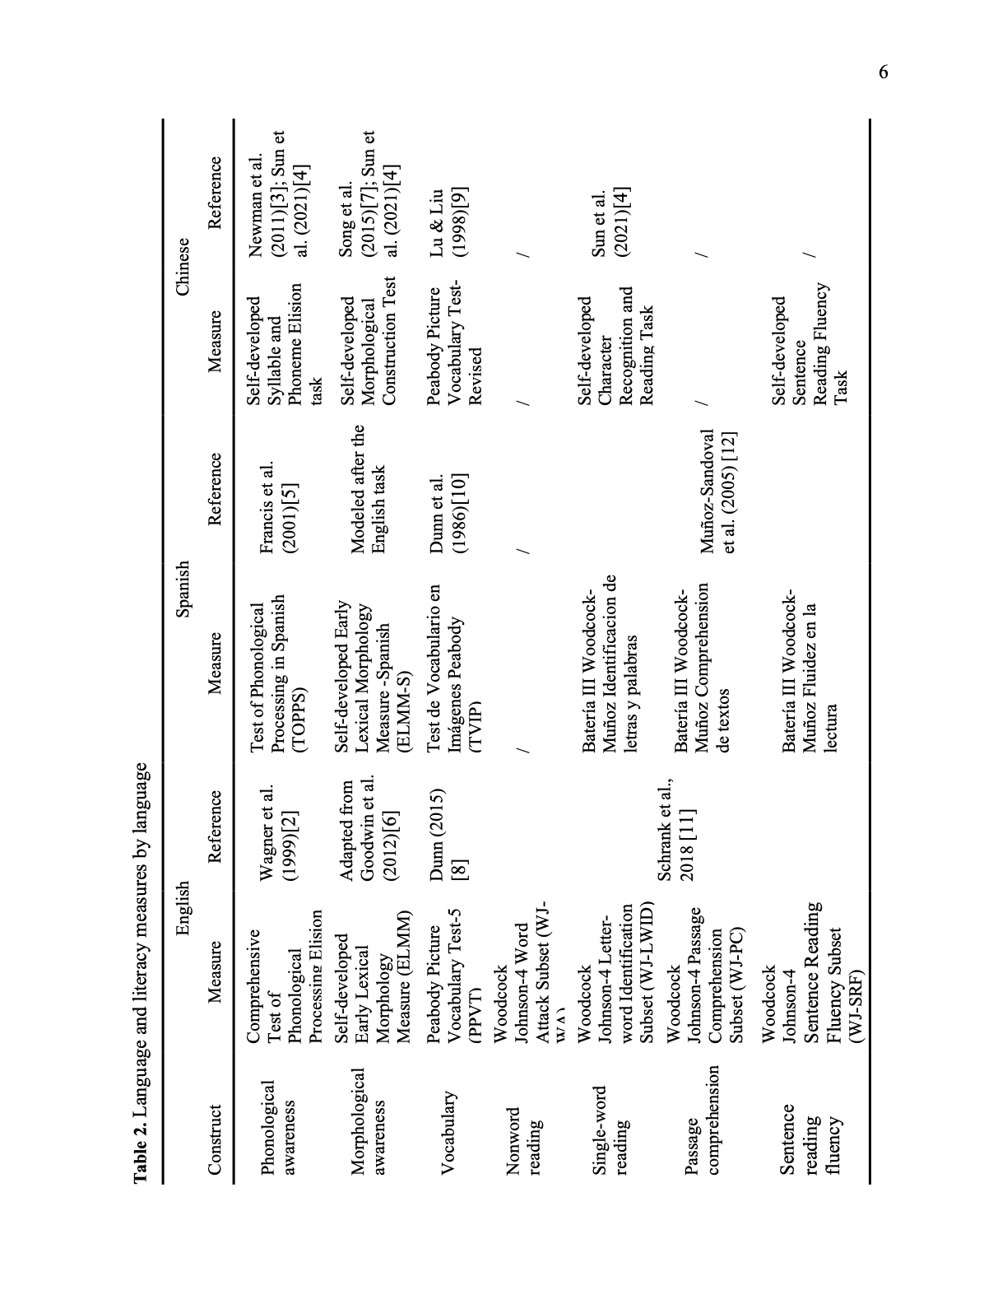

Ethics Statements
Informed consent was obtained from all participating children and their guardians. In addition, all research protocols were approved by the Institutional Review Board at the University of Michigan Ann Arbor and the protocol number is HUM00033727. The dataset has also removed all identifying information to protect participant privacy.
CRediT author statement
Xin Sun: Measure development, Data curation, validation, writing - original draft; Kehui Zhang and Rebecca Marks: Measure development, Data curation, validation, writing - review and editing;
Ioulia Kovelman: Conceptualization, Methodology, Supervision, Funding acquisition, writing - review & editing;
All others: Data curation, validation, writing - review and editing.
Acknowledgments
The authors thank members of the Language and Literacy Laboratory at the University of Michigan who helped with participant recruitment, scheduling, and data acquisition. We also thank the National Institutes of Health for funding this work (Kovelman, PI: R01HD092498).
Declaration of Competing Interests
The authors declare that they have no known competing financial interests or personal relationships that could have appeared to influence the work reported in this paper.

References
[1] D.Wechsler, Wechsler Intelligence Scale for Children-Fifth Edition (WISC-V), The Psychological Corporation, 2014.
[2] R. K.Wagner, J. K.Torgesen, C. A. Rashotte, & N. A. Pearson, Comprehensive test of phonological processing: CTOPP, Pro-ed, 1999.
[3] E. H. Newman, T. Tardif, J. Huang, & H. Shu, Phonemes matter: The role of phoneme-level awareness in emergent Chinese readers, Journal of Experimental Child Psychology. 108 (2011) 242–259. https://doi.org/10.1016/j.jecp.2010.09.001
[4] X. Sun, K. Zhang, R. A. Marks, N. Nickerson, R.L. Eggleston, C.L. Yu, T. L. Chou, T. Tardif, & I. Kovelman, What’s in a word? Cross-linguistic influences on Spanish– English and Chinese–English bilingual children’s word reading development, Child Development, 93 (2021) 84-100. https://doi.org/10.1111/cdev.13666
[5] D. Francis, M. Carlo, D. August, D.Kenyon, V. Malabonga, S. Caglarcan, & M. Louguit, Test of Phonological Processing in Spanish, Center for Applied Linguistics, 2001. [6] A. P. Goodwin, A. C. Huggins, M. Carlo, V. Malabonga, D. Kenyon, M. Louguit, & D. August, Development and validation of extract the base: An English derivational morphology test for third through fifth grade monolingual students and Spanish- speaking English language learners, Language Testing, 29 (2012) 265–289. https://doi.org/10.1177/0265532211419827 [7] S. Song, M. Su, C. Kang, H. Liu, Y. Zhang, C. McBride-Chang, T. Tardif, H. Li, W. Liang, Z. Zhang, & H. Shu, Tracing children's vocabulary development from preschool through the school-age years: An 8-year longitudinal study, Developmental Science, 18 (2015) 119–131. https://doi.org/10.1111/desc.12190
[8] D.M. Dunn, Peabody Picture Vocabulary Test 5, NCS Pearson, 2015.
[9] L. Lu, & H. S. Liu, The Peabody Picture Vocabulary Test– revised in Chinese, Psychological Publishing, 1998.
[10] L. Dunn, F. Padilla, D. Lugo, & L. Dunn, TVIP: Test Vocabolario Imágenes Peabody, American Guidance Service, 1986.
[11] F. A. Schrank, K. S. McGrew, & N. Mather, Woodcock-Johnson IV, Riverside, 2014. [12] A. F. Muñoz-Sandoval, R.W. Woodcock, K. S. McGrew, & N. Mather, Batería III Woodcock-Muñoz, Riverside Publishing, 2005.
[13] V. Jurcak, D. Tsuzuki, & I. Dan, 10/20, 10/10, and 10/5 systems revisited: Their validity as relative head-surface-based positioning systems, Neuroimage, 34 (2007) 1600-1611. https://doi.org/10.1016/j.neuroimage.2006.09.024

