2016DiagnosticAccuracyUMHS

Survey Flow
Block: Default Question Block (1 Question)
BlockRandomizer: 1 - Evenly Present Elements
EmbeddedData
self = you
BlockRandomizer: 1 - Evenly Present Elements
EmbeddedData
HeartBenefit = 0.1
EmbeddedData
HeartBenefit = 1
BlockRandomizer: 1 - Evenly Present Elements
EmbeddedData
HeartRisk = 0.1
EmbeddedData
HeartRisk = 1
BlockRandomizer: 1 - Evenly Present Elements
EmbeddedData
HeartCost = 0
EmbeddedData
HeartCost = 100
BlockRandomizer: 1 - Evenly Present Elements
EmbeddedData
TbiBenefit = 0.1
EmbeddedData
TbiBenefit = 1
BlockRandomizer: 1 - Evenly Present Elements
EmbeddedData
TbiRisk = 0.1
EmbeddedData
TbiRisk = 1
BlockRandomizer: 1 - Evenly Present Elements
EmbeddedData
TbiCost = 0
EmbeddedData
TbiCost = 100
BlockRandomizer: 2 - Evenly Present Elements
Standard: ChestPain (10 Questions)
Standard: Head Injury (10 Questions)
Standard: Demographics (15 Questions)
Standard: Numeracy (5 Questions)
EndSurvey: Advanced
Page Break

Start of Block: Default Question Block

Q1 We are conducting a research study to determine your preferences regarding diagnostic testing. This study is completely voluntary and you can choose not to participate at any time without any loss of potential benefits.
This study will take approximately 10 minutes of your time. ­We will give you a hypothetical situation where you have either recently hit your head or are currently experiencing chest pain which is determined by your physician to likely not be from a heart attack.
I agree to take part in this research survey.
- Yes (1)
- No (2)

Skip To: End of Survey If Q1 = 2
End of Block: Default Question Block

Start of Block: ChestPain

Q3 Imagine you are experiencing chest pain which came on suddenly at rest. You go to the emergency department where the physician determines that you most likely did not experience a heart attack. However, to further evaluate the cause of your symptoms you could have a computed tomography coronary angiography (CTCA). This is a special type of x-ray that tells us if you have blockages in your heart arteries (which can cause heart attacks). Your doctor is unsure whether you should get this test or not, and wants you to decide based on the benefits, risks, and costs. You can assume for this research project that the doctor can estimate these perfectly, which we know is not possible in real life. The benefits and risks listed below have been estimated for you personally based on your medical history and medications.
The chance of having the disease is:

Display This Question:
If HeartBenefit = 0.1

Q36 0.1% (1 in 1000)
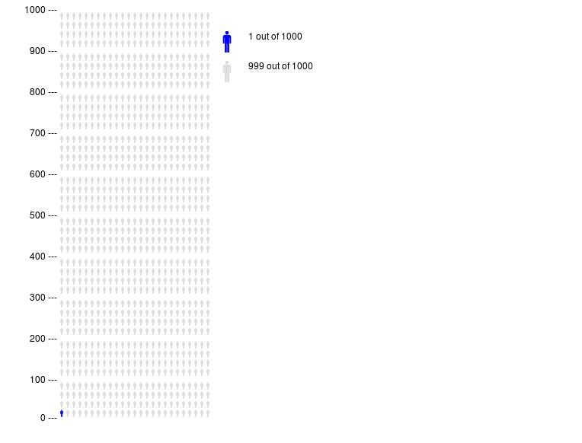

Display This Question:
If HeartBenefit = 1

Q37 1% (10 in 1000)
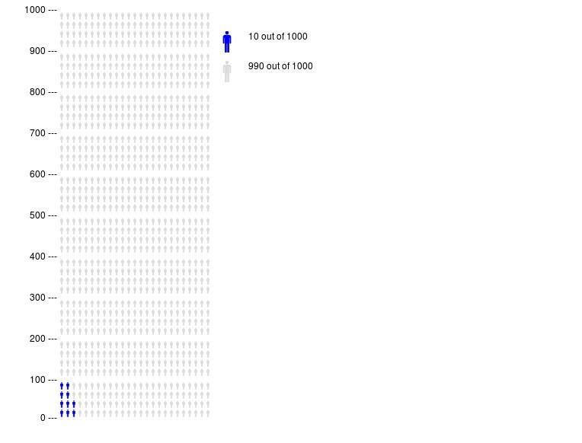

Q33 The chance of getting cancer within the next ten years due to this test is:

Display This Question:
If HeartRisk = 0.1

Q35 0.1% (1 in 1000)

Display This Question:
If HeartRisk = 1

Q34 1% (10 in 1000)

Q67 The out of pocket cost to you after insurance is:

Display This Question:
If HeartCost = 0

Q51 $0

Display This Question:
If HeartCost = 100

Q52 You receive a cash payment of $100 if you DO NOT get the test.

Q7 Would you want to have this diagnostic test performed given the above information.
- Yes (1)
- No (2)

End of Block: ChestPain

Start of Block: Head Injury
Page Break

Display This Question:
If self = you
Or Q13 = 2

Q49 Imagine you have just fallen and hit your head on the ground. You did not lose consciousness. You are experiencing a mild headache. You do not have any vision or speech problems. You have no numbness, tingling or loss of sensation anywhere on your body. You have just presented to the emergency department to be evaluated by a physician.
You could get a head CT (a special type of x-ray) to look for possible bleeding into your head. Your doctor is unsure whether you should get this test or not, and wants you to decide based on benefits, risks, and costs. You can assume for this research project that the doctor can estimate these perfectly, which we know is not possible in real life. The benefits and risks listed below have been estimated for you personally based on your medical history and medications.
The chance you have a brain bleed is:

Display This Question:
If TbiBenefit = 0.1

Q55 0.1% (1 in 1000)

Display This Question:
If TbiBenefit = 1

Q56 1% (10 in 1000)

Q68 The chance you develop cancer within the next ten years from this test is:

Display This Question:
If TbiRisk = 0.1

Q62 0.1% (1 in 1000)

Display This Question:
If TbiRisk = 1

Q63 1% (10 in 1000)

Q69 The out of pocket cost to you is:

Display This Question:
If TbiCost = 0

Q59 $0

Display This Question:
If TbiCost = 100

Q66 You receive a cash payment of $100 if you DO NOT get the test.

Q12 Would you agree to have this diagnostic test performed given the above information.
- Yes (1)
- No (2)

End of Block: Head Injury

Start of Block: Demographics

Q16 What is your age?
________________________________________________________________

Q17 What is your gender
- Male (1)
- Female (2)
- Other/Transgender (3)

Q28 What is your current marital status?
- Married, or living as married (1)
- Widowed (2)
- Divorced (3)
- Seperated (4)
- Never married (5)

Q19 Do you have a history of cancer
- Yes (1)
- No (2)

Page Break

Q20 Do you have high blood pressure or do you take medication for high blood pressure?
- Yes (1)
- No (2)

Q21 Do you have diabetes?
- Yes (1)
- No (2)

Q22 Do you have atrial fibrillation? (An abnormal heart rhythm)
- Yes (1)
- No (2)

Q23 Have you had a heart attack before?
- Yes (1)
- No (2)

Q56 Have you had a head injury before that required a visit to the hospital or emergency department?
- Yes (1)
- No (2)

Q24 What level of education have you achieved?
- Some high school (1)
- High school graduate (2)
- Some college (3)
- College graduate (4)
- Post graduate degree (Master's, PhD, MD, JD, MSW) (5)

Page Break

Q27 Please select the category or categories that best describes your race
- American Indian or Alaska Native (1)
- Asian (2)
- Black or African-American (3)
- Native Hawaiian or Other Pacific Islander (4)
- White (5)
- Other (6) ________________________________________________
- Prefer not to disclose (7)

Q29 Please select the category that best describes your ethnicity
- Hispanic (1)
- Not-Hispanic (2)
- Other (3) ________________________________________________
- Prefer not to disclose (4)

Q30 Have you worked or trained in any of the following medical/health professions: (select all that apply)
- I am not a medical professional (1)
- Physician or practitioner (MD, DO, DDS, CRNP, PA, etc.) (2)
- Nurse (BSN, RN, LPN, etc.) (3)
- Clinical psychologist or social worker (4)
- Pharmacist (5)
- Medical technologist/technician (6)
- Medical/health researcher (7)
- Medical/health administrator (8)
- Other medical/health profession (Please specify) (9) ________________________________________________

Page Break

Q31 In General, would you say your health is:
- Excellent (1)
- Very Good (2)
- Good (3)
- Fair (4)
- Poor (5)

Q49 What is your household income level?
- Less than $10,000 (1)
- $10,000 to $14,999 (2)
- $15,000 to $24,999 (3)
- $25,000 to $34,999 (4)
- $35,000 to $49,999 (5)
- $50,000 to $74,999 (6)
- $75,000 to $99,999 (7)
- $100,000 to $149,999 (8)
- $150,000 to $199,999 (9)
- $200,000 or more (10)
- Prefer not to respond (11)

End of Block: Demographics

Start of Block: Numeracy

Q50 For each of the following questions, please check the circle that best reflects how good you are at doing the following things:
 | Not good at all (1) | . (2) | . (3) | . (4) | . (5) | Extremely Good (6)
How good are you at working with fractions? (1)
How good are you at working with percentages? (2)
How good are you at calculating a 15% tip? (3)
How good are you at figuring out how much a shirt will cost if it is 25% off? (4)

Q51 For each of the following questions, please check the circle that best reflects your answer:
 | Not at all helpful (1) | . (2) | . (3) | . (4) | . (5) | Extremely helpful (6)
When reading the newspaper, how helpful do you find tables and graphs that are parts of a story? (1)

Q53 For each of the following questions, please check the circle that best reflects your answer:
 | Always Prefer Words (1) | . (2) | . (3) | . (4) | . (5) | Always Prefer Numbers (6)
When people tell you the chance of something happening, do you prefer that they use words ("it rarely happens") or numbers ("there's a 1% chance")? (1)

Q54 For each of the following questions, please check the circle that best reflects your answer:
 | Always Prefer Percentages (1) | . (2) | . (3) | . (4) | . (5) | Always Prefer Words (6)
When you hear a weather forecast, do you prefer predictions using percentages (e.g., “there will be a 20% chance of rain today”) or predictions using only words (e.g., “there is a small chance of rain today”)? (1)

Q55 For each of the following questions, please check the circle that best reflects your answer:
 | Never (1) | . (2) | . (3) | . (4) | . (5) | Very Often (6)
How often do you find numerical information to be useful? (1)

End of Block: Numeracy

