Supplementary Online Content

eTable 1. European Network for the Study of Adrenal Tumors staging system.
eFigure 1. Sensitivity analysis 1, overall survival with 2:1 matching
eFigure 2. Sensitivity analysis 1, local recurrence-free survival with 2:1 matching
eFigure 3. Sensitivity analysis 1, all recurrence-free survival with 2:1 matching
eTable 2. Sensitivity analysis 2, sample characteristics of Immortal Time Bias Analysis
eFigure 4. Sensitivity analysis 2, overall survival with immortal time bias
eFigure 5. Sensitivity analysis 2, local recurrence-free survival with immortal time bias
eFigure 6. Sensitivity analysis 2, all recurrence-free survival with immortal time bias
eTable 3. Sensitivity analysis 3, sample characteristics of sensitivity analysis matching by initial stage
eFigure 7. Sensitivity analysis 3, overall survival with comparison with initial stage matched at diagnosis
eFigure 8. Sensitivity analysis 3, local recurrence-free survival with initial stage matched at diagnosis
eFigure 9. Sensitivity analysis 3, all recurrence-free survival with iniital stage matched at diagnosis

eTable 1: ENSAT staging
European Network for the Study of Adrenal Tumors staging system
Stage | TNM
I | T1 N0 M0
II | T2 N0 M0
III | T1-2 N1 M0  T3-4 N0-1 M0
IV | any M1

eFigure 1: Sensitivity analysis 1, overall survival with 2:1 matching
Overall survival of adrenocortical carcinoma patients treated with or without adjuvant radiotherapy, sensitivity analysis matching one adjuvant radiotherapy case to up to two control cases where possible.
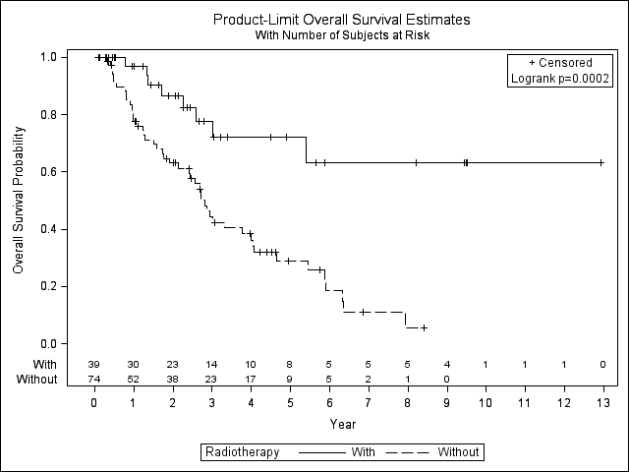

eFigure 2: Sensitivity analysis 1, local recurrence-free survival with 2:1 matching
Local recurrence-free survival of adrenocortical carcinoma patients treated with or without adjuvant radiotherapy, sensitivity analysis matching one adjuvant radiotherapy case to up to two control cases where possible.
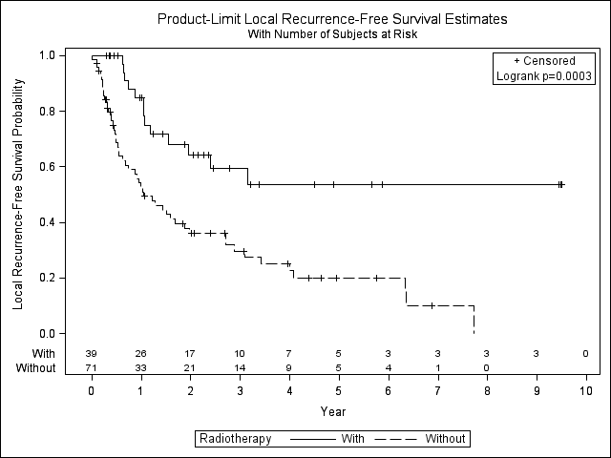

eFigure 3: Sensitivity analysis 1, all recurrence-free survival with 2:1 matching
All recurrence-free survival of adrenocortical carcinoma patients treated with or without adjuvant radiotherapy, sensitivity analysis matching one adjuvant radiotherapy case to up to two control cases where possible.
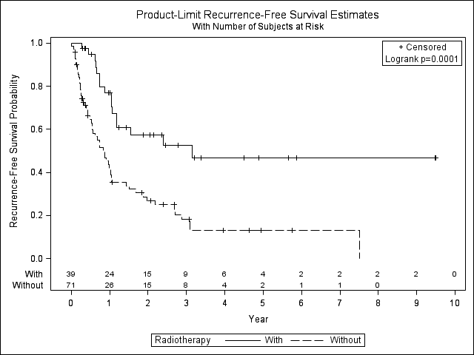

eTable 2: Sensitivity analysis 2, sample characteristics of Immortal Time Bias Analysis
Sample characteristics of immortal time bias analysis.
 | No radiation therapy | Radiation therapy | p-value
 | (N=39) | (N=39)
Sex: N (%)
Males | 19 (48.7) | 18 (46.2) | 0.808^{a,c}
Females | 20 (51.3) | 21 (53.9)
Age in years: | 44.9 (18 – 69) | 47.1 (13 – 74) | 0.699^{b,c}
Mean (Min. – Max.)
Disease stage
I | 2 (5.1) | 2 (5.7) | 0.795^{a,c}
II | 15 (38.5) | 16 (41.0)
III | 21 (53.9) | 18 (44.9)
IV | 1 (2.6) | 3 (7.7)
Mitotane Use
Yes | 28 (71.8) | 30 (76.9) | 0.617ª
No | 11 (28.2) | 9 (23.1)
Tumor Grade
Low | 7 (18.0) | 10 (25.6) | 0.317^{a,c}
High | 32 (82.0) | 29 (74.4)
Tumor Size (cm): | 11.7 (4.1 – 23.0) | 10.4 (0.6 – 22.5) | 0.077^{b}
Mean (Min. – Max., cm)
Hormone production (any)
No | 19 (48.7) | 19 (48.7) | 0.158ª
Yes | 20 (51.3) | 20 (51.3)
Not reported | 0 | 5 (12.8)
Cortisol production
No | 26 (66.7) | 21 (53.9) | 0.156ª
Yes | 13 (33.3) | 13 (33.3)
Not reported | 0 | 5 (12.8)
Surgical Margins
Negative | 24 (61.5) | 30 (76.9) | 0.428^{a,c}
Positive | 7 (18.0) | 5 (12.8)
Not reported | 8 (20.5) | 4 (10.3)
ªMcNemar’s test of dependent proportion or Bowker’s test of symmetry.
^{b}Paired t-test.
^{c}Accounted for in the model calculating the propensity weights for adjuvant radiotherapy.

eFigure 4: Sensitivity analysis 2, overall survival with immortal time bias
The overall survival distribution for cases and controls was significantly different (log-rank p = 0.0029). The 5-year survival estimate for patients with RT was 72.1%, 95% CI: 49.2 – 86.0 and for patients without was 37.1%, 95% CI: 19.8 – 54.6. If we use a cox proportional hazard models, adjusting for any mitotane use, then the hazards ratio is 2.98, 95% CI: 1.33 – 6.68, p = 0.0082.
eFigure 5: Sensitivity analysis 2, local recurrence-free survival with immortal time bias
The local recurrence-free survival distribution for significantly higher cases then controls (log-rank p-value 0.0075). The 5-year survival estimate for patients with RT was 53.5%, 95% CI: 32.2 – 70.8 and for patients without was 26.6%, 95% CI: 12.1 – 43.6. If we use a cox proportional hazard models, adjusting for any mitotane use, the hazards ratio is 2.29, 95% CI: 1.17 – 4.46, p = 0.0154.
eFigure 6: Sensitivity analysis 2, all recurrence-free survival with immortal time bias
The recurrence-free survival distribution for significantly higher cases then controls (log-rank p-value 0.0059). The 5-year survival estimate for patients with RT was 46.7%, 95% CI: 26.9 – 64.3 and for patients without was 19.7%, 95% CI: 7.5 – 36.2. If we use a cox proportional hazard models, adjusting for any mitotane use, the hazards ratio is 2.15, 95% CI: 1.16 – 3.99, p = 0.0153.

eTable 3: Sensitivity analysis 3, sample characteristics of sensitivity analysis matching by initial stage
 | No radiation therapy  (N=39) | Radiation therapy  (N=39) | P-value
Sex: N (%)
Males | 18 (46.2) | 18 (46.2) | 1^{a,c}
Females | 21 (53.9) | 21 (53.9)
Age in years:  Mean (Min. – Max.) | 45.6 (18 – 80) | 47.1 (13 – 74) | 0.527^{b,c}
Disease stage
I | 2 (5.1) | 2 (5.1) | 0.809^{a,c}
II | 16 (41.0) | 16 (41.0)
III | 15 (38.5) | 18 (46.2)
IV | 6 (15.4) | 3 (7.7)
Mitotane Use
Yes | 29 (74.4) | 30 (76.9) | 0.782ª
No | 10 (25.6) | 9 (23.1)
Tumor Grade
Low | 12 (30.8) | 10 (25.6) | 0.317^{a,c}
High | 27 (69.2) | 29 (74.4)
Size in cm:  Mean (Min. – Max.) | 12.1 (4.1 – 20.0) | 10.4 (0.6 – 22.5) | 0.065^{b}
Hormone production (any)
Yes | 19 (48.7) | 15 (38.5) | 0.152ª
No | 20 (51.3) | 19 (48.7)
Not reported | 0 | 5 (12.8)
Cortisol production
Yes | 13 (33.3%) | 13 (33.3) | 0.152ª
No | 26 (66.7) | 21 (53.9)
Not reported | 0 | 5 (12.8)
Surgical Margins
Negative | 31 (79.5) | 30 (76.9) | 0.343^{a,c}
Positive | 2 (5.1) | 5 (12.8)
Not reported | 6 (15.4) | 4 (10.3)
ªMcNemar’s test of dependent proportion or Bowker’s test of symmetry.
^{b}Paired t-test.
^{c}Accounted for in the model calculating the propensity weights for adjuvant radiotherapy.

eFigure 7: Sensitivity analysis 3, overall survival with comparison with initial stage matched at diagnosis
The overall survival distribution for cases and controls was significantly different (log-rank p = 0.0054). The 5-year survival estimate for patients with RT was 72.1%, 95% CI: 49.2 – 86.0 and for patients without was 28.1%, 95% CI: 6.9 – 54.6. If we use a cox proportional hazard models, adjusting for any mitotane use, then the hazards ratio is 3.23, 95% CI: 1.37 – 7.63, p = 0.008.
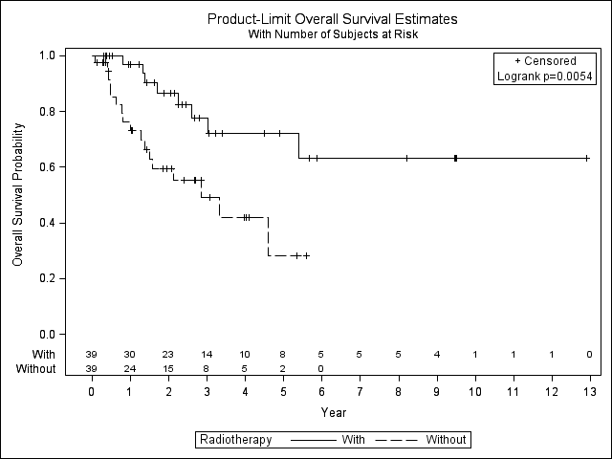

eFigure 8: Sensitivity analysis 3, local recurrence-free survival with initial stage matched at diagnosis
The local recurrence-free survival distribution was significantly higher for cases than controls (log-rank p-value 0.0024). The 5-year local recurrence-free survival estimate for patients with RT was 53.5%, 95% CI: 32.2 – 70.8 and for patients without was 21.1%, 95% CI: 1.9 – 54.1. If we use a cox proportional hazard models, adjusting adjusting for any mitotane use, the hazards ratio is 2.19, 95% CI: 1.09–4.42, p = 0.028.
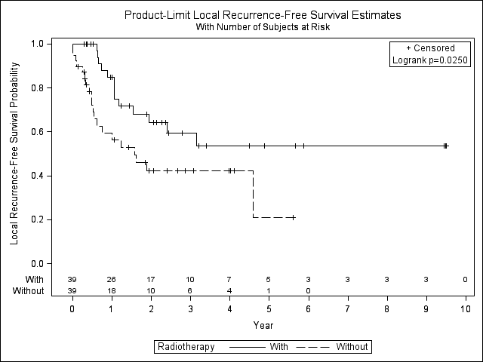

eFigure 9: Sensitivity analysis 3, all recurrence-free survival with iniital stage matched at diagnosis
The recurrence-free survival distribution was higher, but not significantly, for cases than controls (log-rank p-value 0.128). The 5-year survival estimate for patients with RT was 46.7%, 95% CI: 26.9 – 64.3 and for patients without was 22.0%, 95% CI: 2.0 – 55.9. If we use a cox proportional hazard models, adjusting for any mitotane use, the hazards ratio is 1.68, 95% CI: 0.86 – 3.28, p = 0.127.
