Dream Gigs

 |  | 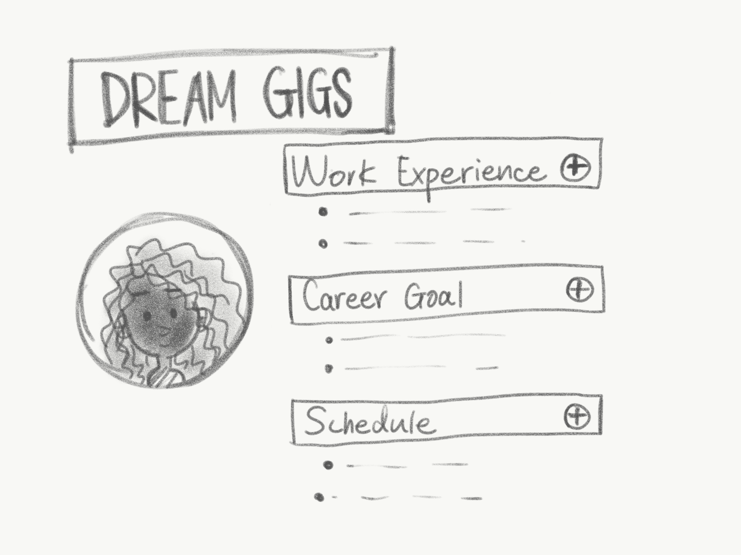 | 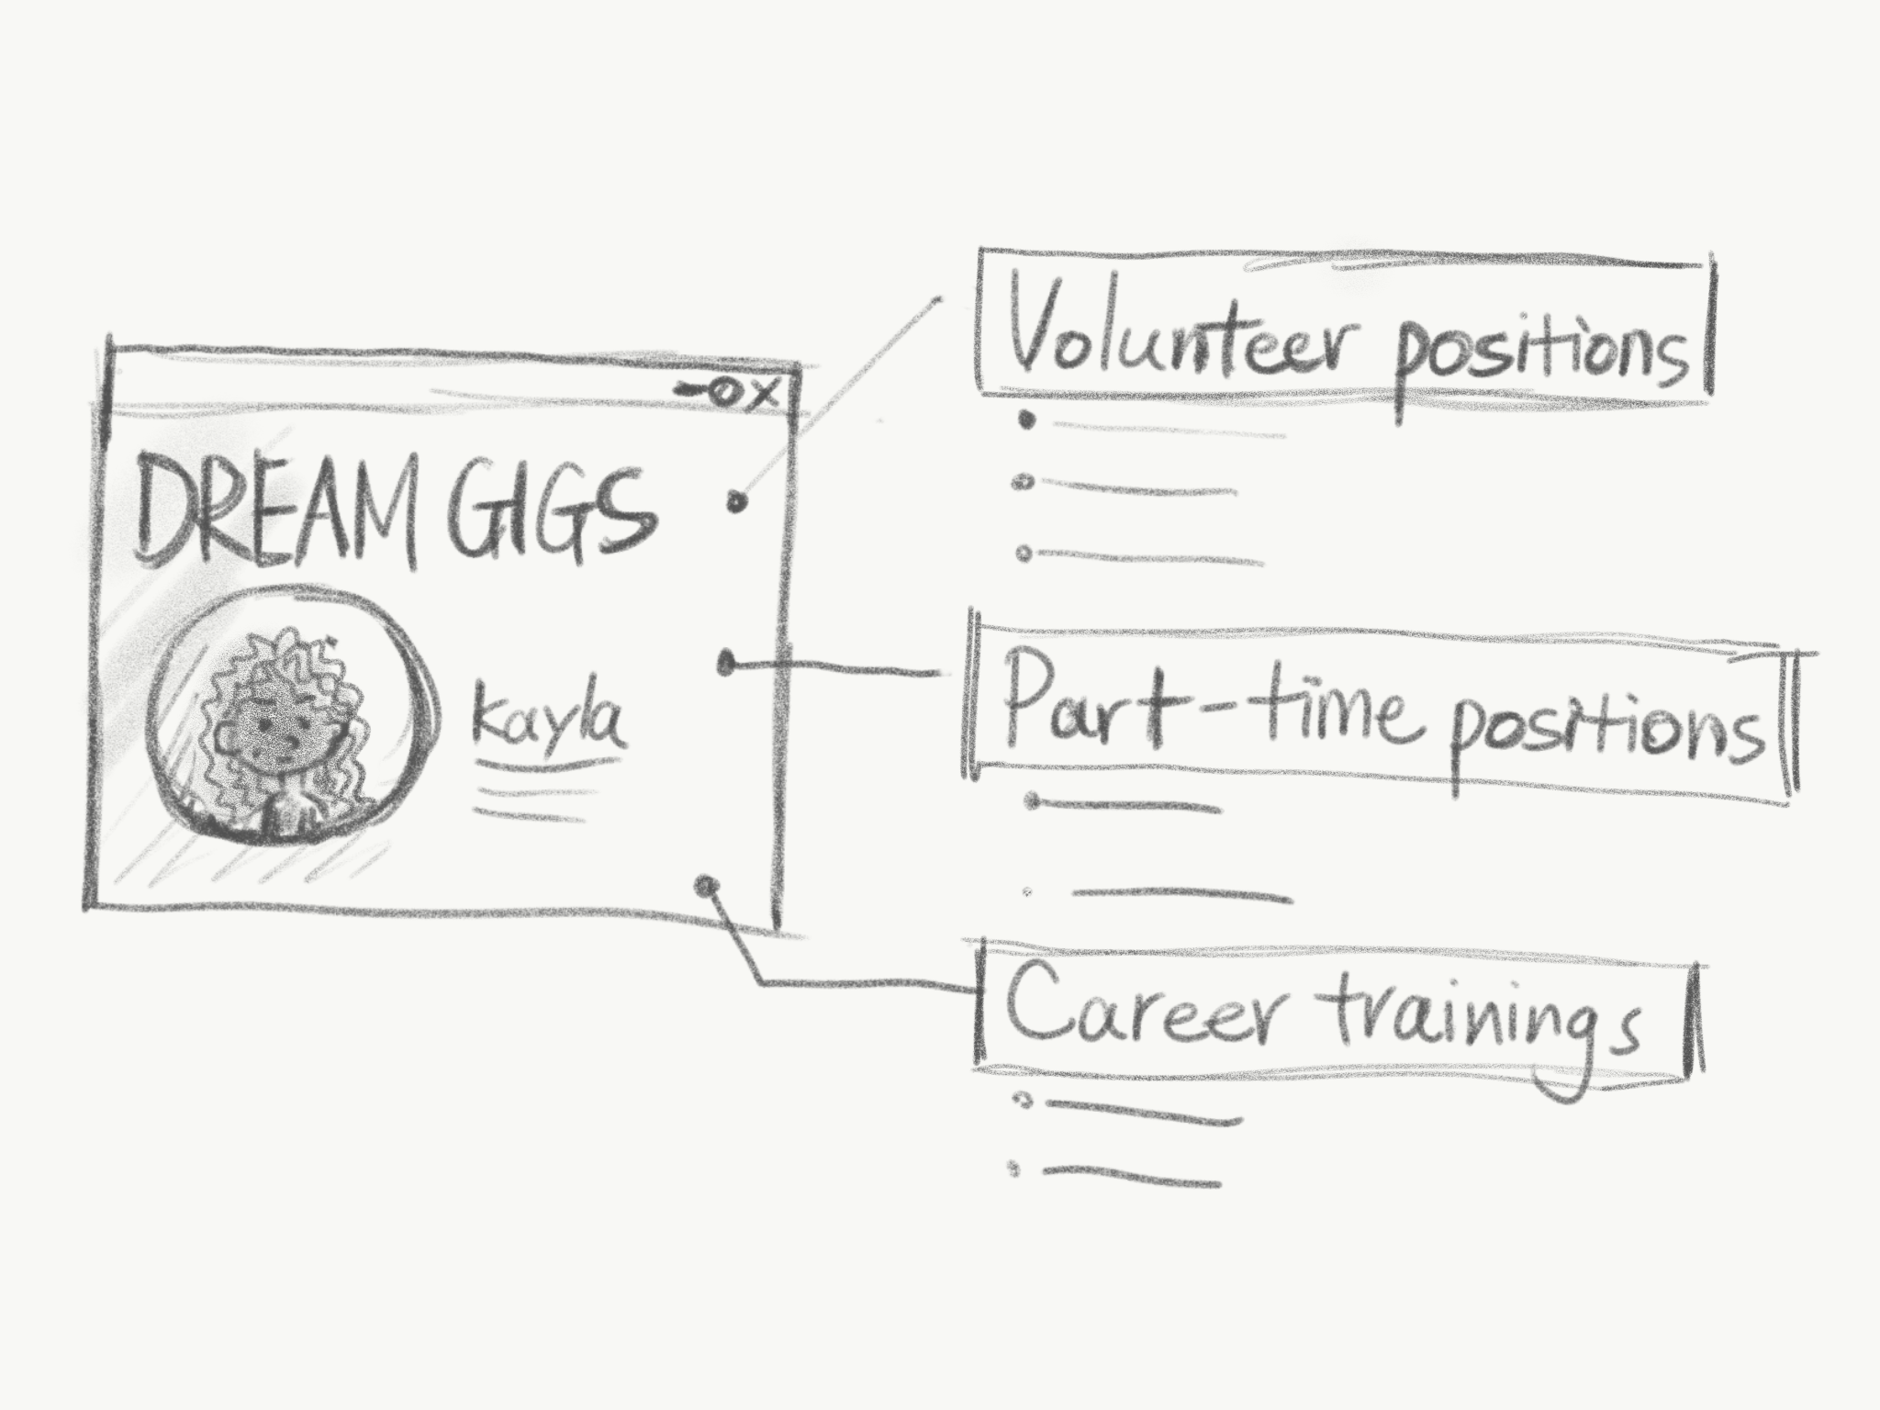
Kayla is interested in becoming a manager, but she’s not sure how to build up her experience. | Kayla hears about Dream Gigs: a tool that helps individuals acquire career related skills. | Kayla types in her previous jobs, goal of being a manager, and schedule into Dream Gigs. | Dream Gigs identifies volunteer positions, part time jobs, online work, and free online classes that will help her gain management skills within her timeframe.

Vouch for Me
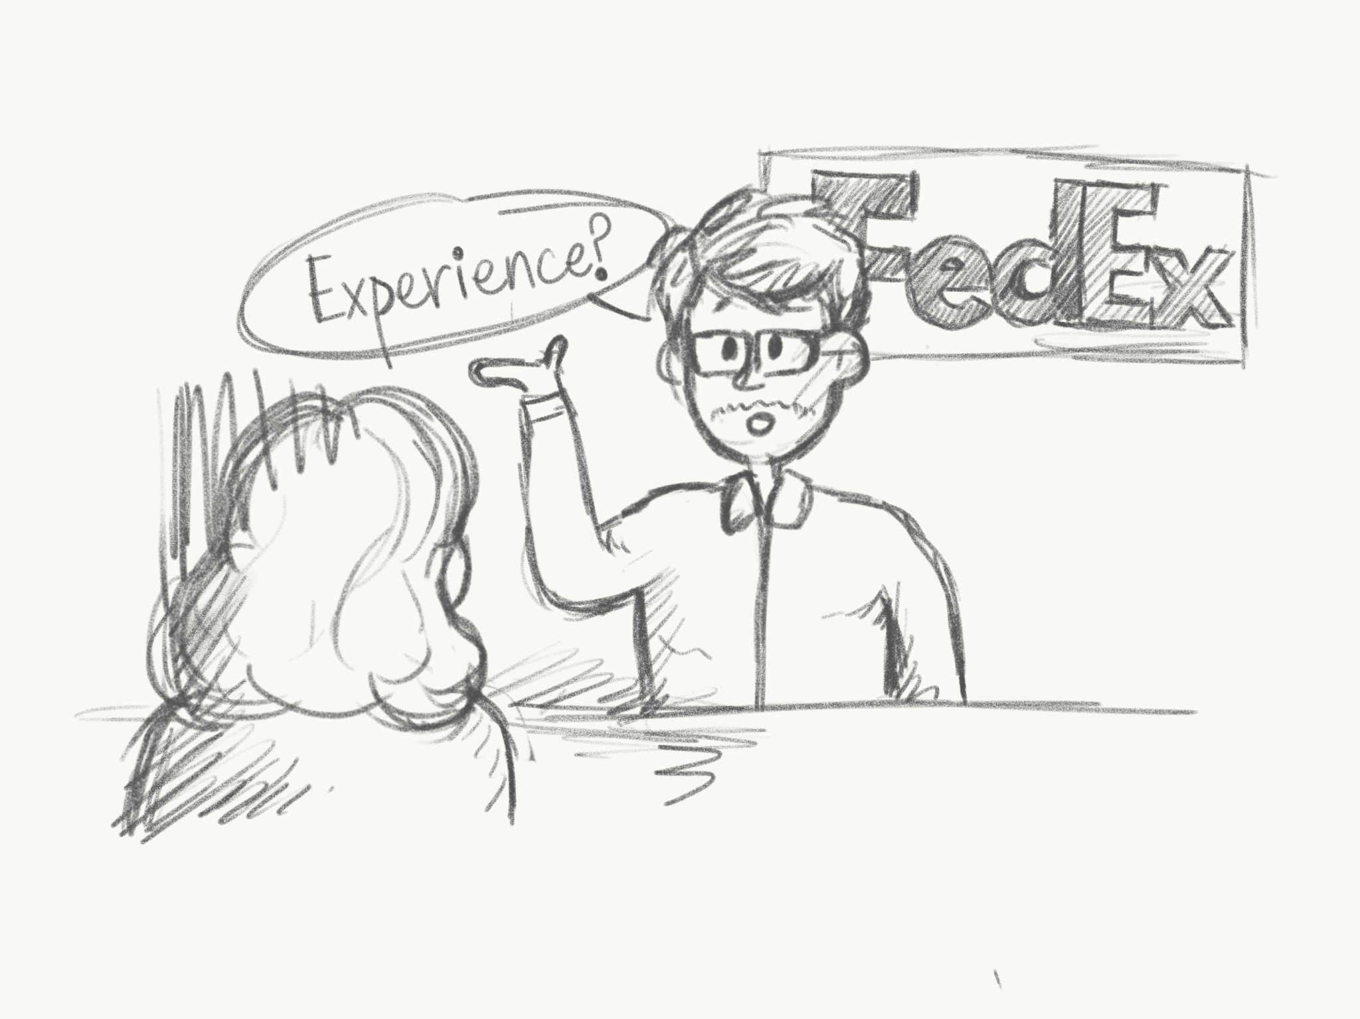 |  | 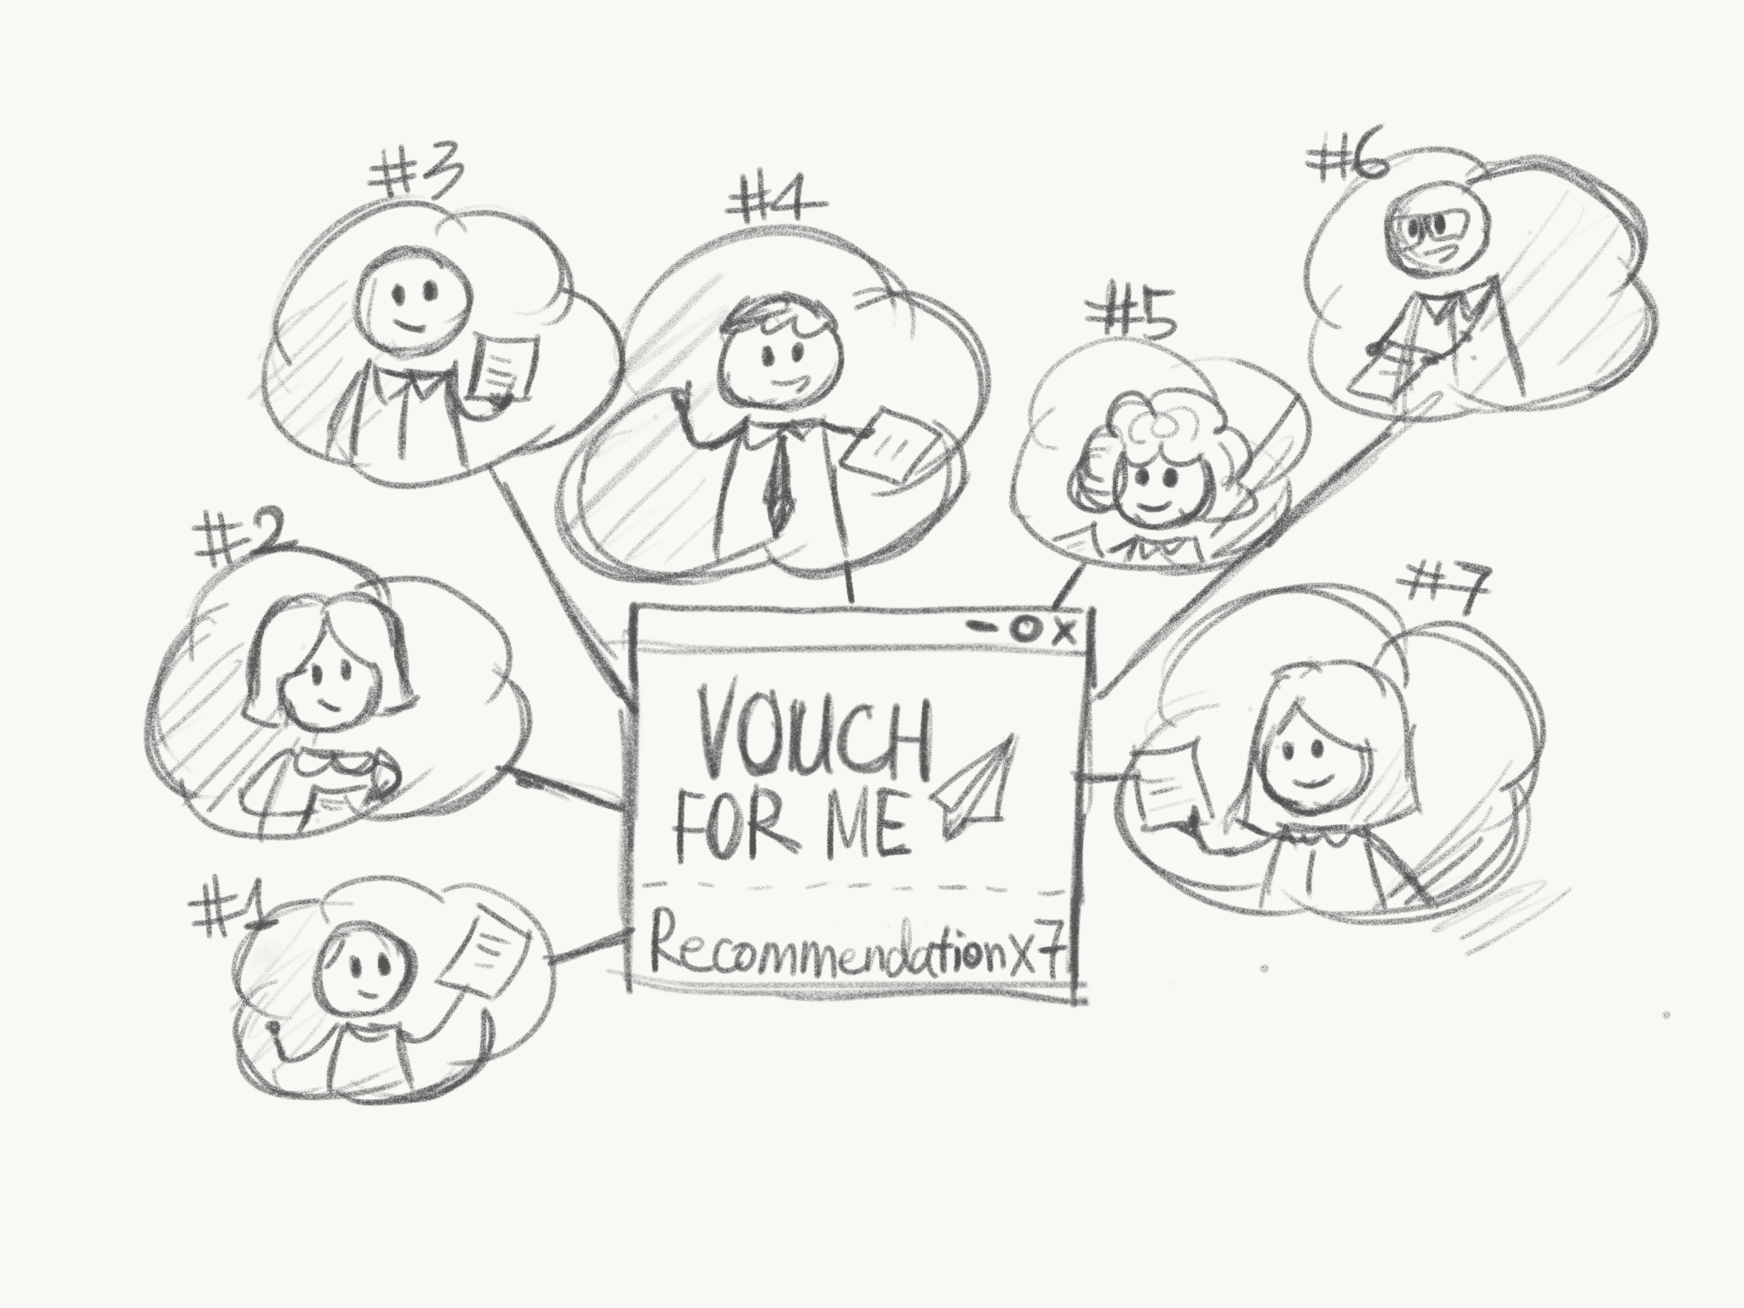
Jacky wants to be a full time job delivering packages at FedEx. She applies to be a driver Fedex, but they say she isn’t qualified. She has spent the last 5 years delivering packages for small businesses in her community and wishes she had a way to show her qualifications. | Her friend tells her about Vouch for Me - a tool that allows freelancers to gather testimonials. | Using Vouch for Me, she is able to create a profile where past clients and customers can leave comments about their experiences. | Jacky resubmits her application to Fedex and including testimonials she’s gathered.

Skills Identifier

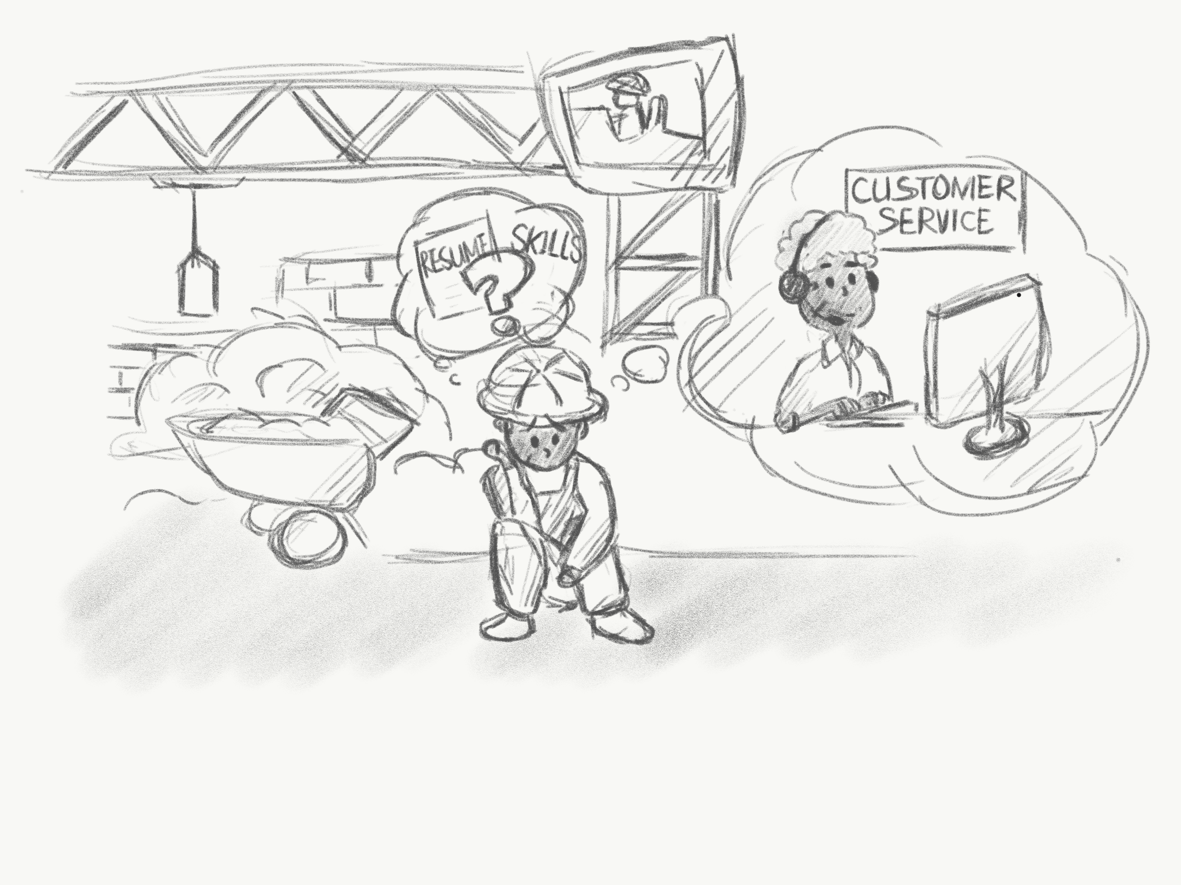 | 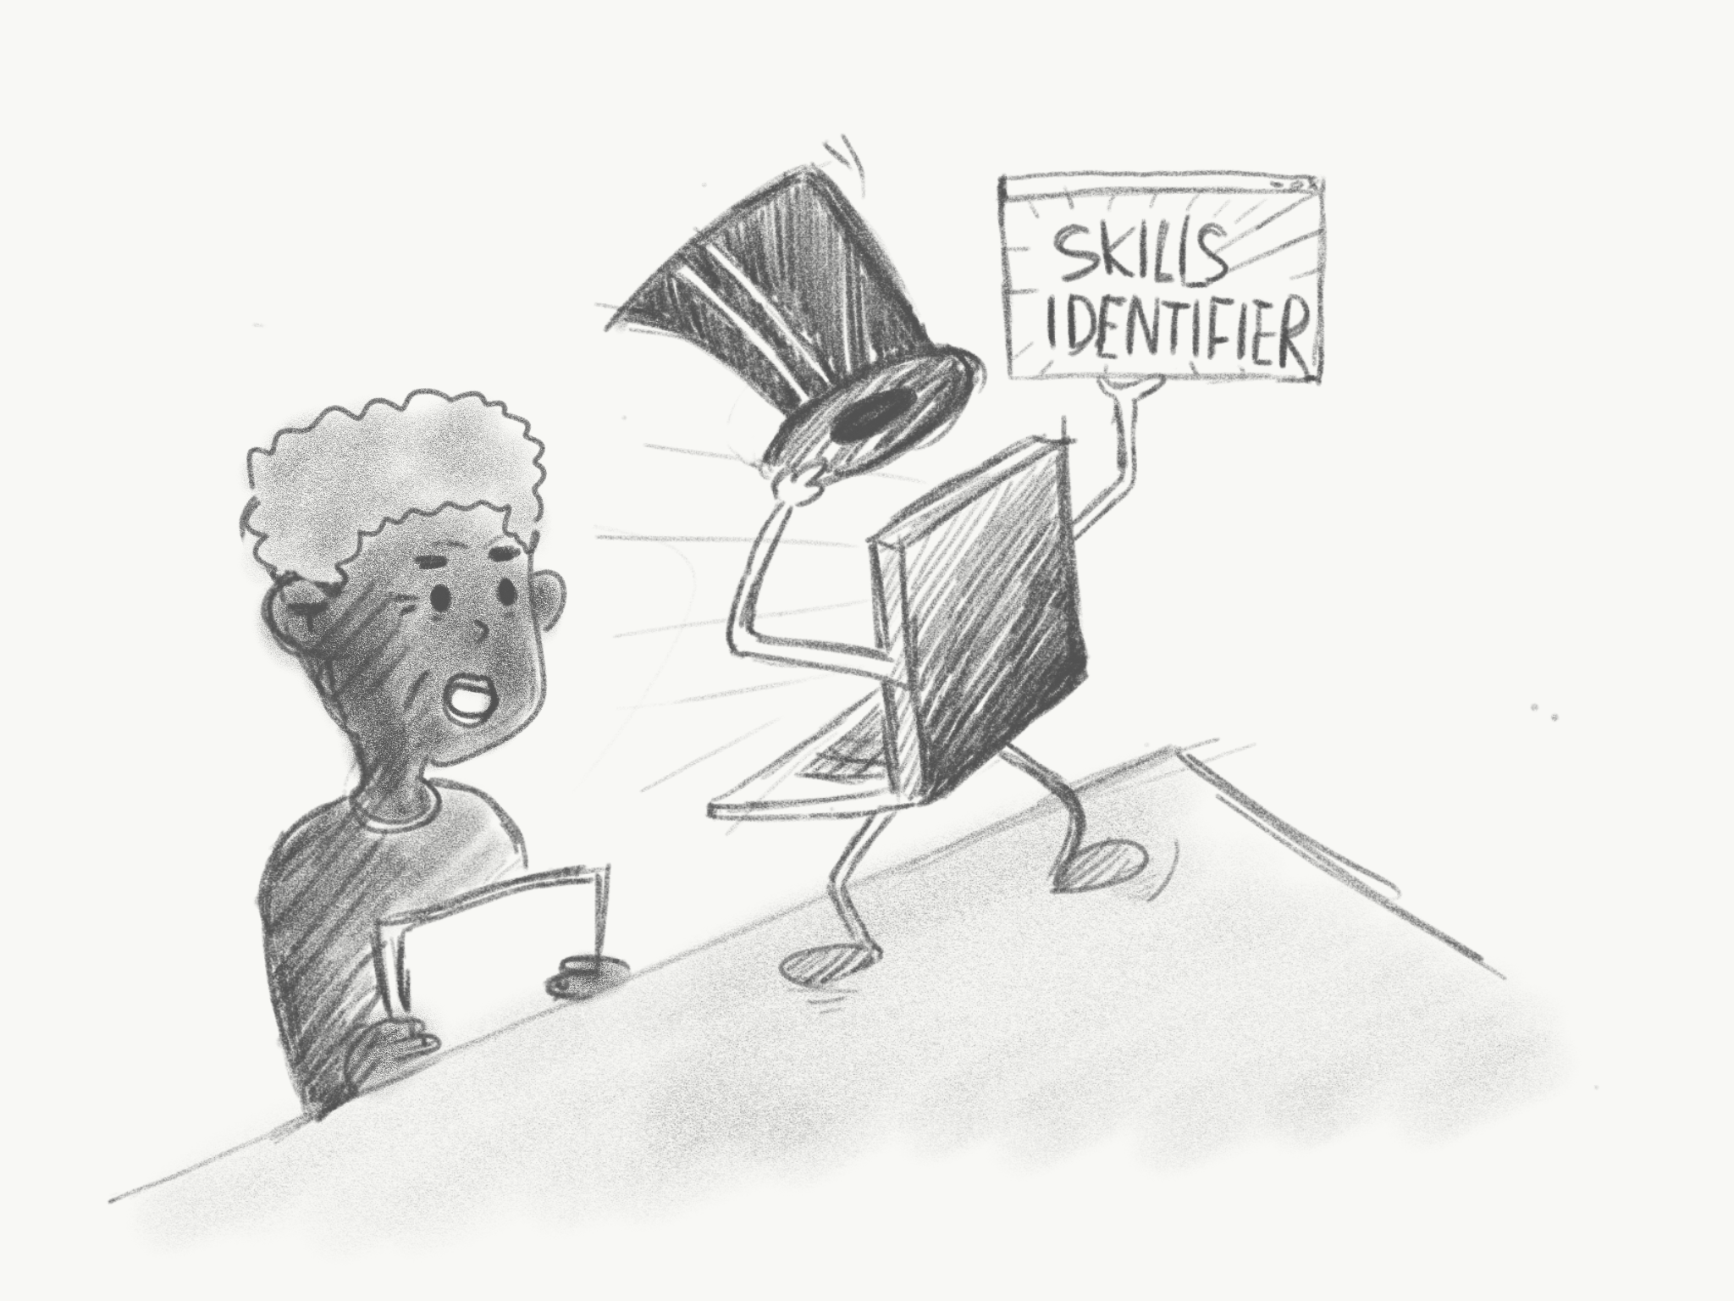 | 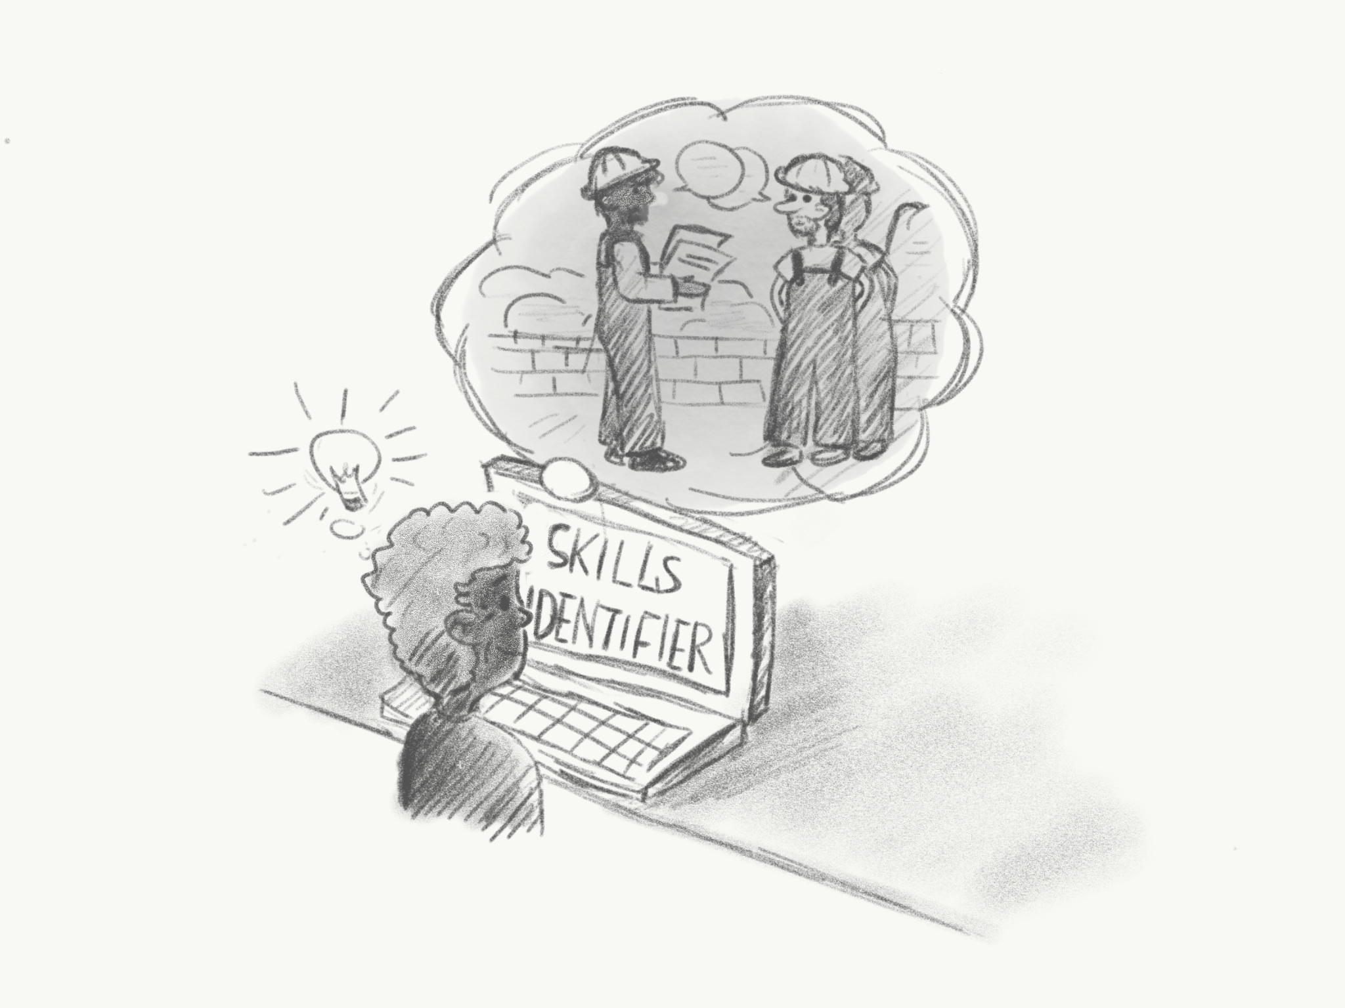
Andy wants to work in a customer-service related job, but is not sure how his previous experiences are related to these positions. | He stumbles on Skills Identifier; a tool that helps identify and communicate his skills. | Andy enters his previous experience as a construction worker. Skills Identifier determines that customer service jobs and construction jobs both had requirements in problem solving skills and teamwork skills. | Andy rewrites his resume and cover letter to highlight his skills in problem solving and teamwork.

Review Me

 | 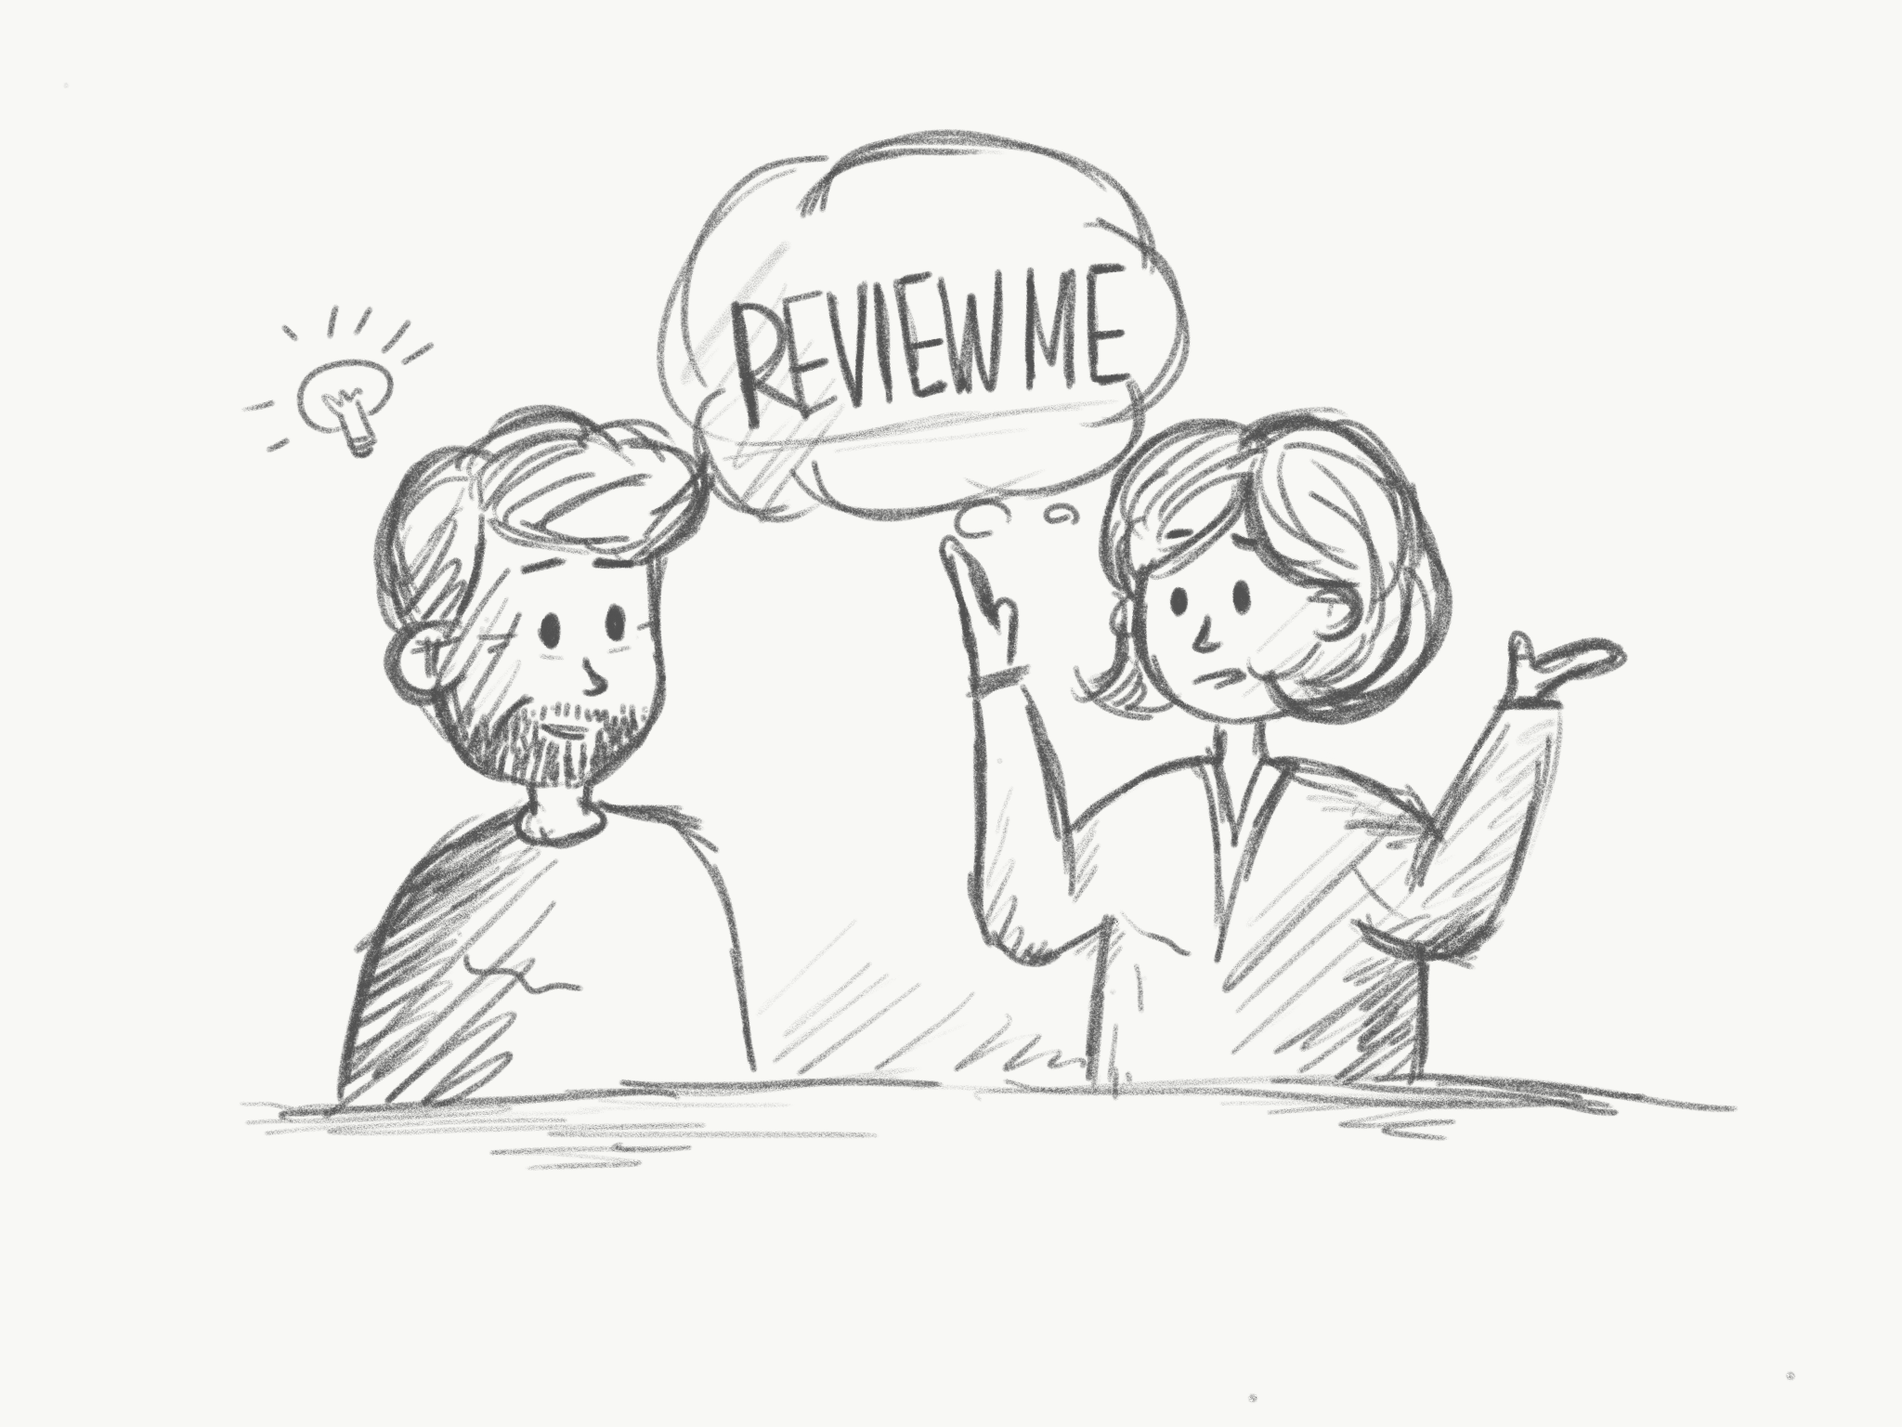 | 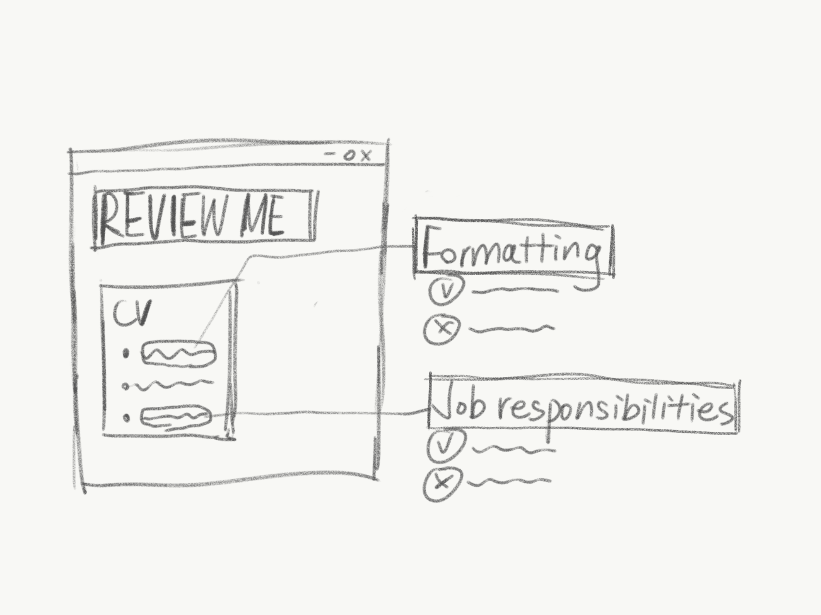
Joe is creating his CV and is unsure what he should include. | Joe’s friend tells him about Review-Me; a tool that provides feedback on resumes. | Joe submits a rough draft of his CV, and receives specific details about how to rephrase his job responsibilities and improve the formatting of his CV. | After making the changes, Joe has a CV that better highlights his job responsibilities and is easier to read.

Interview 4

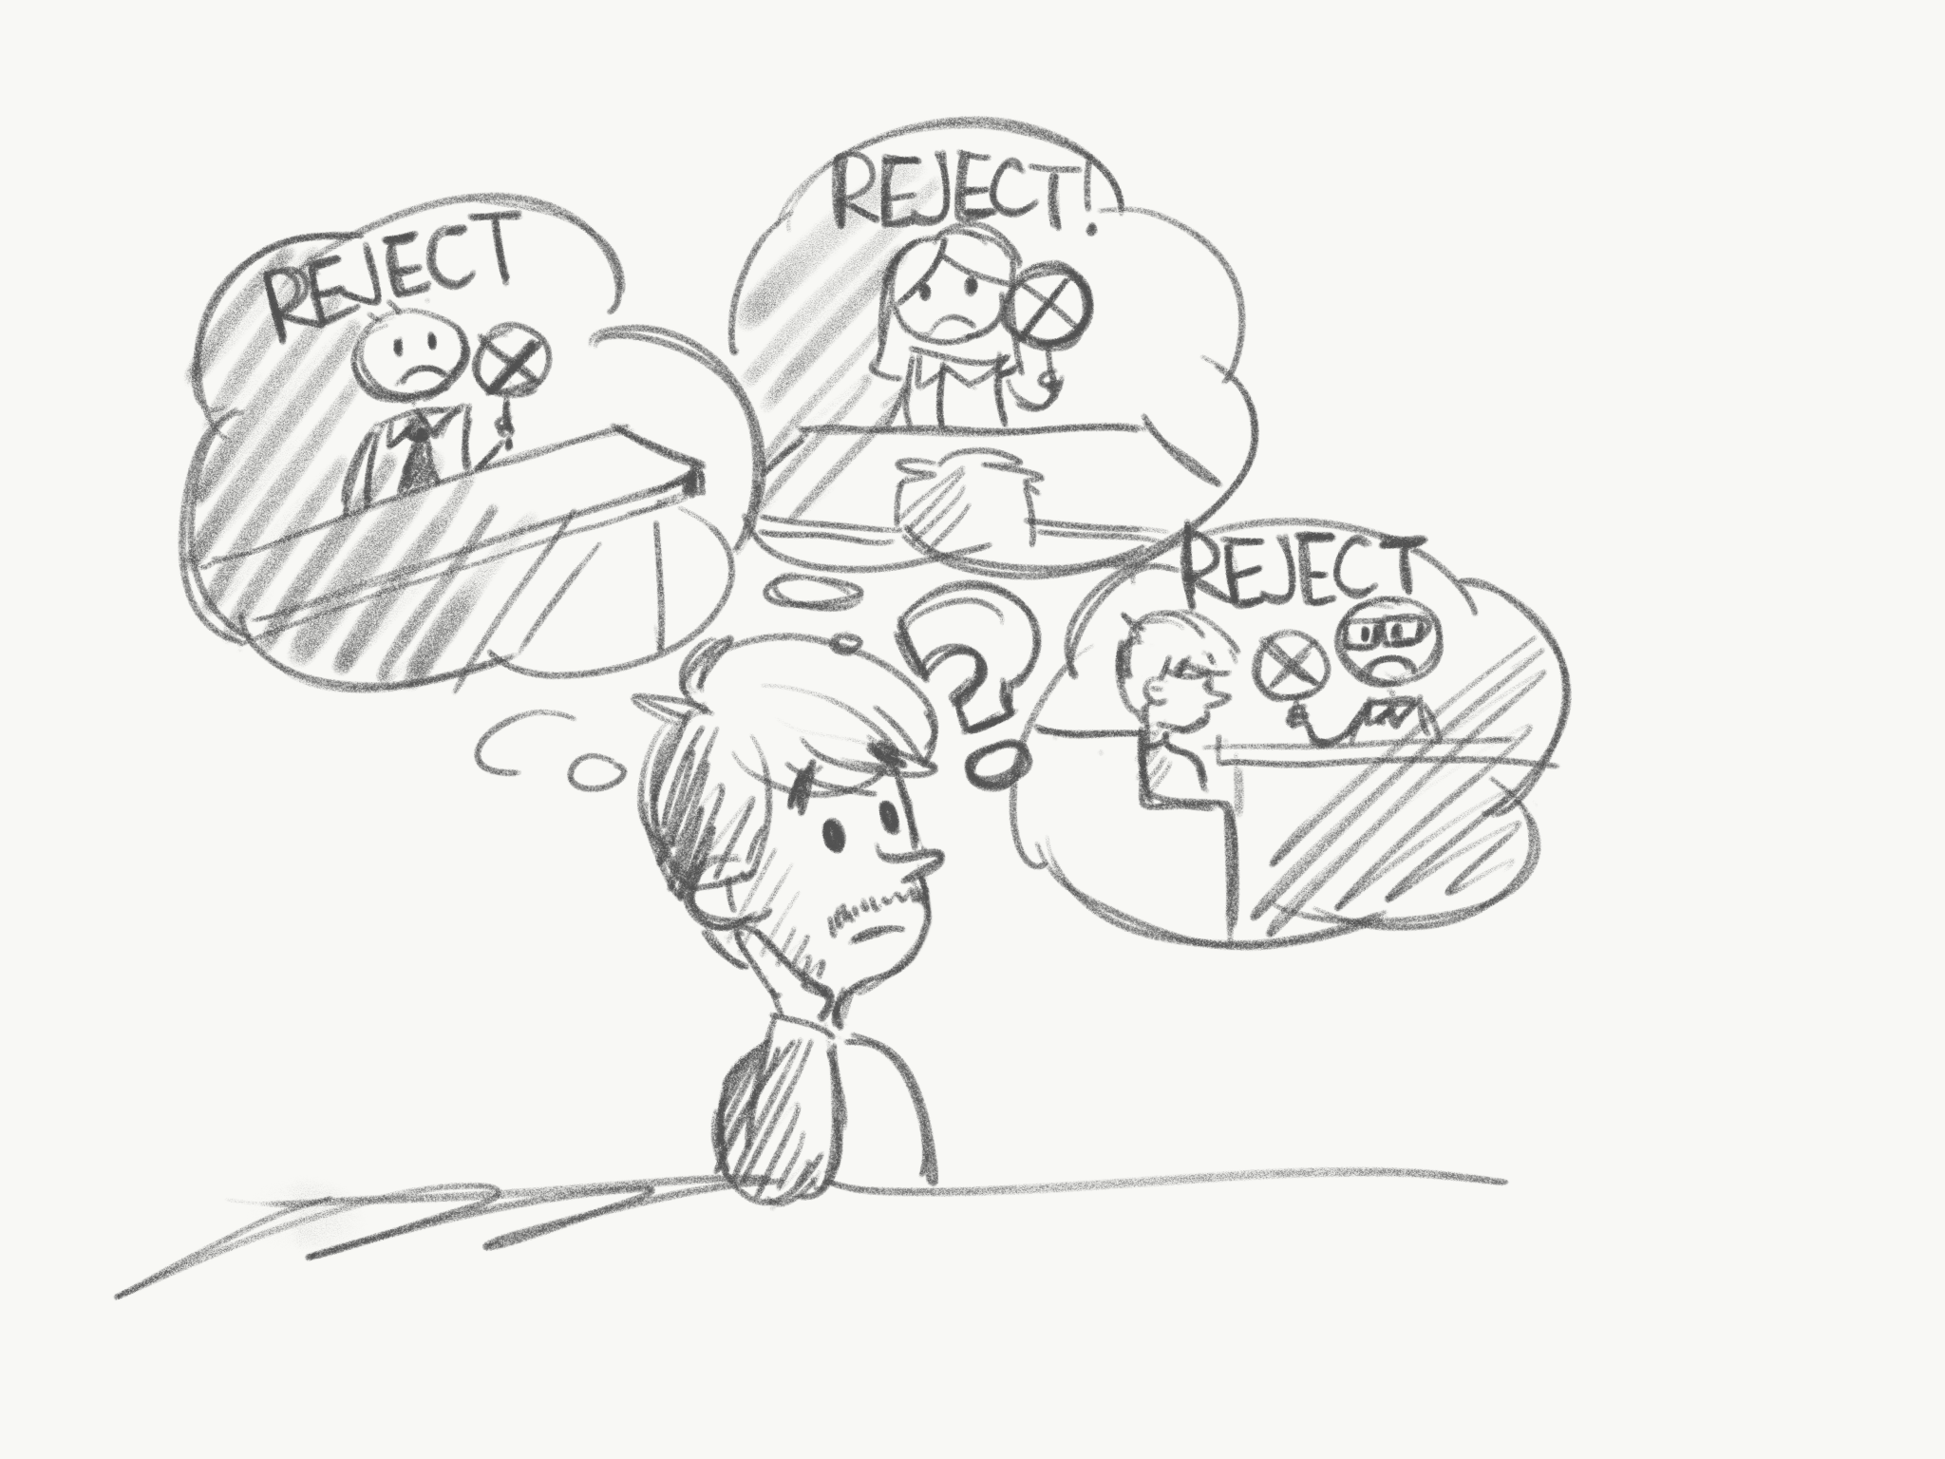 |  | 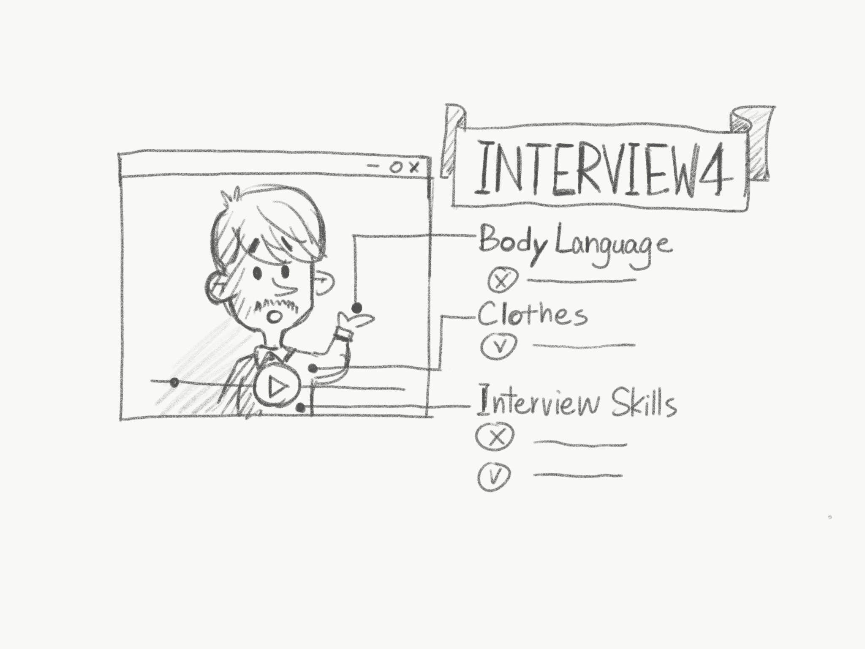
Zachary has had 3 interviews this month, but he hasn’t received an official offer. He feels he is poorly communicating his skills during interviews and wants a way to improve. | He hears about Interview 4; a tool designed to provide feedback and help people improve their interview skills. | Zachary records a demo session that is privately reviewed by a professional consultant. He gets feedback on how he can better answer interview questions, as well as basic tips on body language and tone. | During his next interview, Zachary remembers how to discuss how his previous responsibilities in a restaurant would be helpful in being a line cook.

MediaTutorial

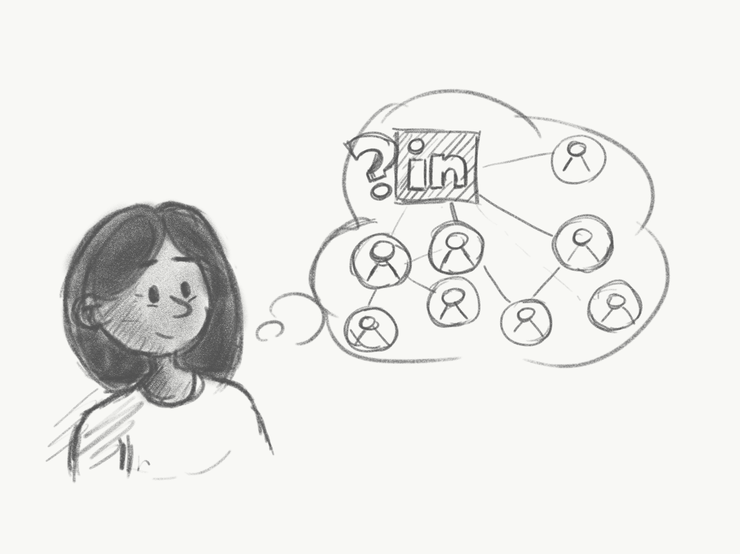 | 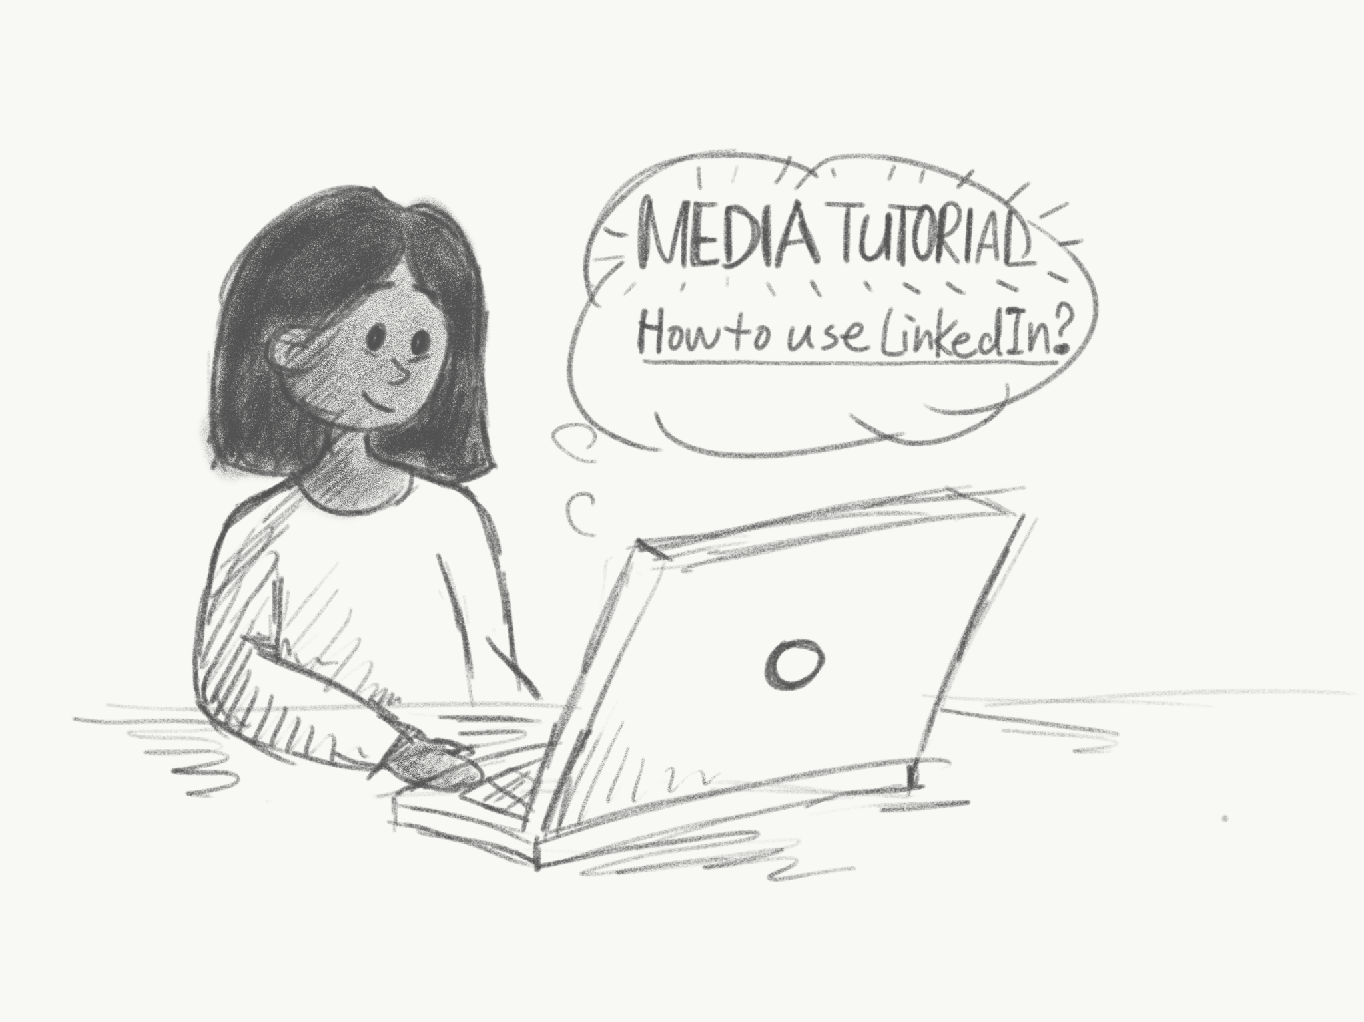 | 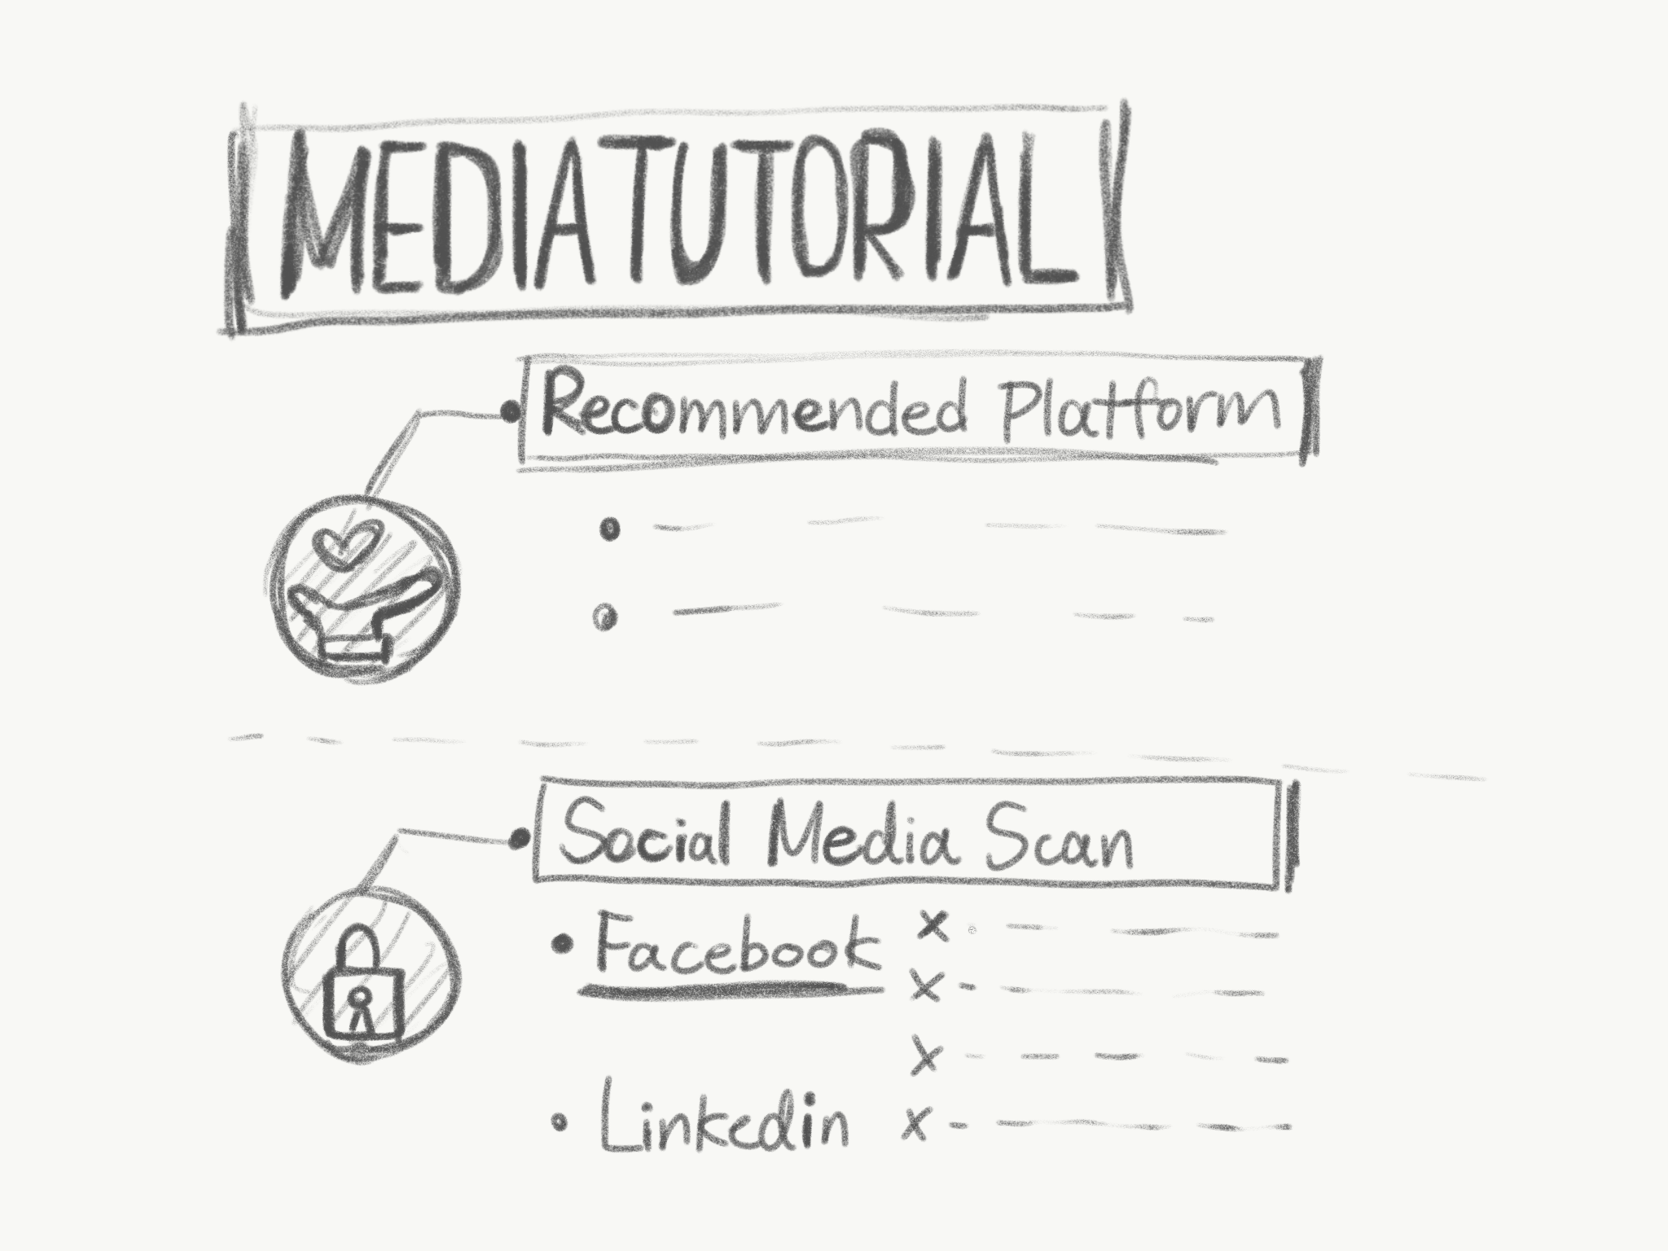 | 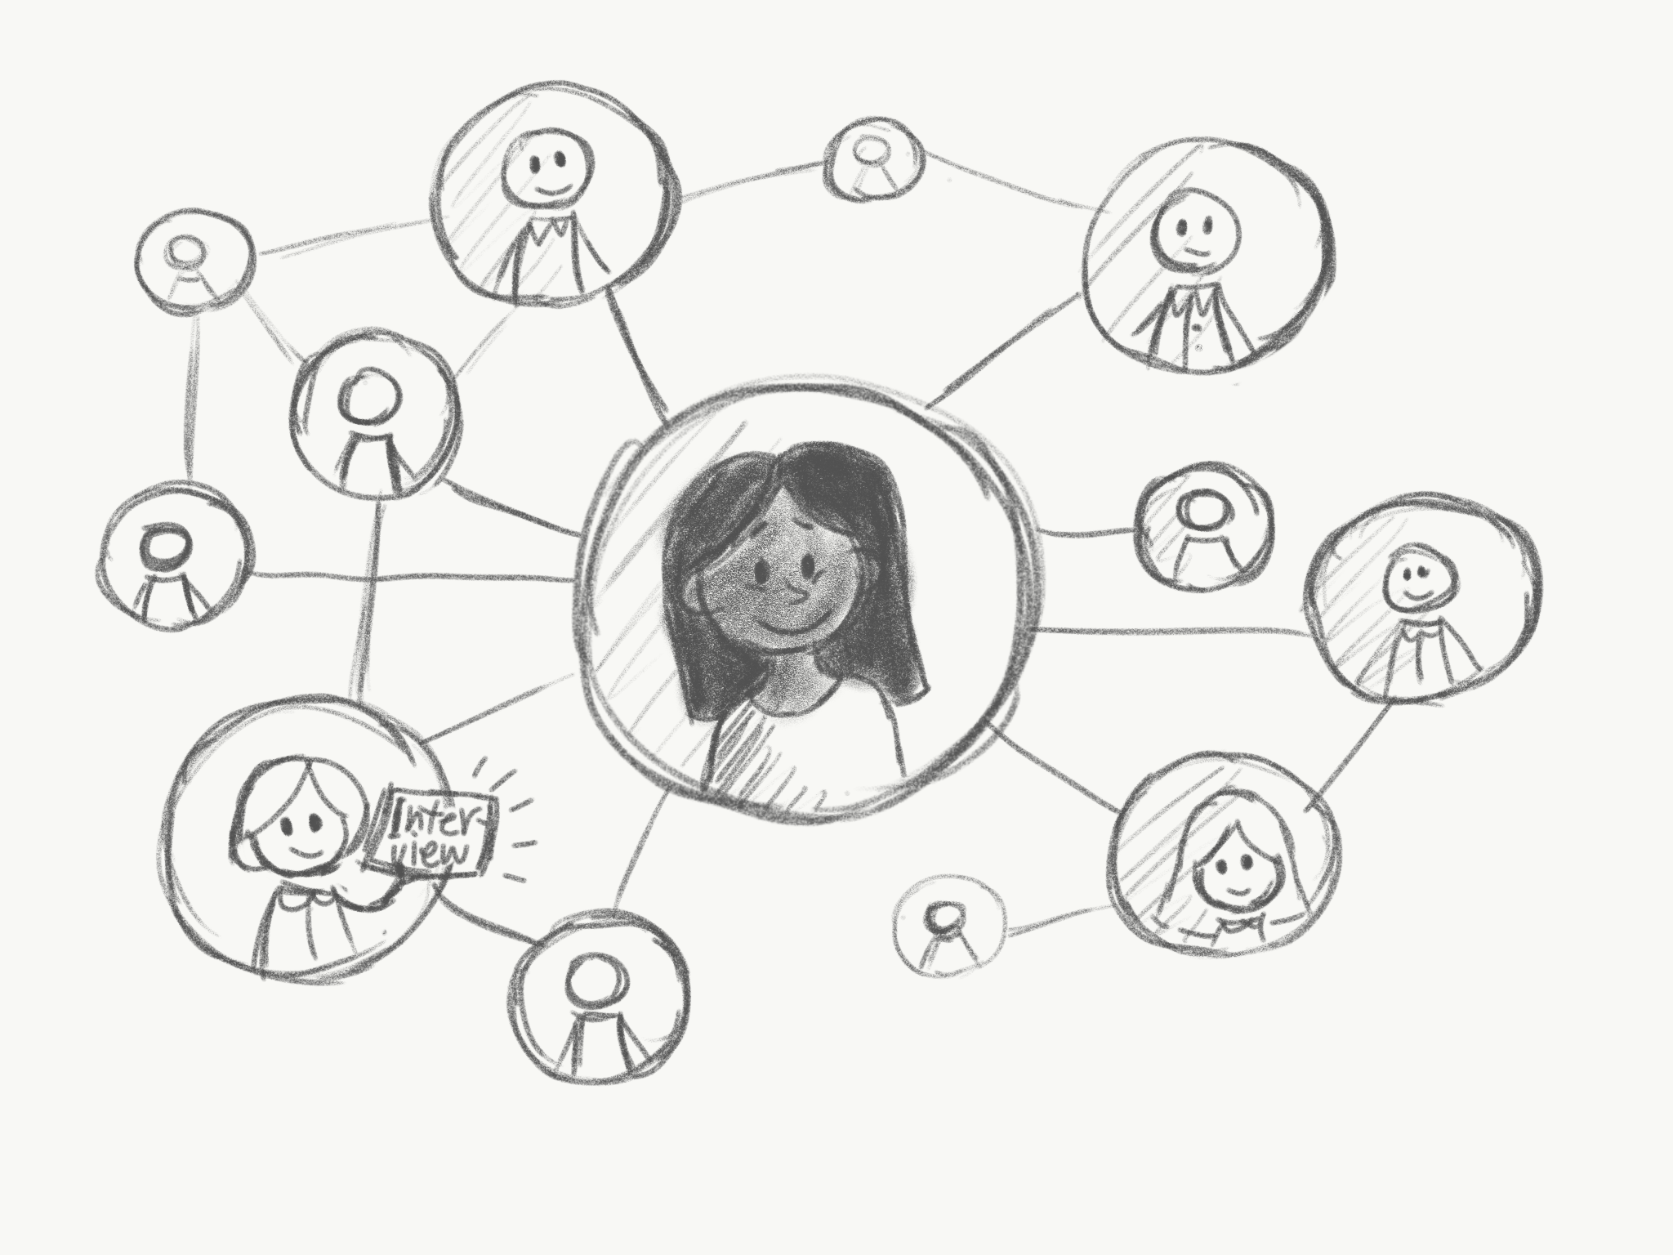
Samantha is a freelance designer looking for a way to get her name out there. She hears about many different online platforms to use, but is unsure how she should spend her time and worries how she will be perceived online. | She hears about MediaTutorial - a tool that helps job seekers develop a professional online brand. | Samantha uses MediaTutorial to identify free platforms to help her display her work and advertise herself. It also scans her Facebook and Linkedin site to determine what content to change and remove. | Using MediaTutorial, Samantha is able to change how she presents herself online and remove potentially harmful information.

Anon-Interviews

 | 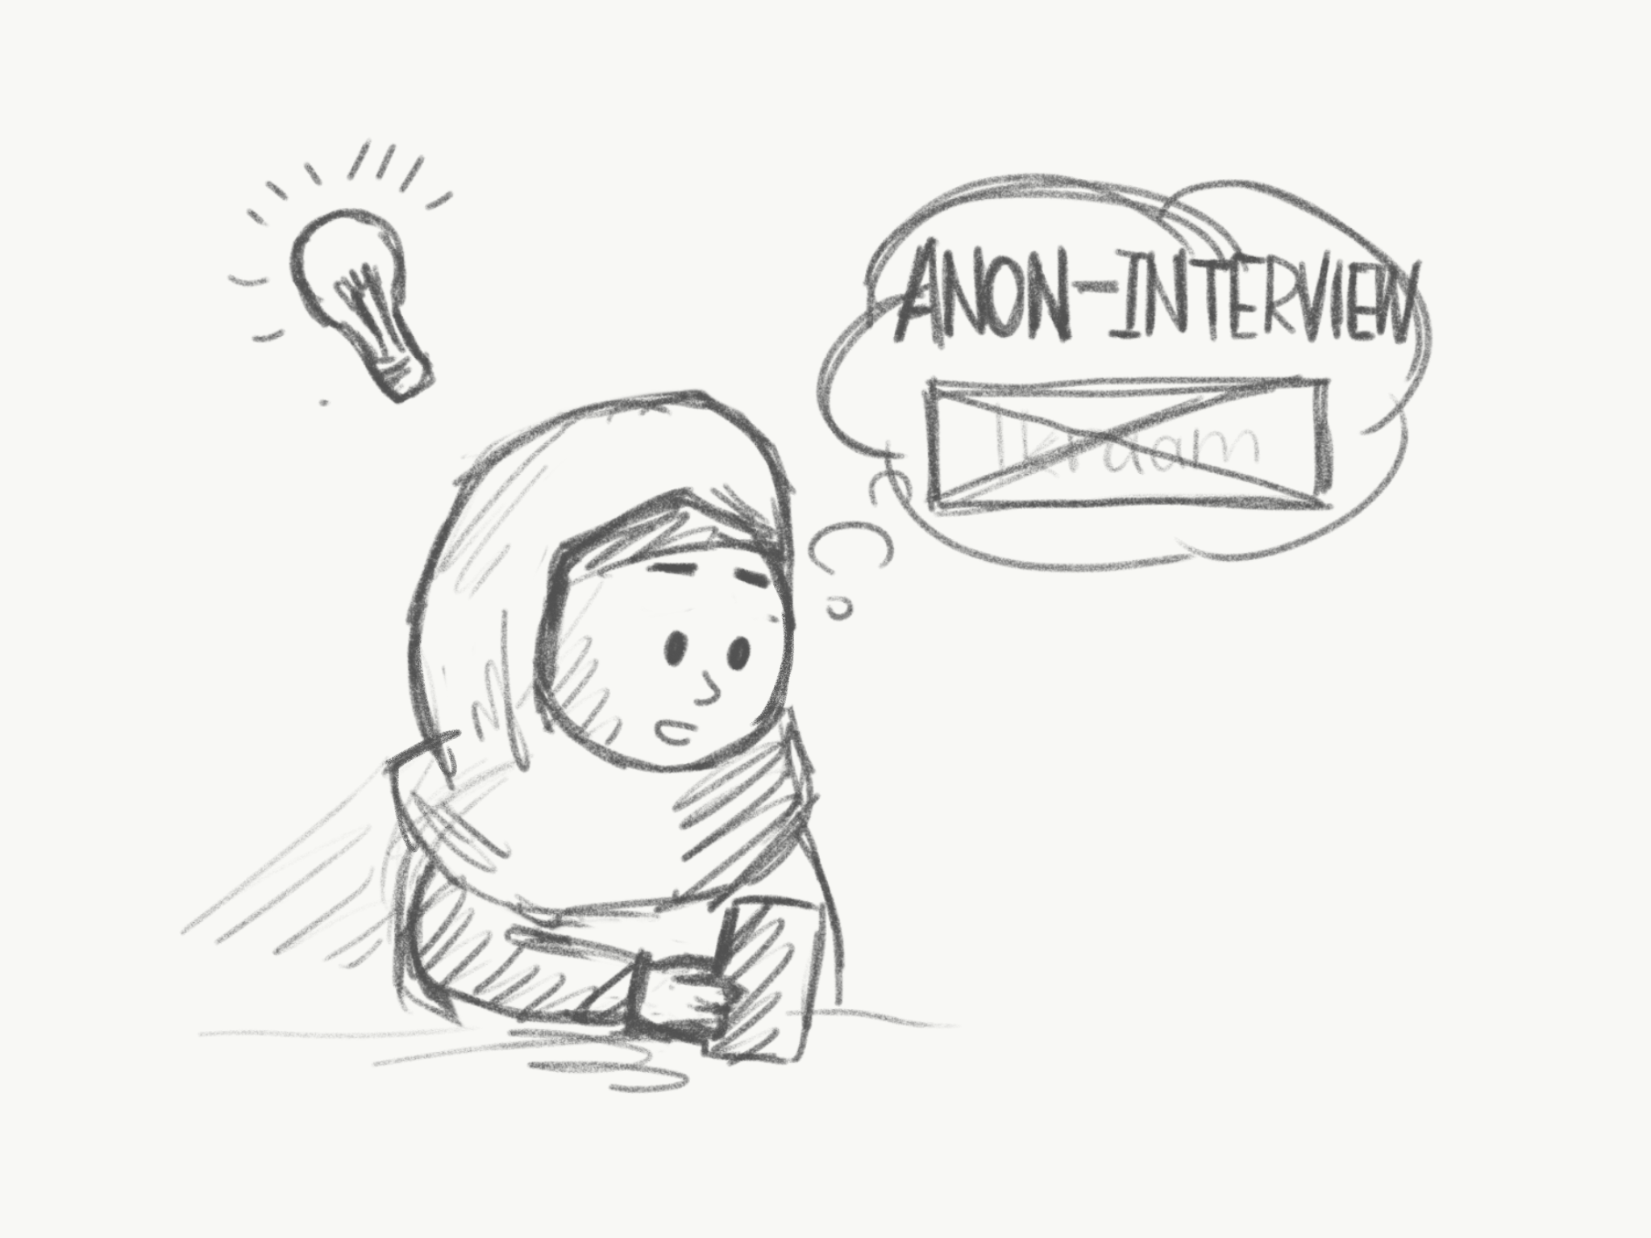 | 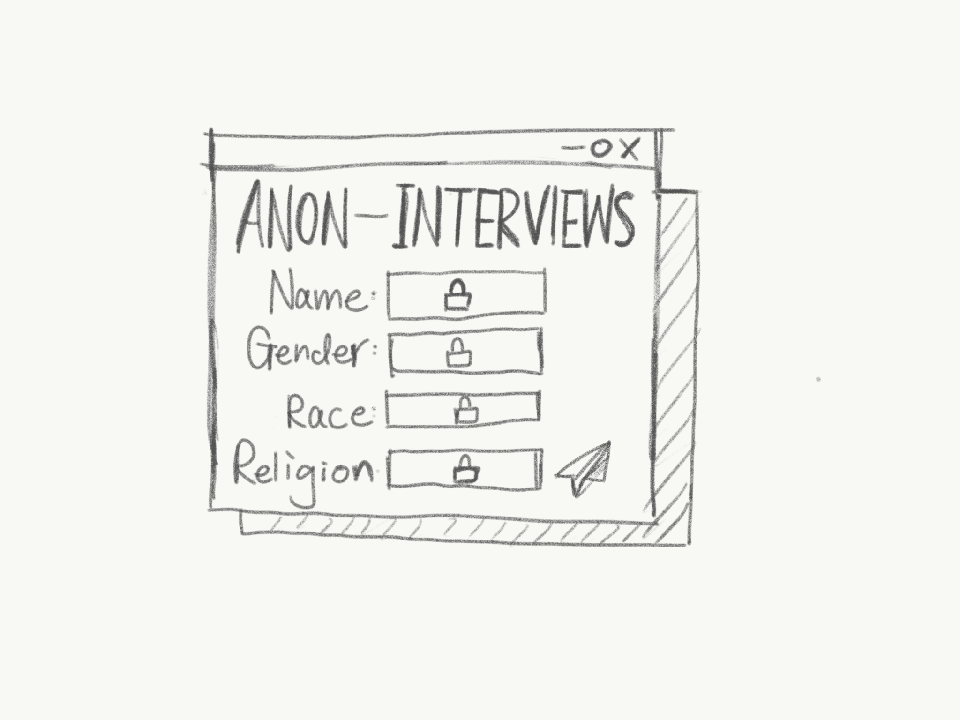
Ikraam has been applying for jobs for the last 2 months but has not been hearing back. Ikraam wonders if her name is being screened out due to discrimination. | Ikraam finds Anon-Interviews: a tool that masks identifying information when applying for jobs. | She submits her CV, then Anon-Interviews masks her gender, race, or religion, and submits her application to relevant jobs at large companies that desire more diverse employees. | Ikraam is content knowing she is applying to jobs at companies where there is an effort to reduce discriminatory practices, and diversity is appreciated.

ForgetAboutIt

 | 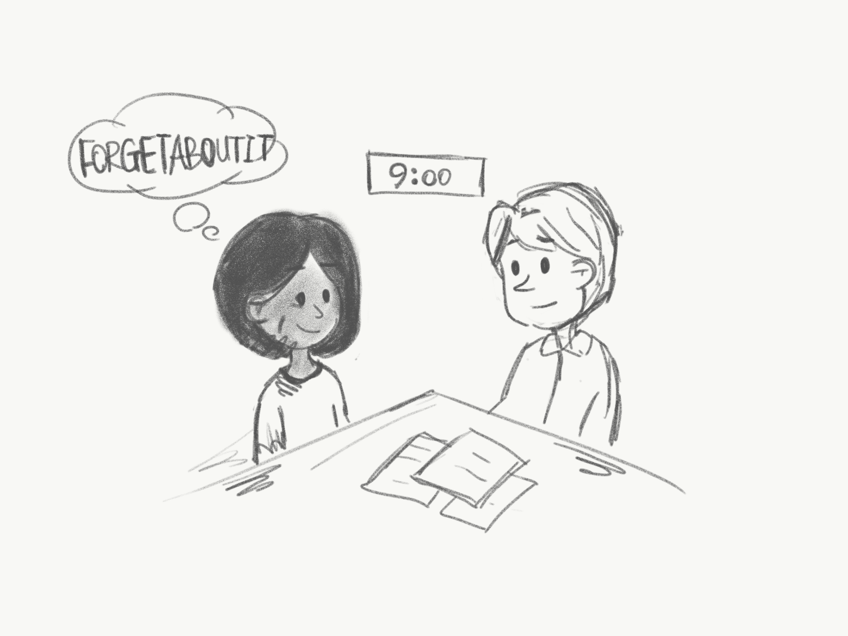 | 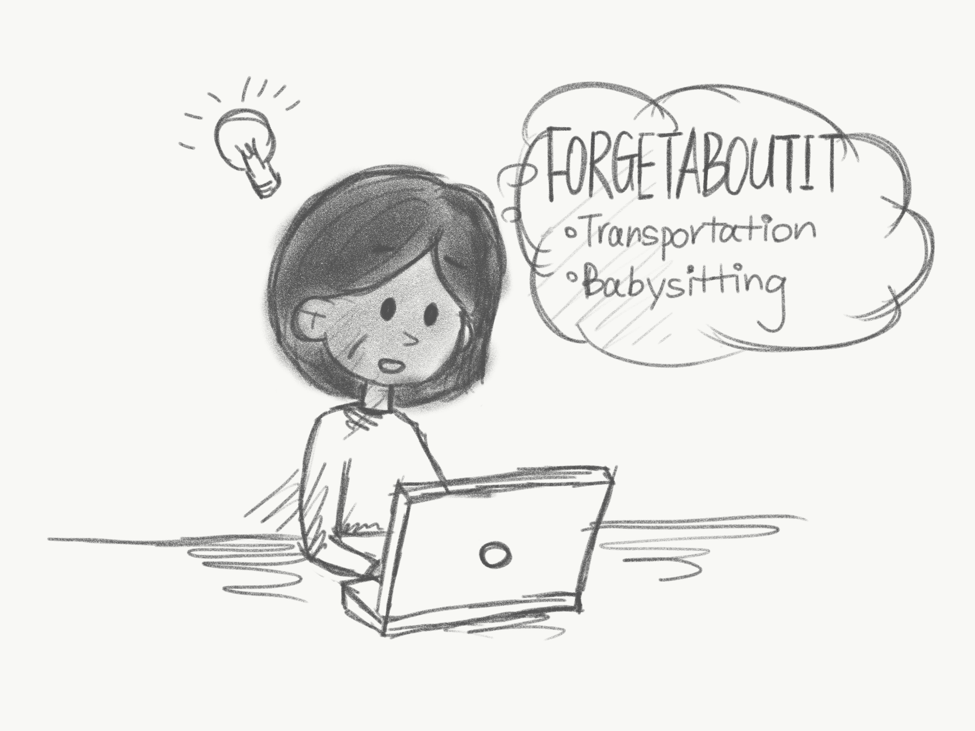
Jane has a full day - she needs to drop her kids off at school at 9am, then has an interview at 11am. Unfortunately, Jane’s daughter has an issue at school causing Jane to be late for her interview. | Jane discusses the issue with a friend who mentions ForgetAboutIt - a service that helps arrange transportation and babysitting services for job seekers. | The next time, Jane gets an interview, she decides to use ForgetAboutIt. By paying a small fee, ForgetAboutIt gets a babysitter and car to come to her house. | Jane is able to leave her house on time and without issues.

WeCanDoIt

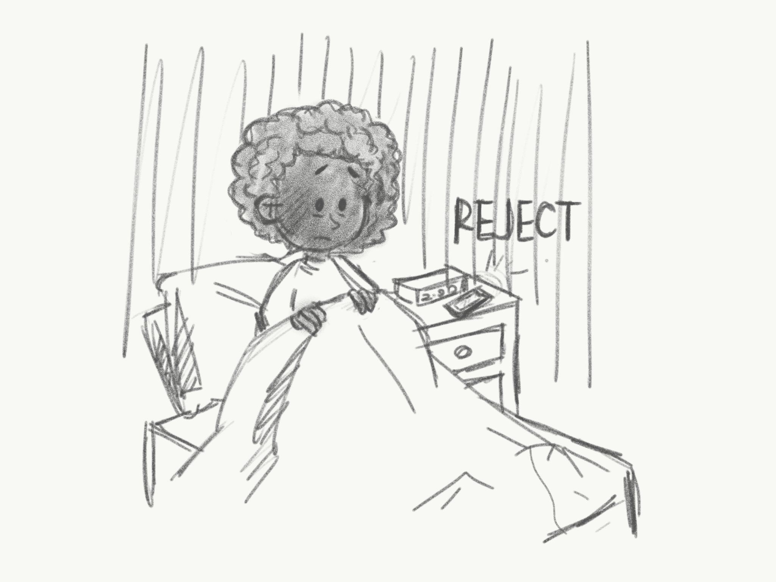 | 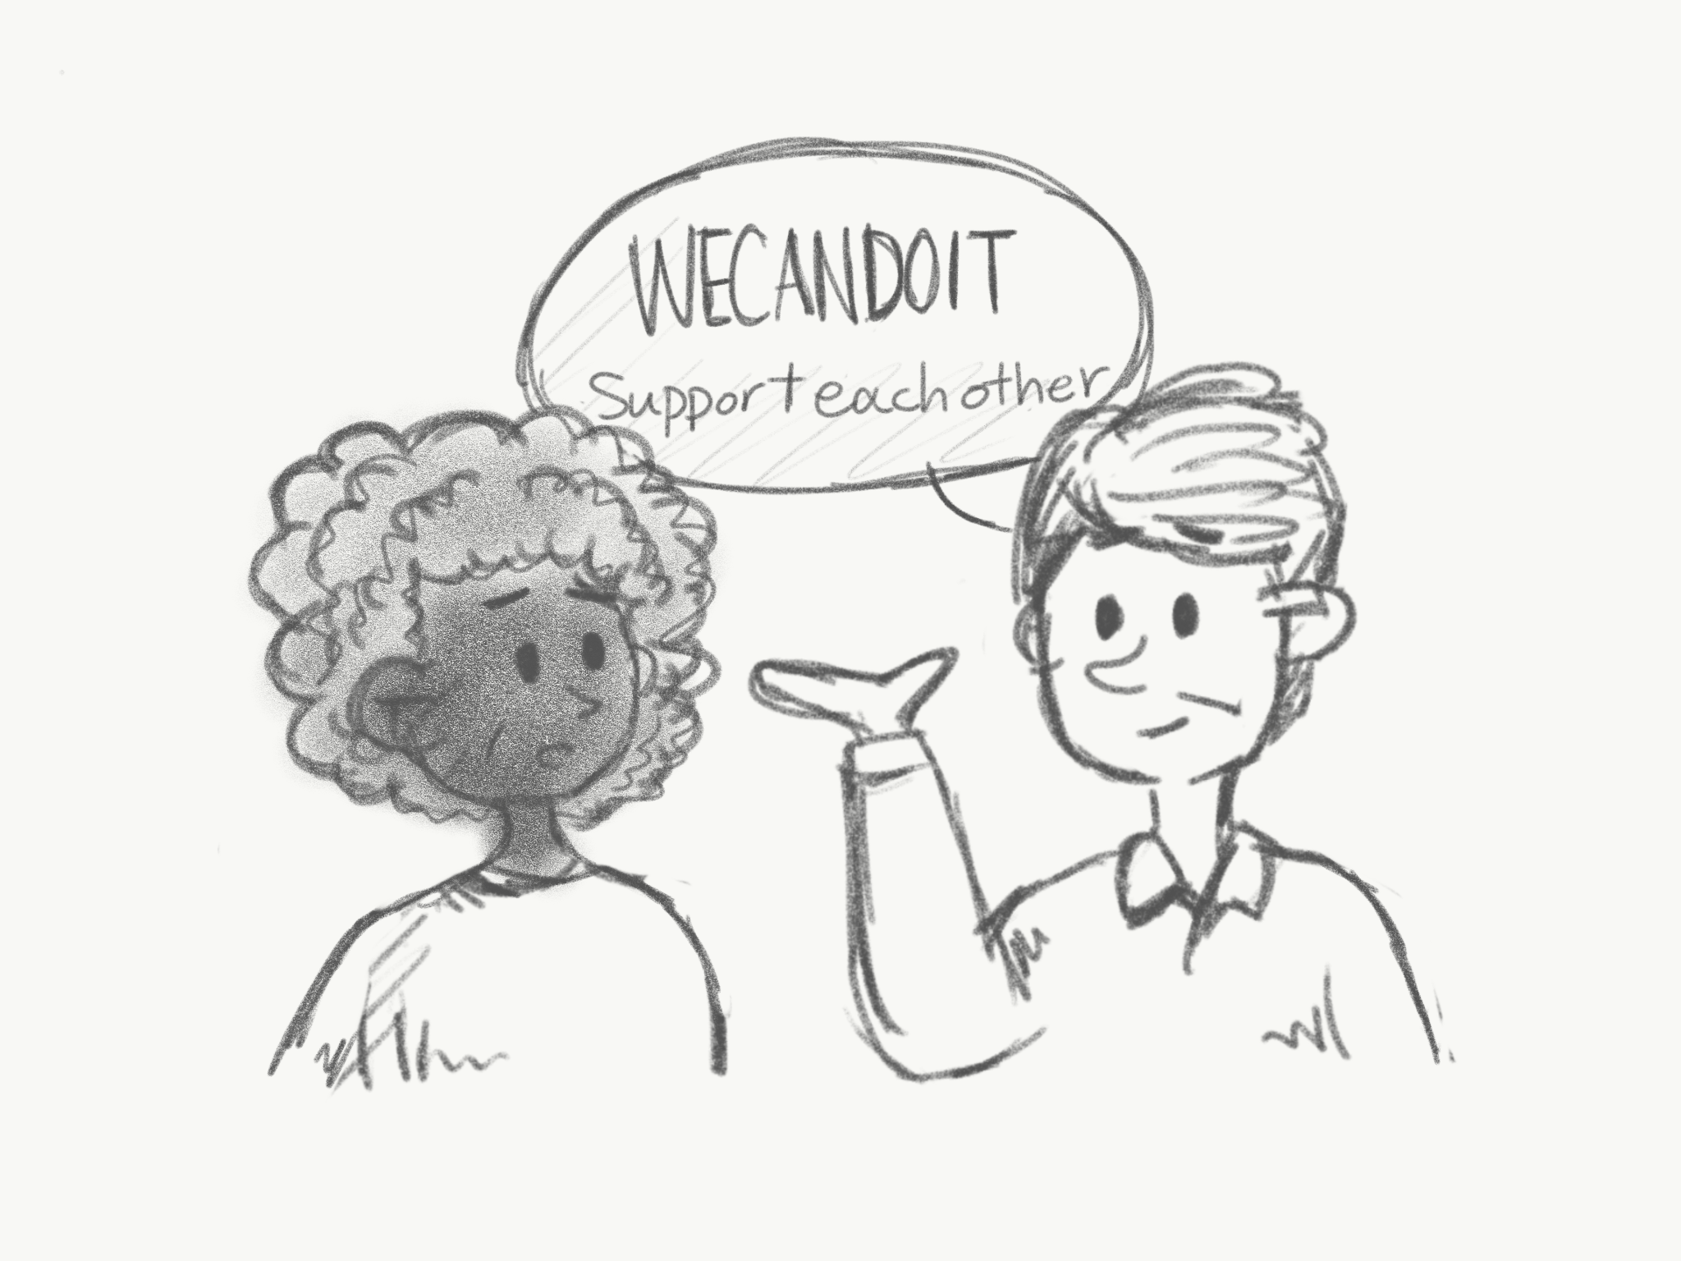 | 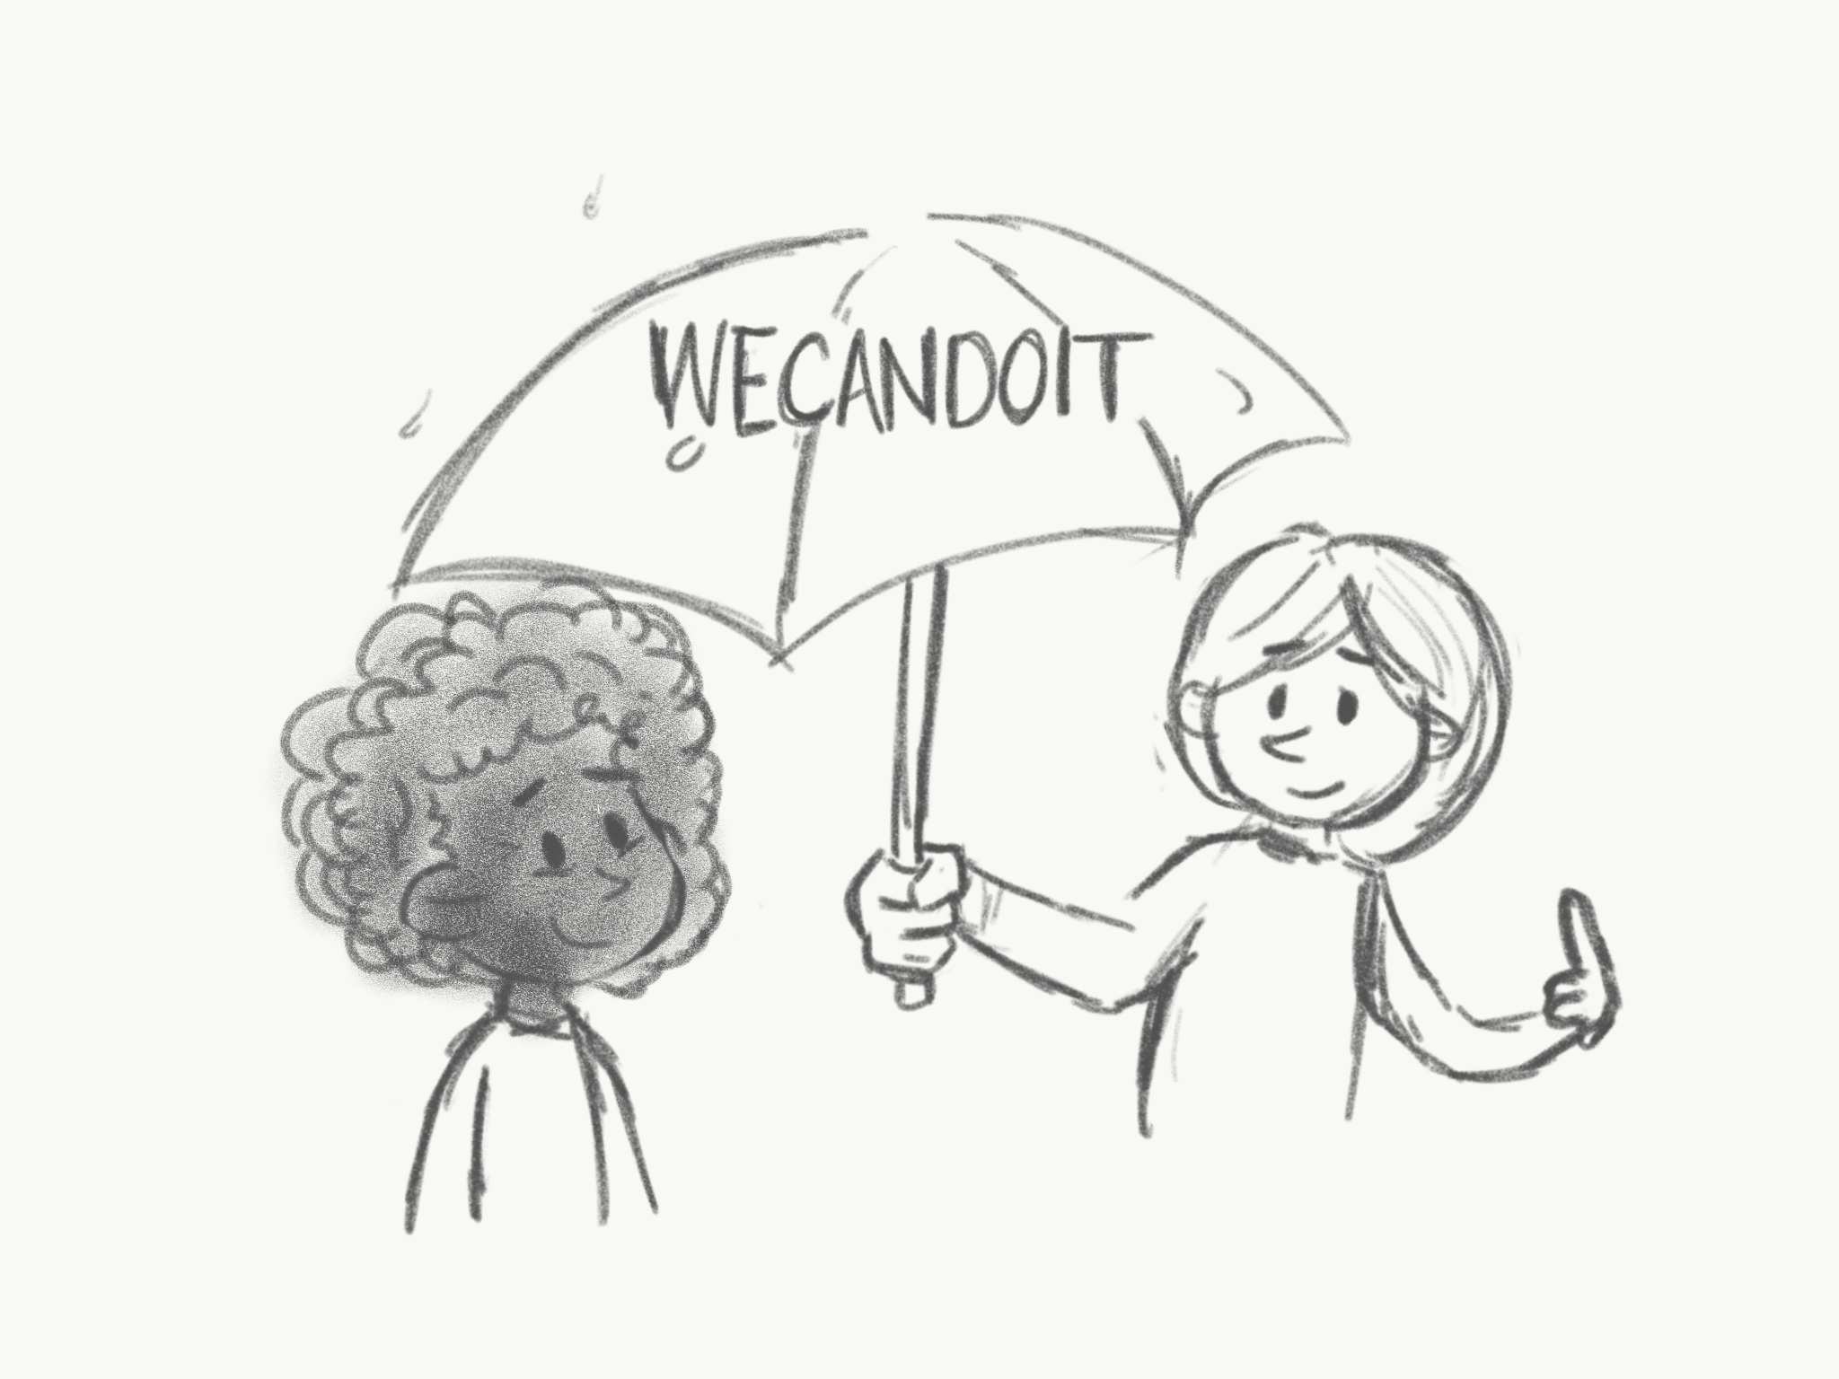 | 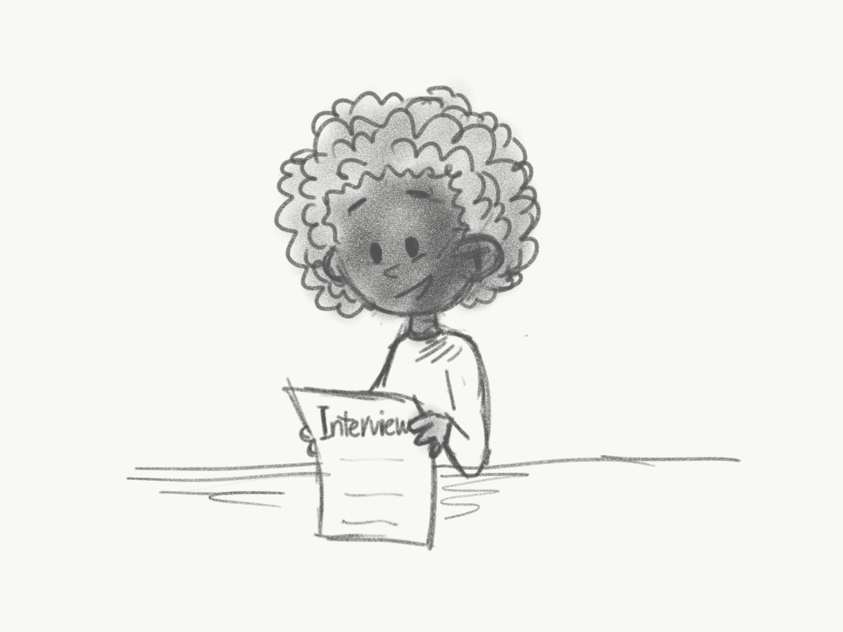
Alina has been searching for a job as an office coordinator for the last 3 months but hasn’t had any success. She is losing motivation and finds it hard to continue looking. | Alina runs into Kenny who tells her about WeCanDoIt - an online support group where people can support each other and share tips. | WeCanDoIt helps match people looking for similar jobs but in different geographical areas together, so they can share practical tips on how they go about job searches, interviews, and give positive affirmations to help them stay motivated. | Alina hears on WeCanDoIt that hiring is slow right now for larger companies, but people have had success with local organizations. Alina changes her strategy and spends more time networking and applying for jobs at local businesses in her area.

Job Score

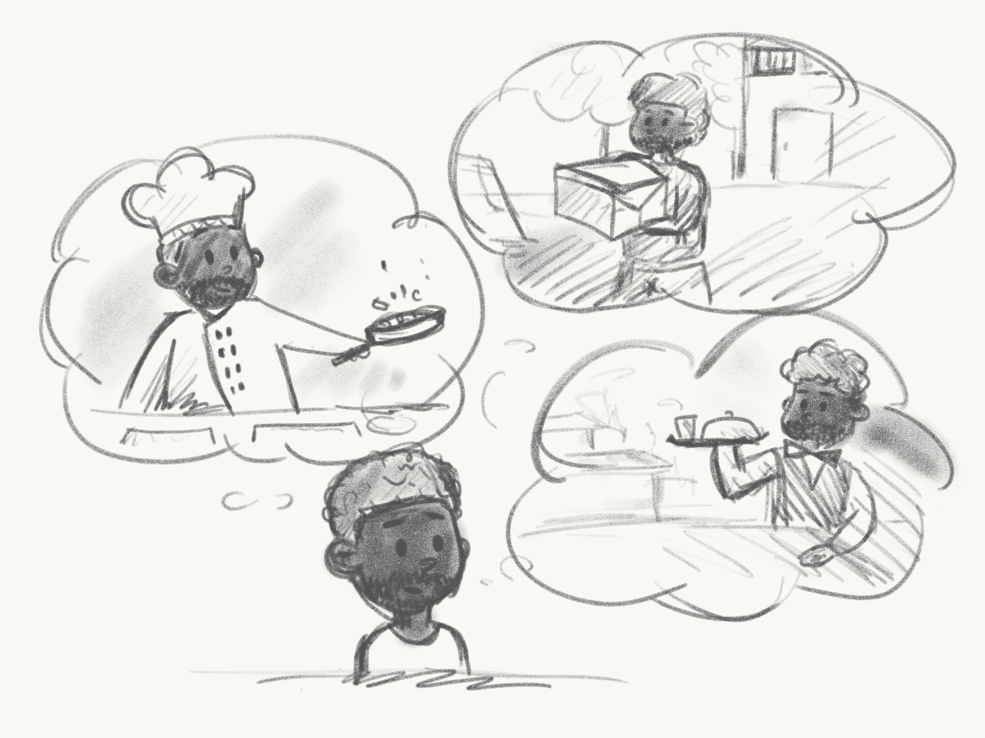 | 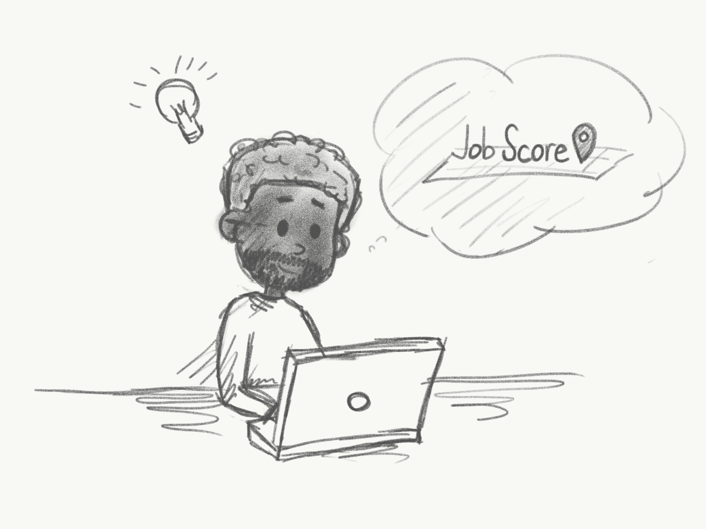 | 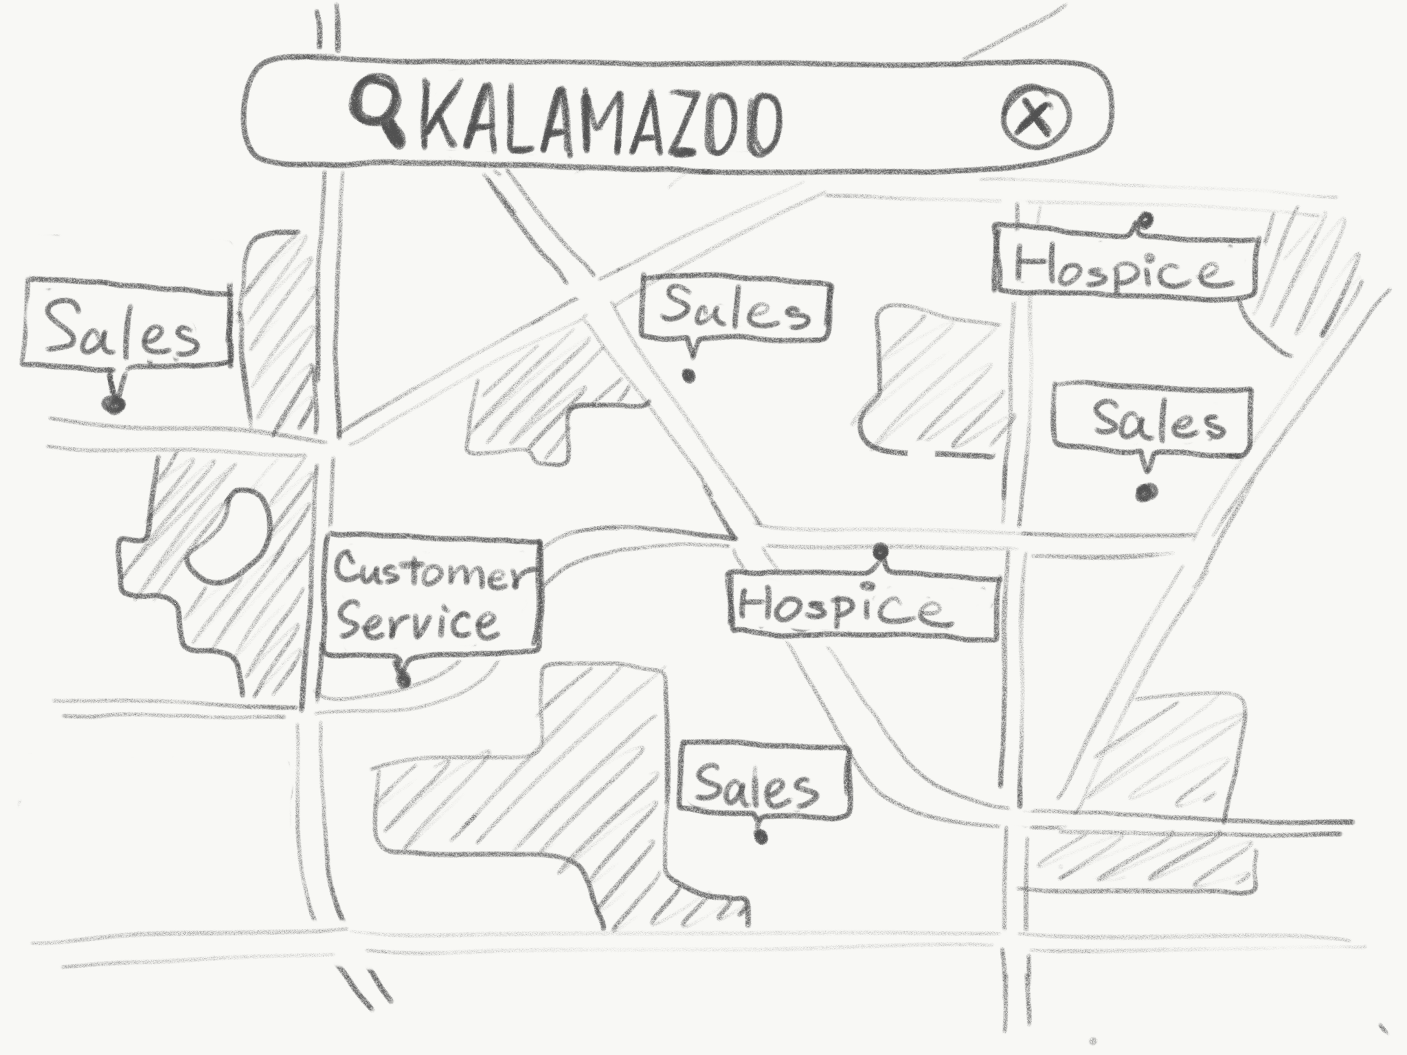 | 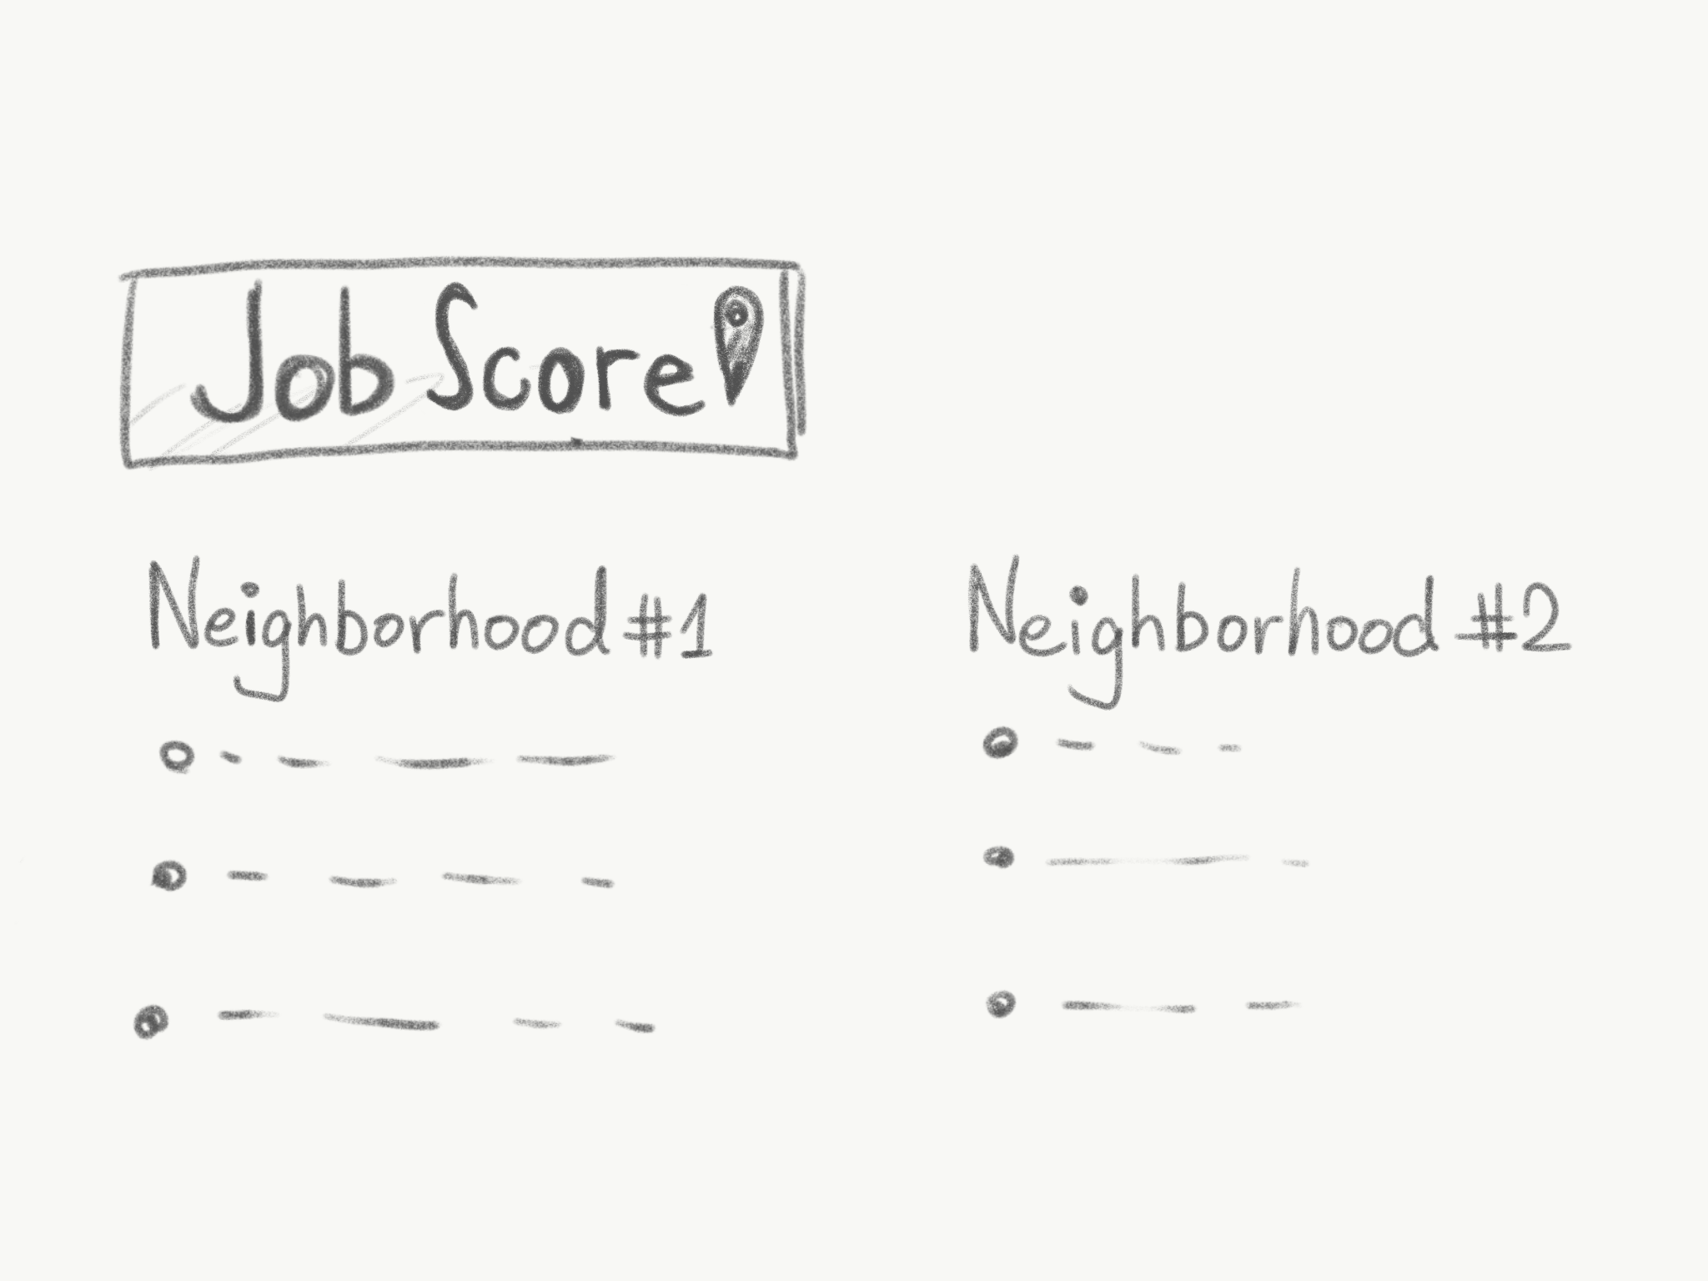
Trevor plans to move to a new neighborhood. He has been working temp jobs for the last few years and hopes that moving elsewhere will improve his chances for finding a full time job. | Trevor uses Job Score - a tool that provides detailed information about job prospects for a specified area or location. | Trevor enters Kalamazoo, which displays the need for individuals skilled in customer service, hospice, and sales. It displays the current companies and projected growth within a walkable distance. | Trevor uses Job Score to look up different neighborhoods and choose where to move

